**Table of Contents**

|  |  |  |  |
| --- | --- | --- | --- |
| **S.no.** | **Title of Experiment** | **Date of Experiment** | **Page no.** |
| 1) | Docker Installation | 11/08/2023 | 3-6 |
| 2) | Docker Lifecycle | 18/08/2023 | 7-9 |
| 3) | Apache, JDK installation | 25/08/2023 | 10-12 |
| 4) | Dockerfile | 01/09/2023 | 13-16 |
| 5) | Data Management in Docker | 08/09/2023 | 17-22 |
| 6) | Docker Networking | 15/09/2023 | 23-27 |
| 7) | Docker Compose | 22/09/2023 | 28-35 |
| 8) | Docker Swarm | 6/10/2023 | 36-49 |
| 9) | CI/CD Pipeline | 20/10/2023 | 50-51 |
| 10) | Minikube | 27/10/2023 | 52-56 |
| 11) | ECS(Elastic Container Service) | 24/11/2023 | 57-72 |
| 12) | EKS(Elastic Kubernetes Service) | 01/12/2023 | 73-82 |

**EXPERIMENT -1: Docker Insatallation**

**For Windows**

**Step-1:** Go to the browser and search docker desktop. Download docker desktop.

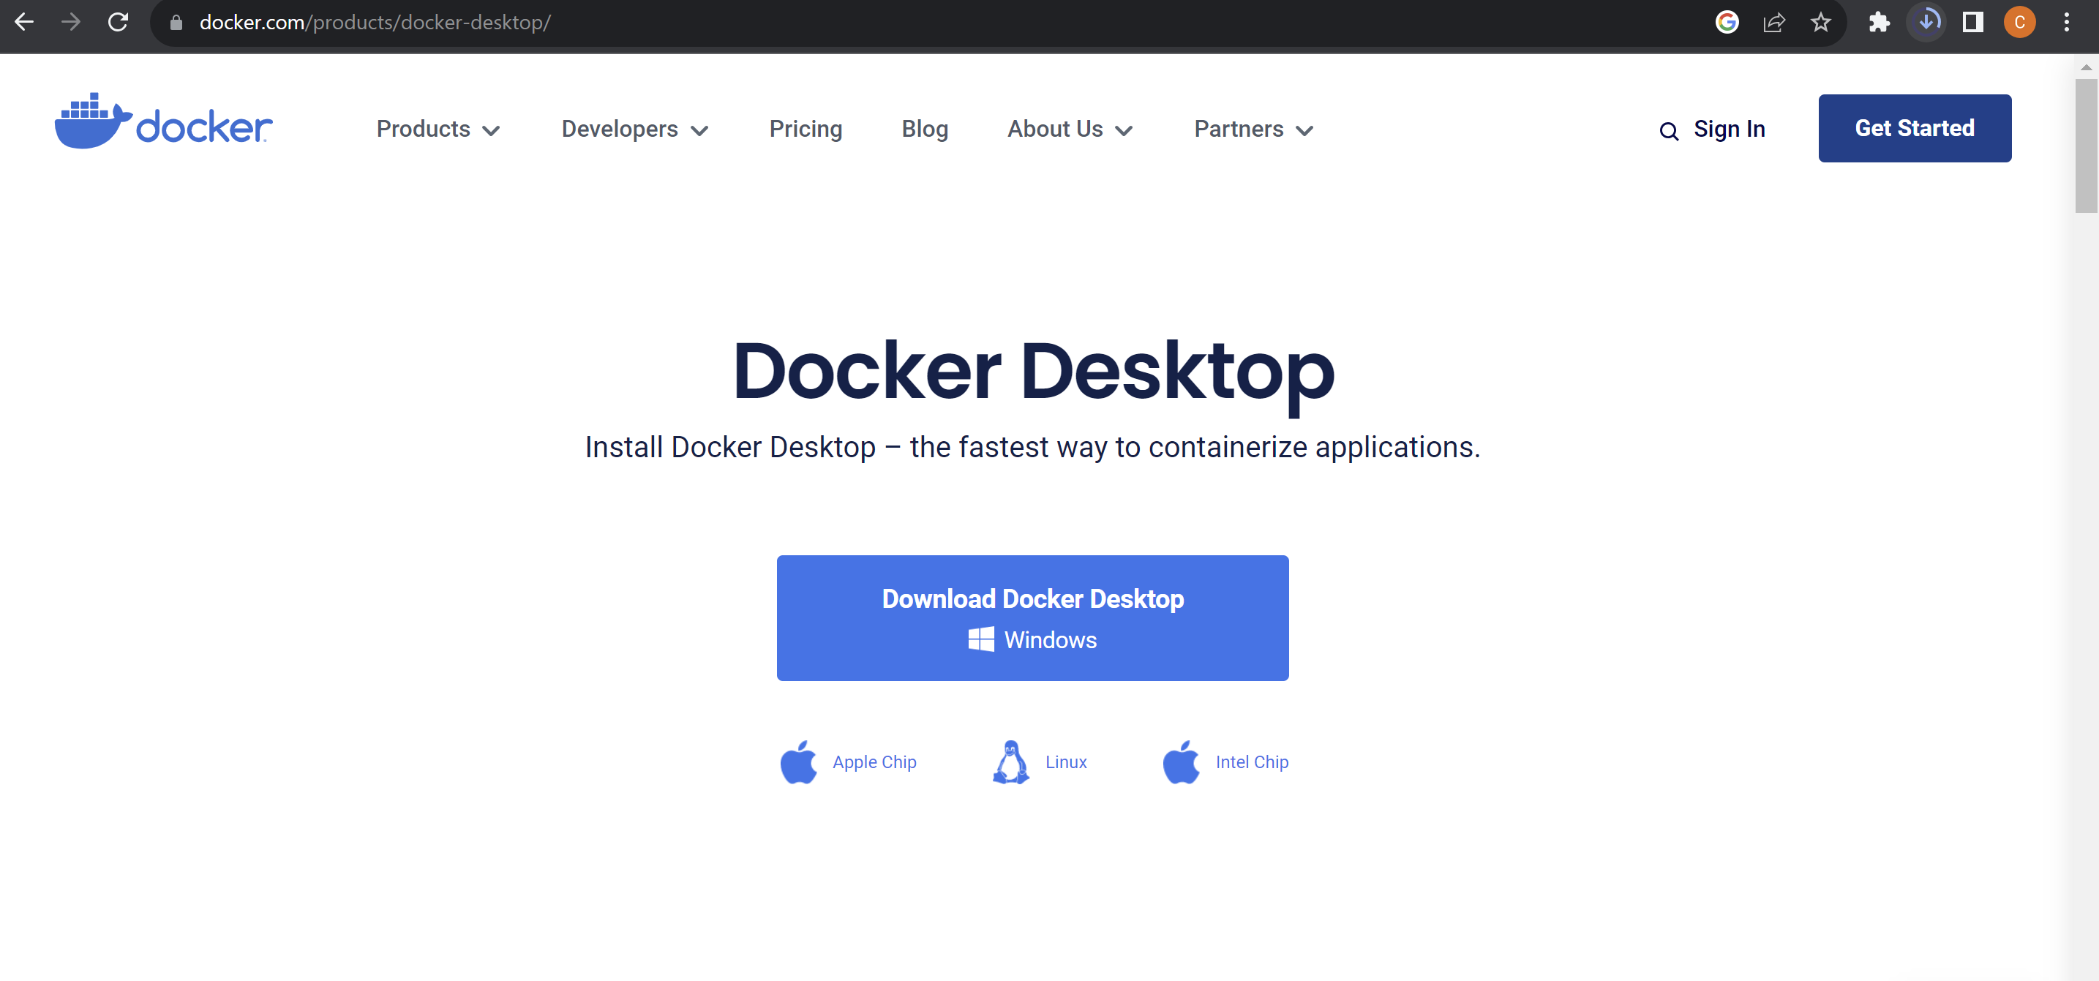

**Step-2:** Run the downloaded .exe file and complete the docker installation.

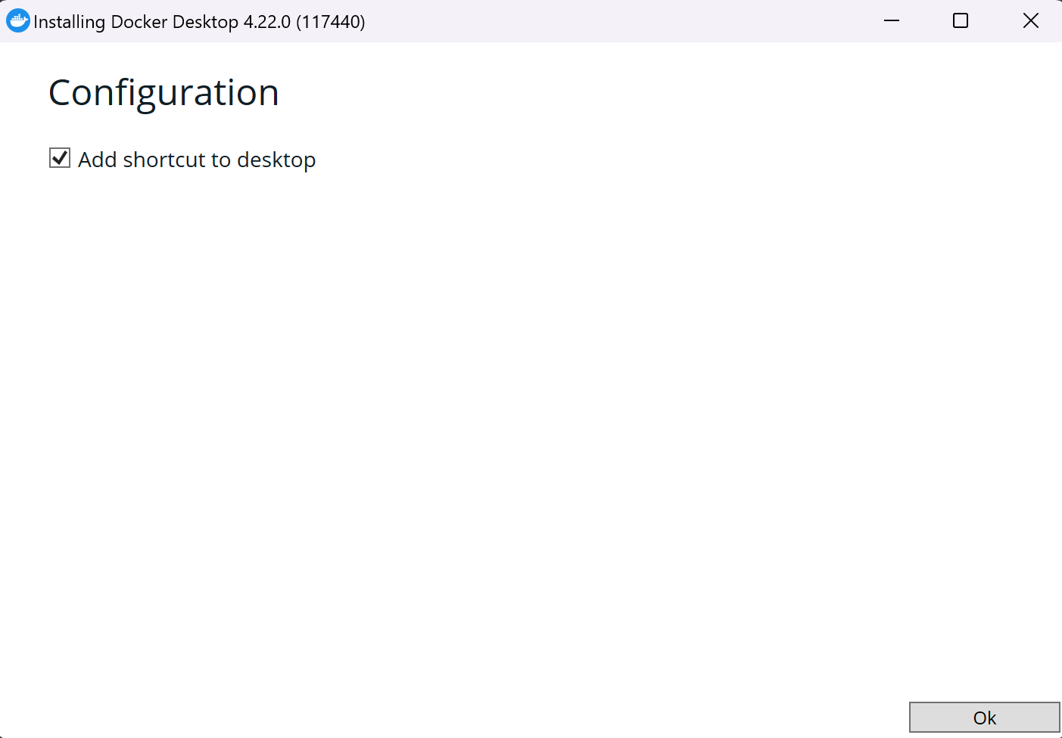

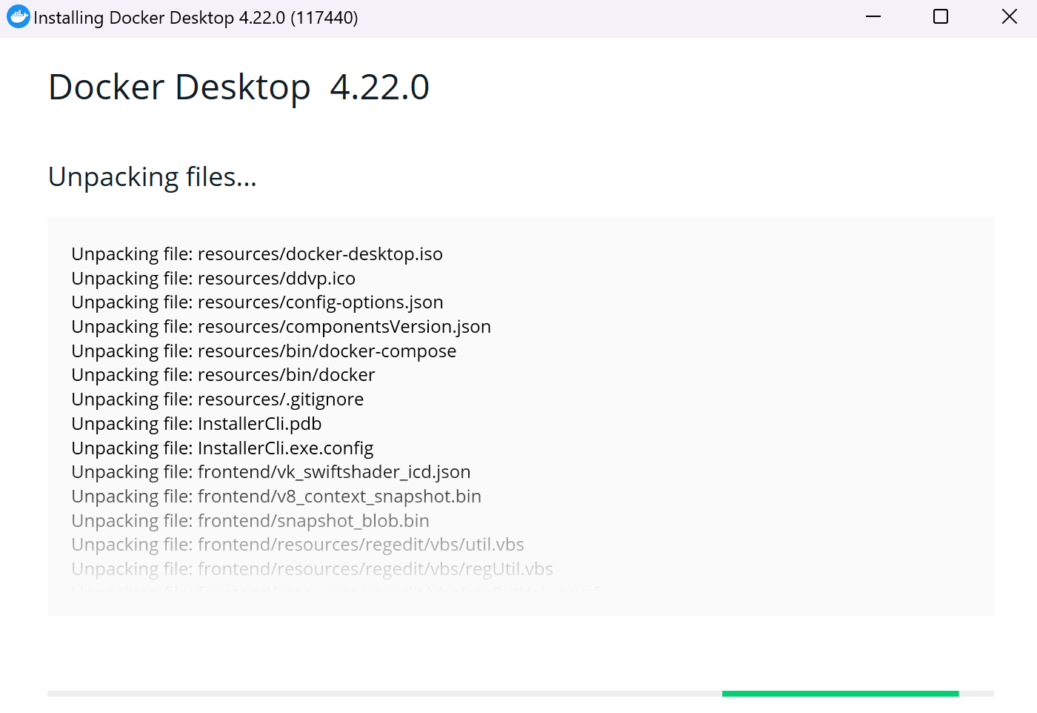

**Step-3:** After the installation is complete, go to command prompt and write the command – “ docker –version”.

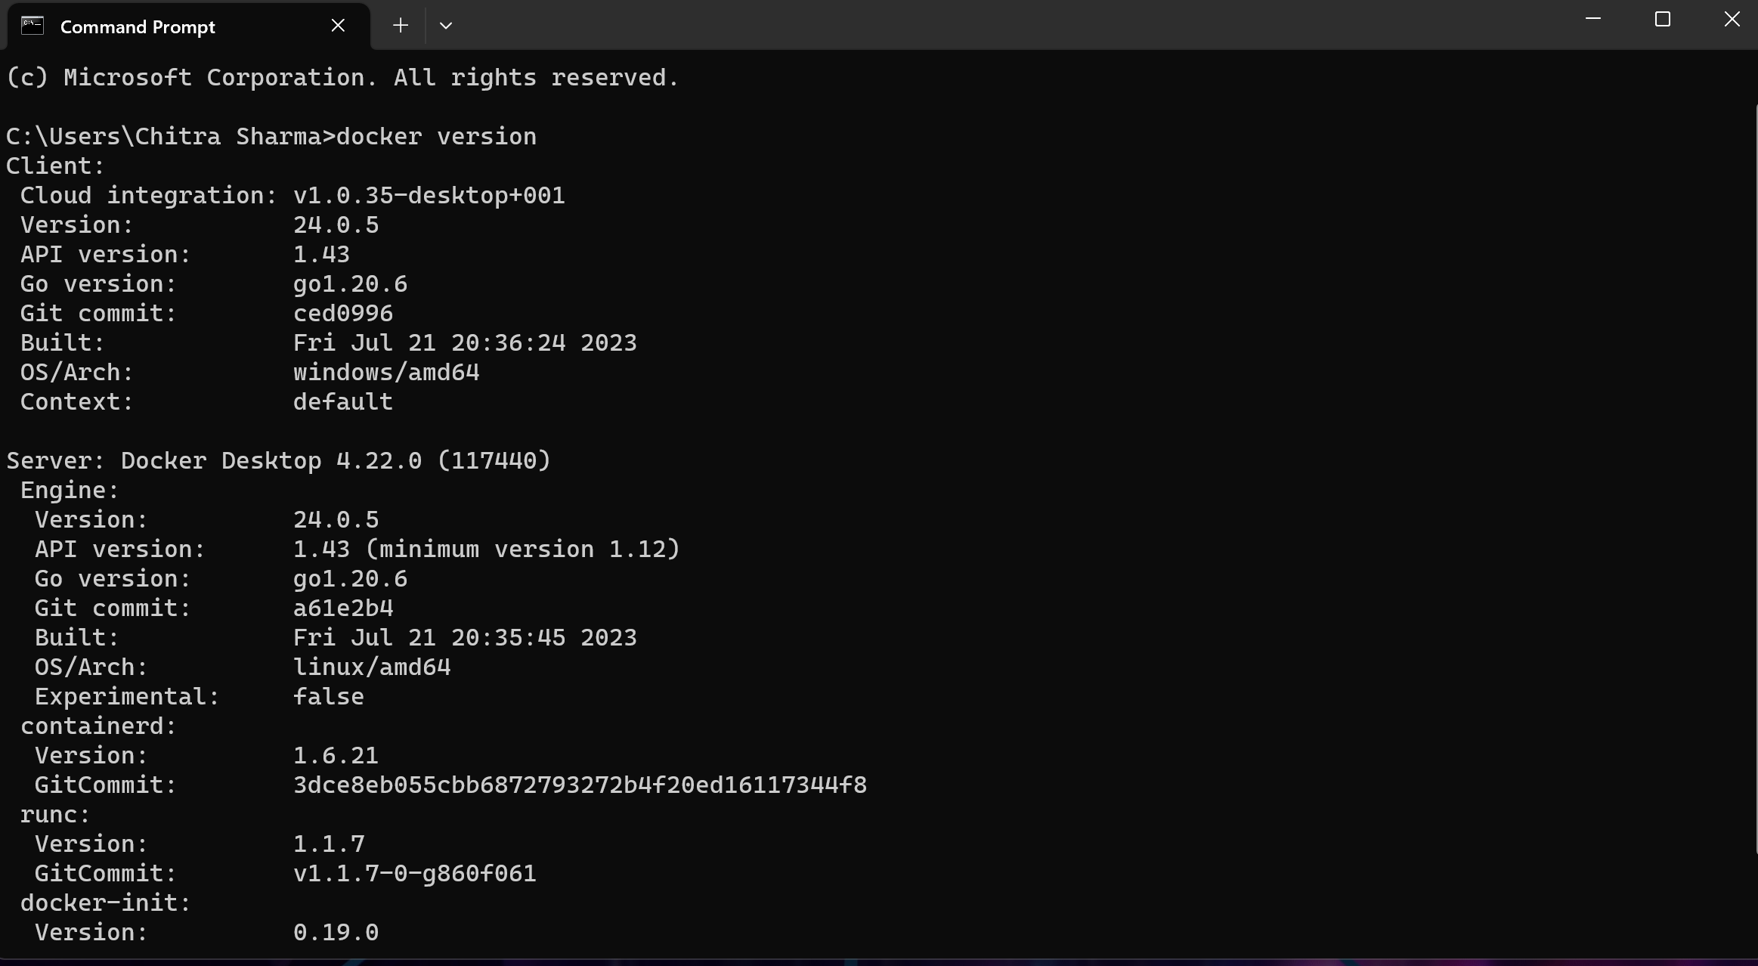

**Result:** Client and Server information is displayed hence the docker is installed and running.

**For Ubuntu**

**Step-1:** Go to the native ubuntu application and update the ubuntu using the command – “sudo apt update”

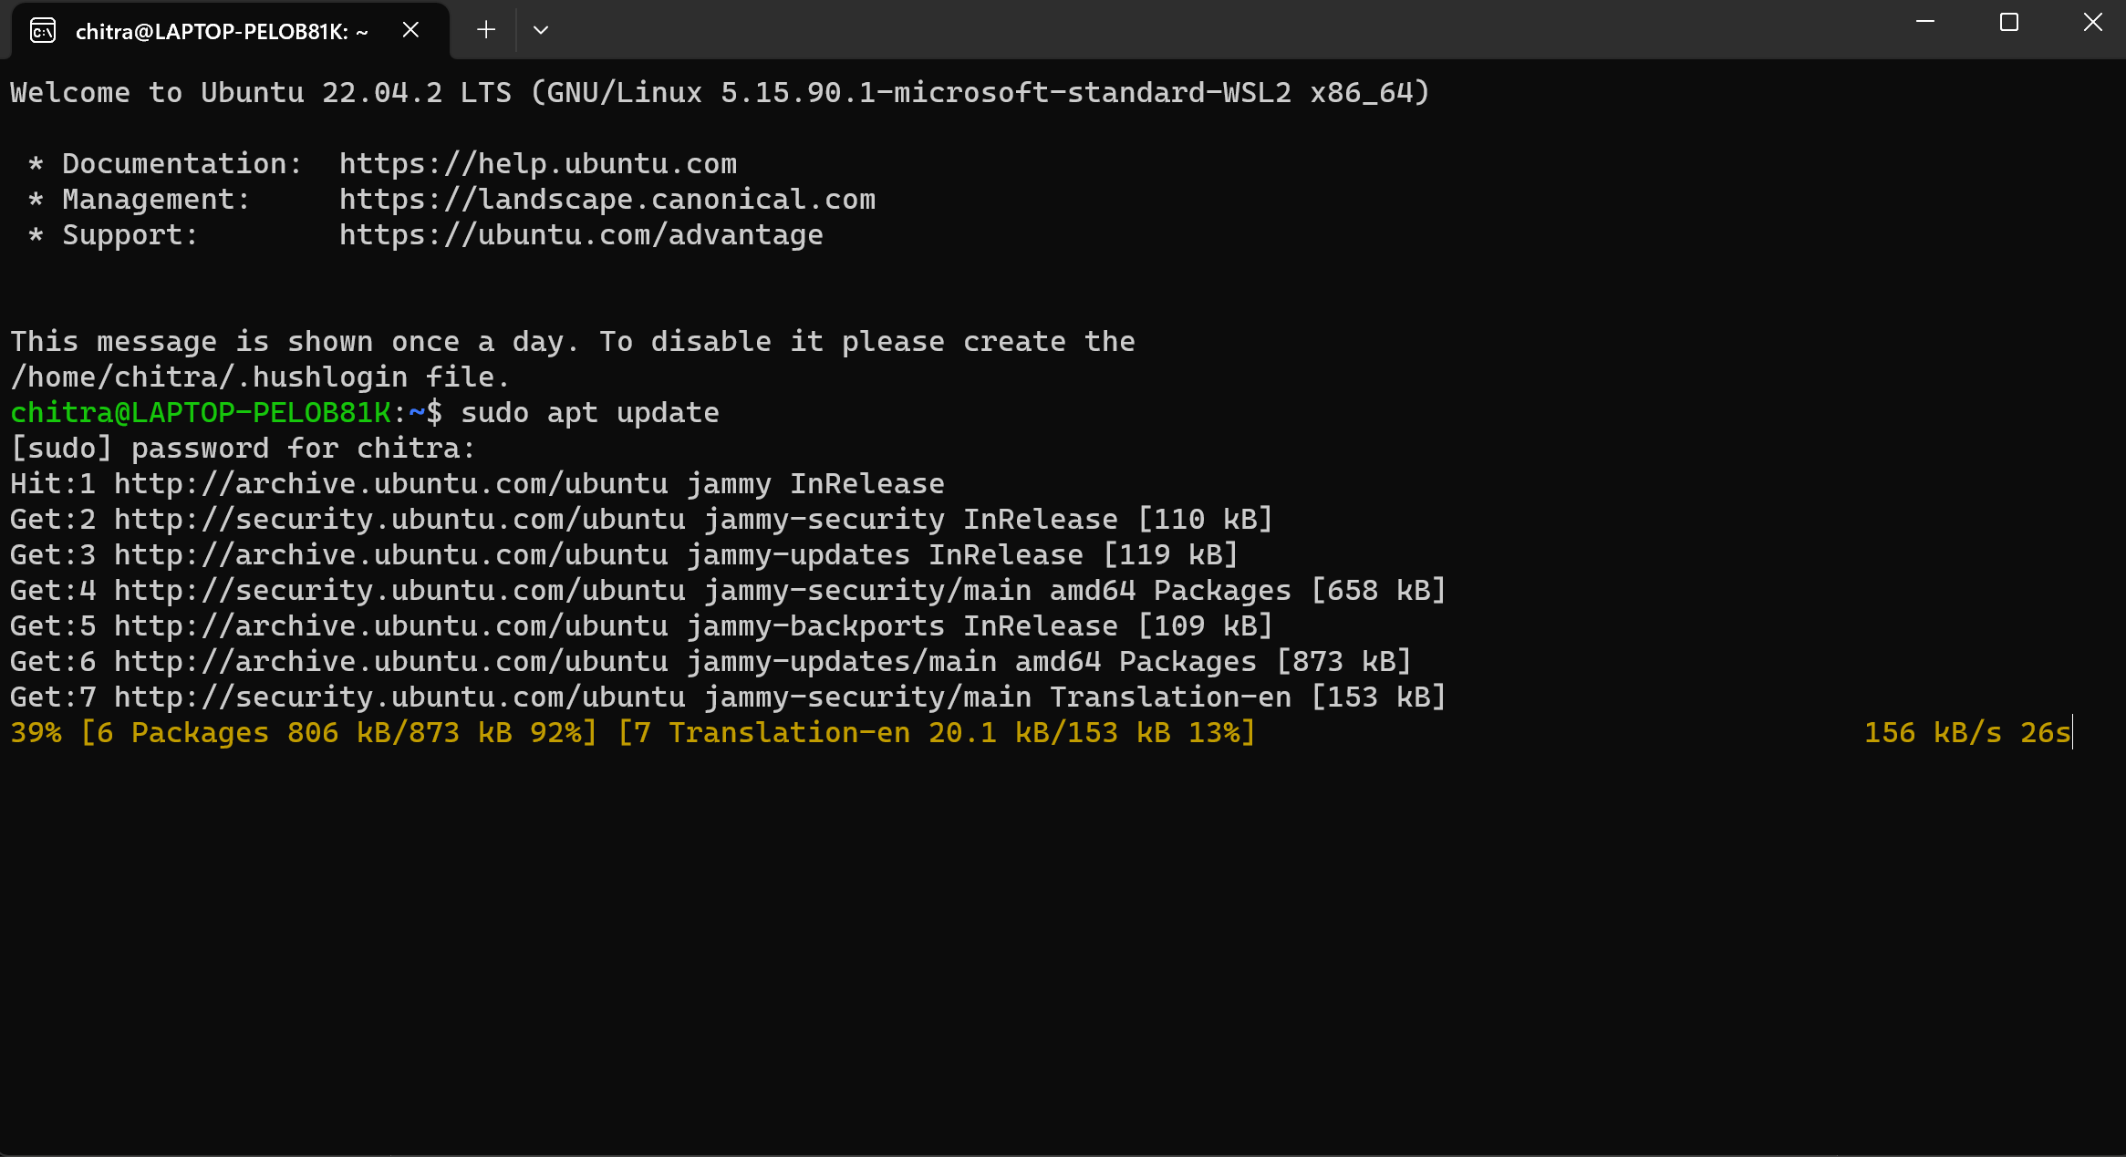

**Step-2:** After the successful updation, upgrade the ubuntu using the command – “sudo apt upgrade”

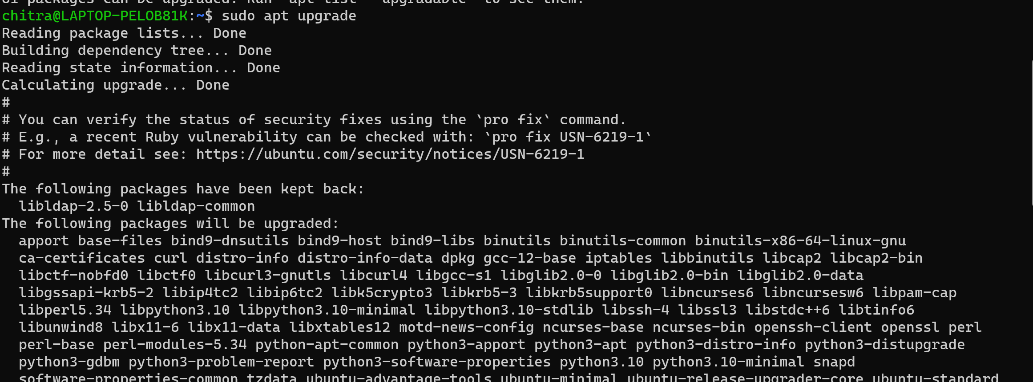

**Step-3:** After updating and upgrading the ubuntu, install docker using the command – “sudo apt install -y docker.io”

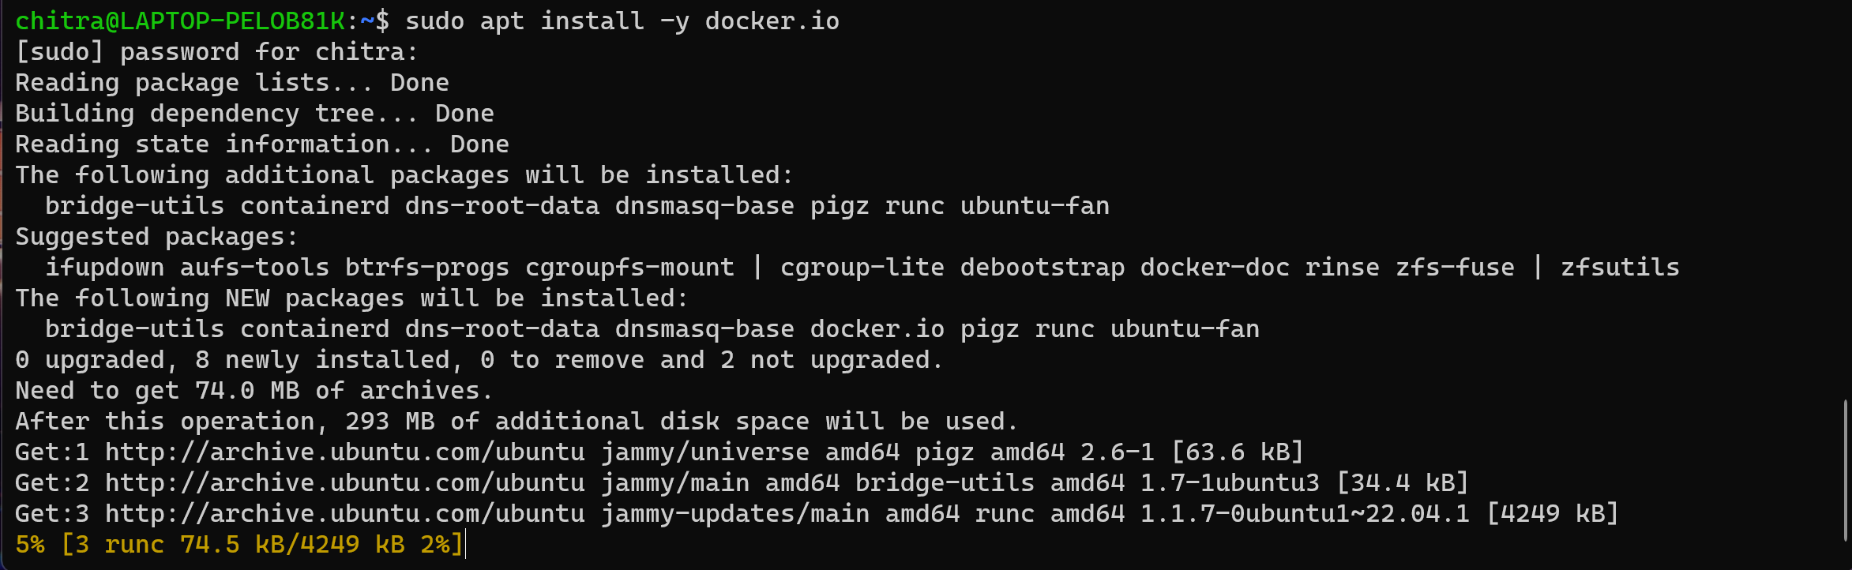

**Step-4:** By running the “docker info” command, check whether your docker is successfully installed or not

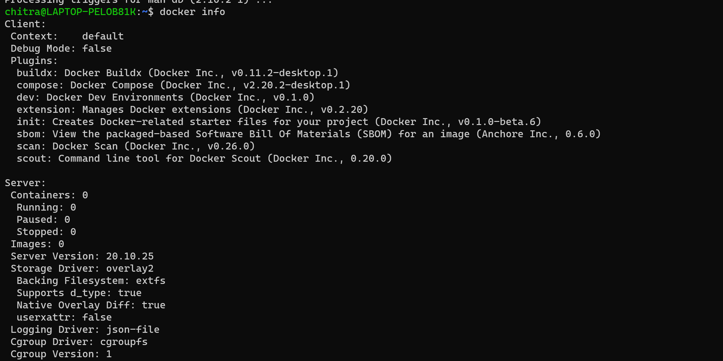

**Result:** Client and the server details are displayed hence the docker is successfully installed on Ubuntu

**EXPERIMENT -2: Container Lifecycle**

**1)docker ps-** This command is used to show the running containers by default.



**2)docker ps -a** - This command is used to show all the containers available either running or stopped.



**3)docker create -** This command creates a new container from the specified image, without starting it.

Here we are making the ubuntu container and naming it “ubucon”

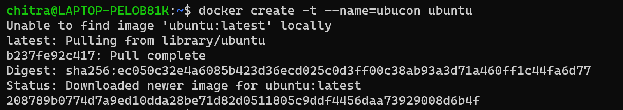

**4)docker start** - This command is used to start the newly created or stopped container.





**5)docker stop** – This command is used to stop the running containers.

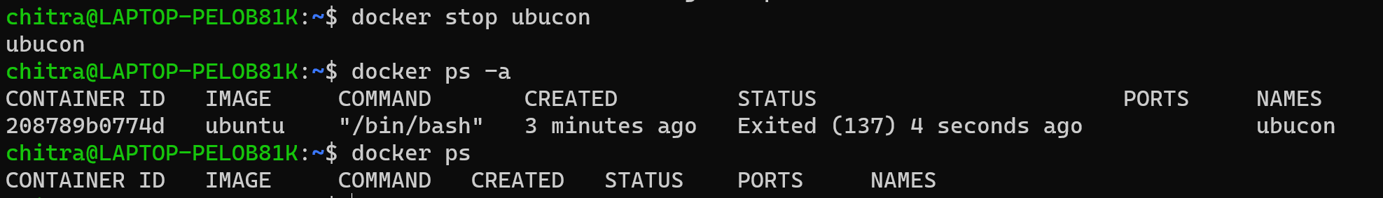

**6)docker kill** – This command kills one or more containers

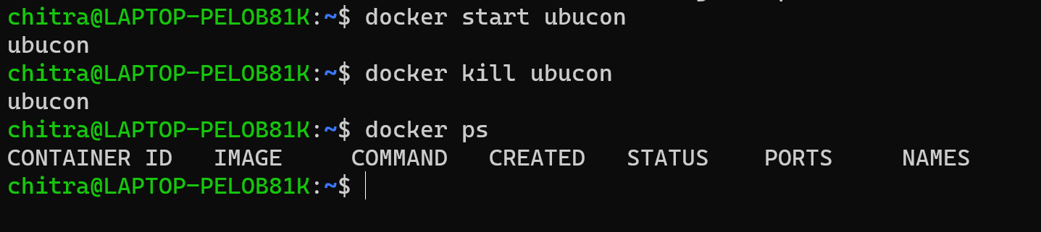

**7)docker restart** - This command restart one or more containers

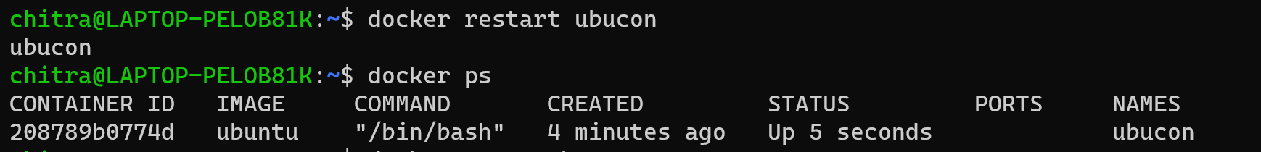

**8)docker pause** - This command pause one or more containers

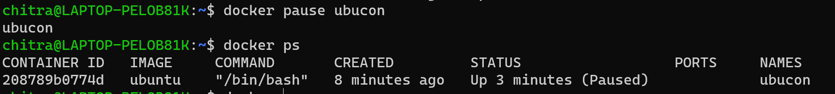

**9)docker unpause** - This command unpause one or more containers

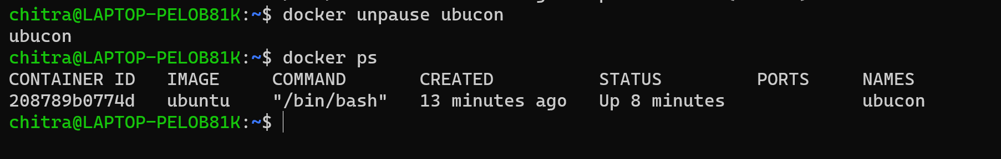

**10)docker rm** – This command is used to remove the containers that are not running.

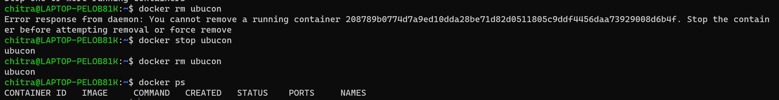

**11)docker run -dt** – This command is used to start the container in the detached mode.

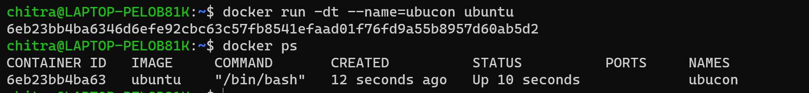

**12)docker run -it** – This command is used to start the container in the interactive mode.

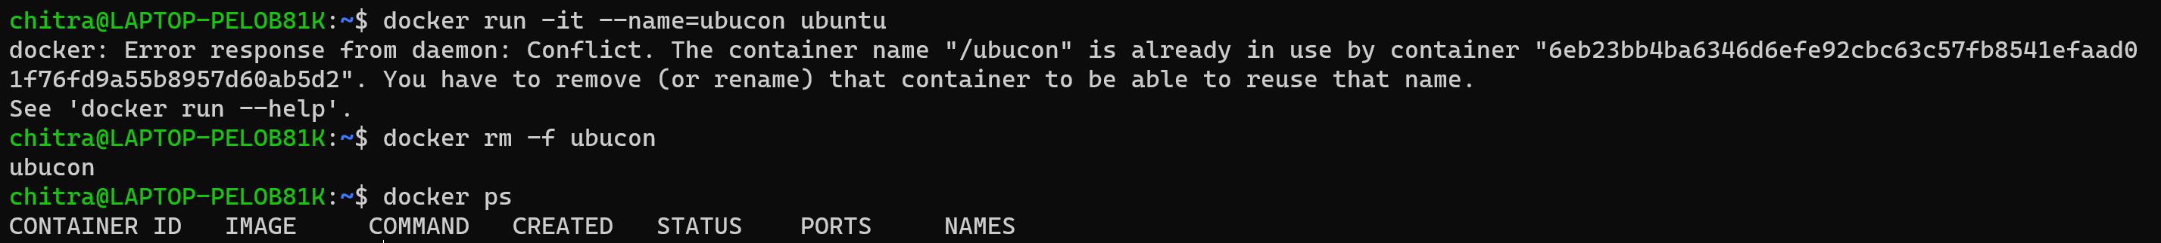

**13)docker run hello-world** – This command is executing a simple “Hello world” program by pulling the hello-world image from the docker hub.

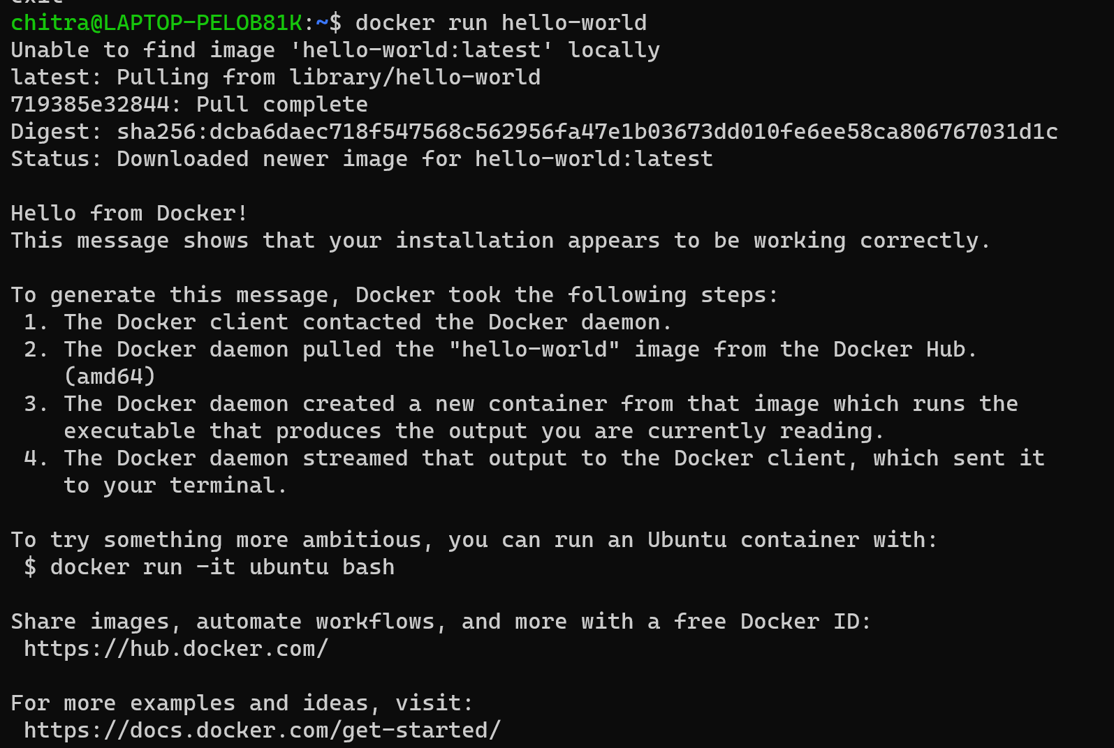

**13)docker run -it –name=ubucon ubuntu:19.04** – This command is creating and running the ubuntu container of version 19.04 in interactive mode.

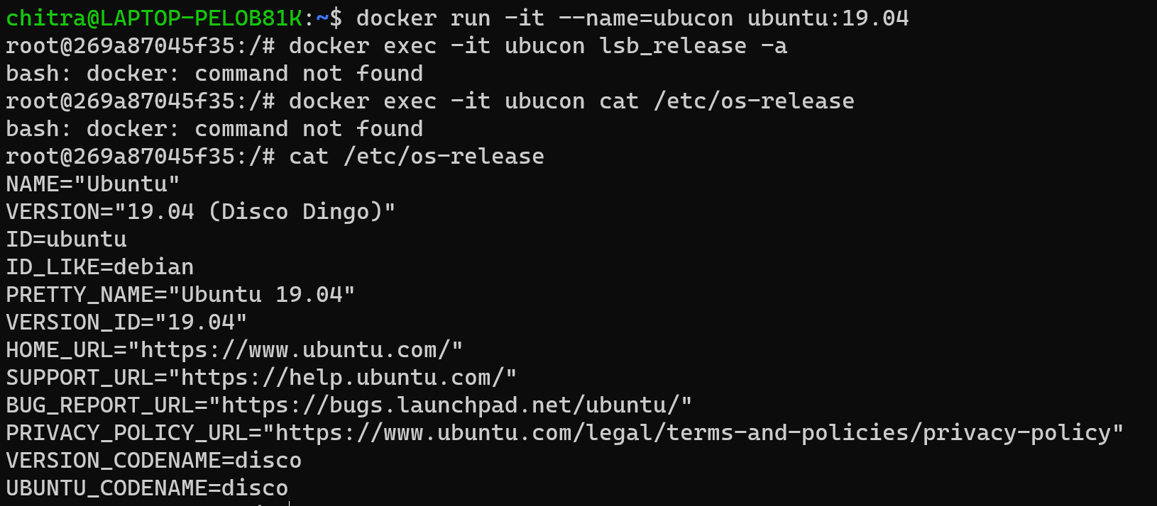

Here, the command used to check the version of Ubuntu inside the shell is

Cat /etc/os-release

**EXPERIMENT -3: JDK installation and Java program**

**Ques-1:** Do the following

1)Create an Ubuntu container, install Java, and run a hello world program.2)Make an image of this setup.3)Push this image into a private Docker Hub registry.4)Run the image from the private registry by pulling it back.

Step-1: Create an ubuntu container and enter in its shell by using the command:

docker run -it --name=ubucon ubuntu

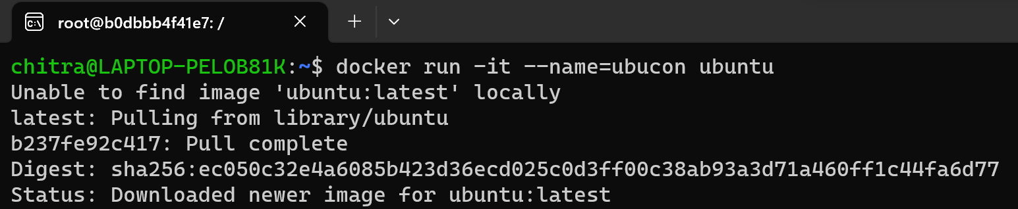

Step-2: Update the ubuntu and then install Java(OpenJDK) inside the container:

apt update

apt install default-jdk -y

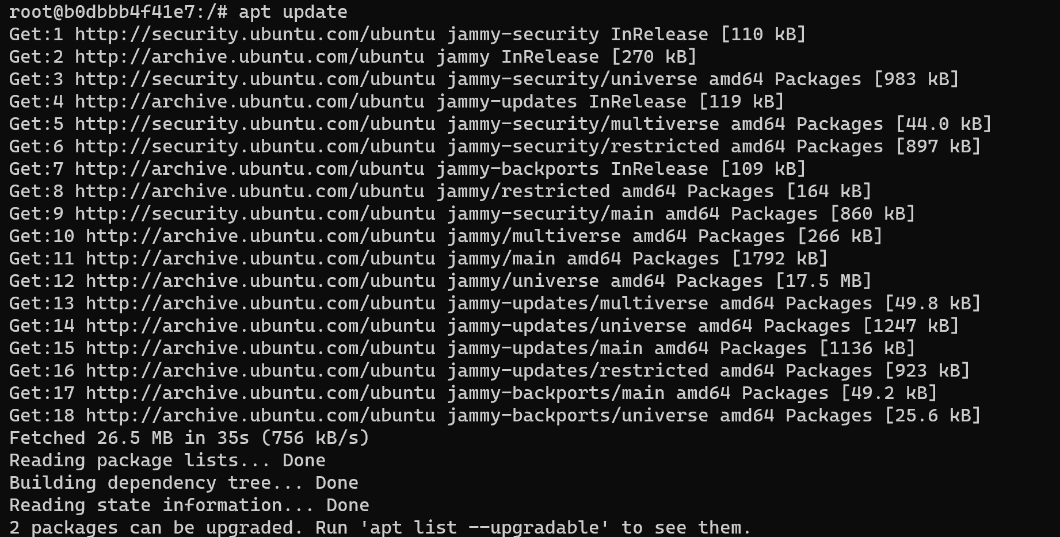

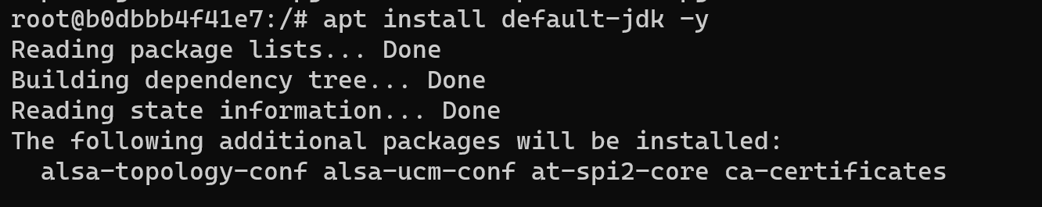

Step-3: Create and run a simple java program using the command:

echo "public class HelloWorld { public static void main(String[] args) { System.out.println(\"Hello, World!\"); } }" > HelloWorld.java



Step-4: Compile the java program and run it using the commands:

javac HelloWorld.java

java HelloWorld

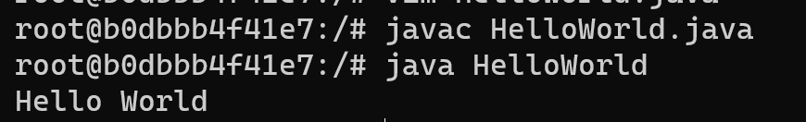

Step-5: Come out of the shell and commit the changes in the container to a new image.

docker commit ubucon newimage



Step-6: Login to your docker account.

docker login

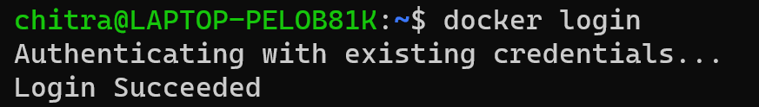

Step-7: Tag the image with the Docker hub username and repository name and then push the tagged image to your private Docker hub repository

docker tag newimage your-dockerhub-username/newimage

docker push your-dockerhub-username/newimage

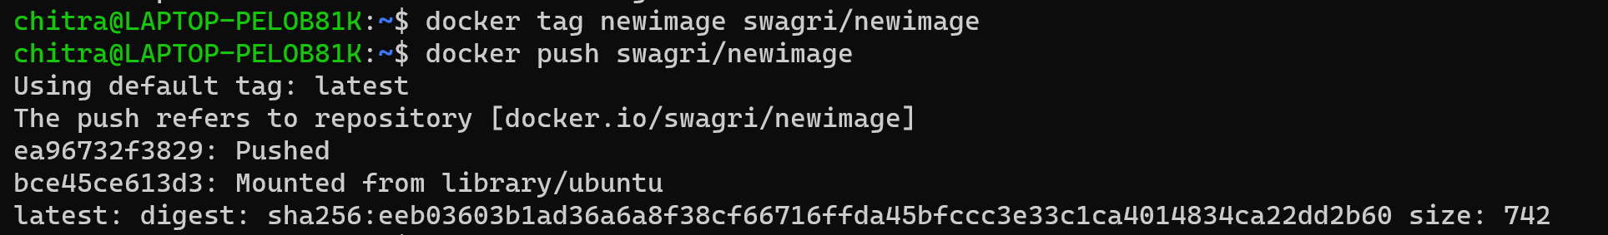

Step-8: Pull the image from your private docker hub repository

docker pull swagri/newimage

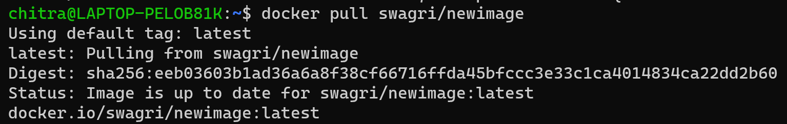

Step-9: Run a container using the pulled image

docker run -it swagri/newimage java HelloWorld



**EXPERIMENT -4: Dockerfile**

Ques-1: Do the following

1. Create a dockerfile and run
2. Create an image from the dockerfile
3. Run a container from this docker image
4. Push this image into your repository
5. Pull the image from repository
6. Run a container from this image
7. Install JDK on top of it
8. Write a Hello-World program in it
9. Convert the entire set into an image again
10. Run a container from this image

**Step-1:** Firstly make images folder using the command and then navigate to the folder

mkdir images

cd documents/images



**Step-2:** Now make a java program and save it in the same “images” folder and save it with the name of the class. Here, the program is saved with the name, Hello.java

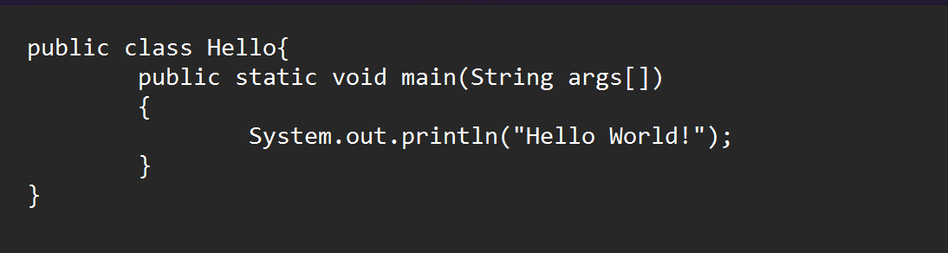

**Step-3:** Now open notepad and create a dockerfile. The file should be saved in all files format within the double quotes i.e. “dockerfile”.

notepad dockerfile



**Step-4:** In order to run a java program inside the container, we need to include the following instruction inside the dockerfile.

FROM ubuntu:latest

RUN apt-get update && apt-get install -y openjdk-11-jdk

COPY Hello.java /app/

WORKDIR /app/

RUN javac Hello.java

CMD ["java", "Hello"]

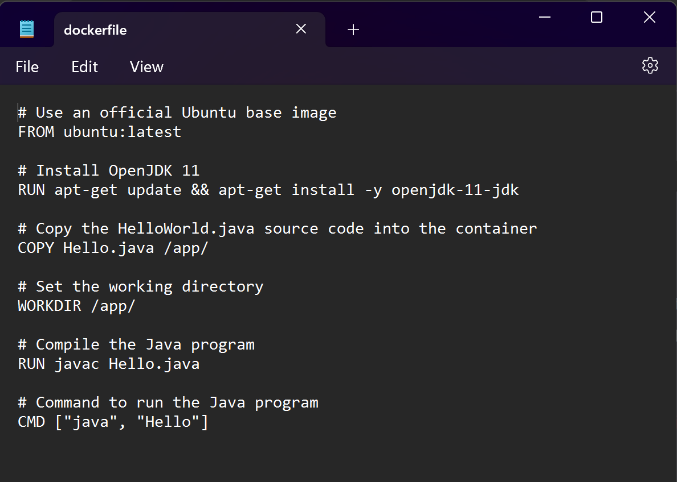

**Step-5:** Now build an image using this dockerfile.

docker build -t mybusybox:1.0 .

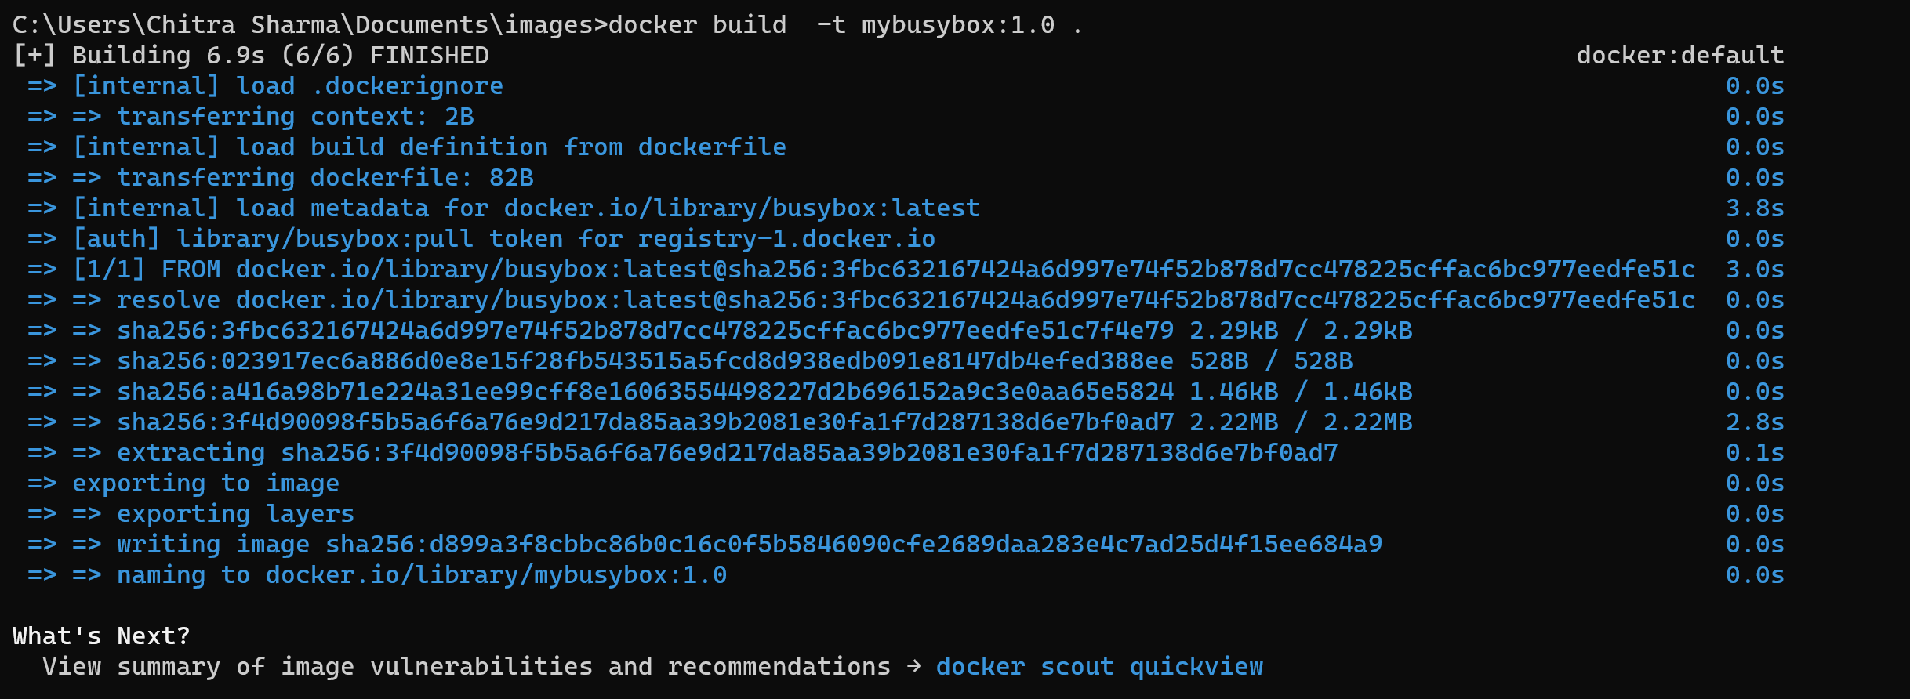

**Step-6:** Next step is to run a container from the image that we just created

docker run - -name=newcon mybusybox:1.0



**Step-7:** Now commit the changes in the container to a new image.

docker commit newcon newimage



**Step-8:** Login to your docker account

docker login

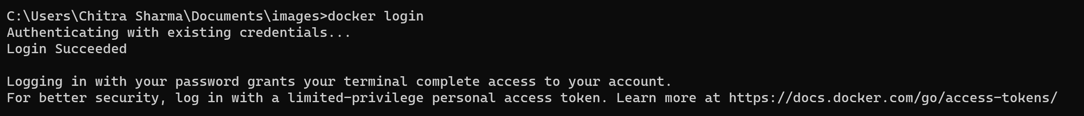

**Step-9:** Tag the image with the Docker hub username and repository name and then push the tagged image to your private Docker hub repository

docker tag newimage your-dockerhub-username/newimage

docker push your-dockerhub-username/newimage



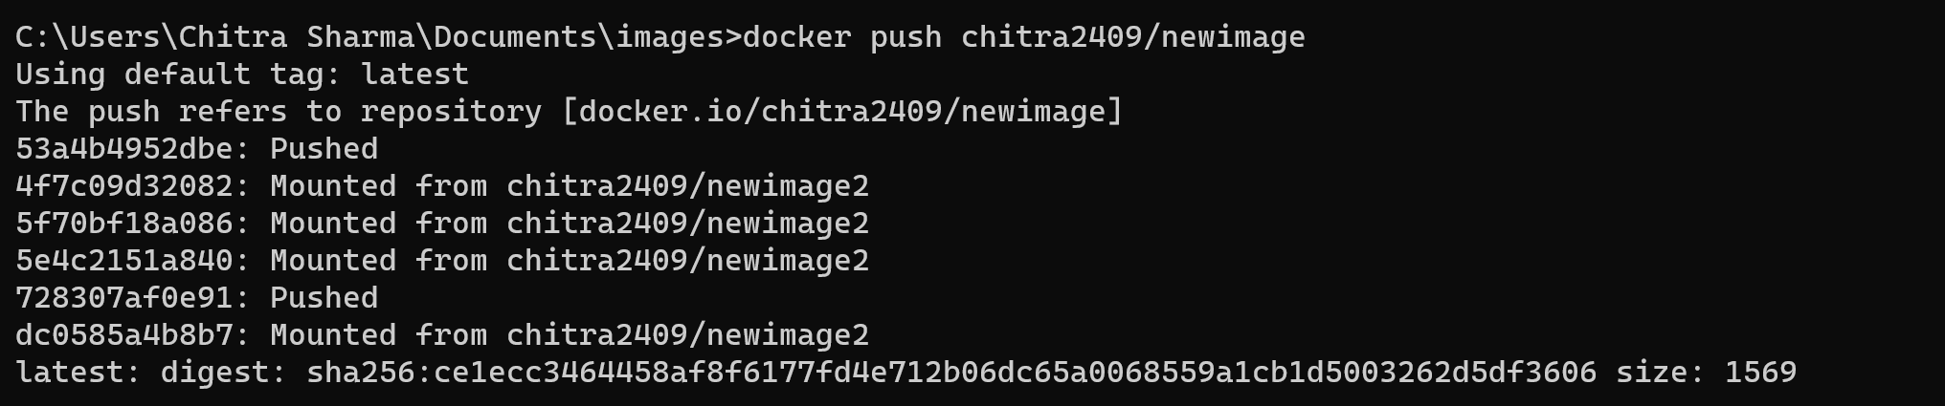

Step-8: Pull the image from your private docker hub repository

docker pull chitra2409/newimage

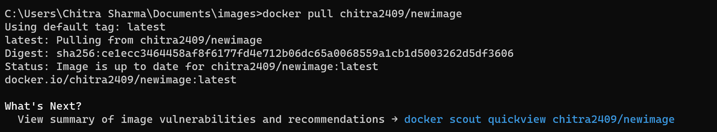

Step-9: Run a container using the pulled image

docker run -it chitra2409/newimage



**Experiment-5: Data Management in Docker through Volumes and Bind mounts**

Ques-1: Do the following

1. Run a container with docker volume
2. Inspect whether the volume is attached with the container or not
3. Create a file inside the volume
4. Stop container, remove the container and then remove the volume

**1)Volumes - Using the “- -mount” flag**

**Step-1:** Firstly we are creating and running a container named “newcon” based on the “nginx:latest” image in detached mode, while also mounting a volume named “newvol” into the container at the path “/newfol” for data sharing or persistence.

docker run -d --name=newcon --mount source=newvol, target=/newfol nginx:latest



**Step-2:** Now using the inspect command we are retrieving the detailed information about the docker container and checking whether the volume is mounted or not.

docker inspect container newcon



**Step-3:** In the “Mounts” section, we can see that the volume is successfully mounted into the container.

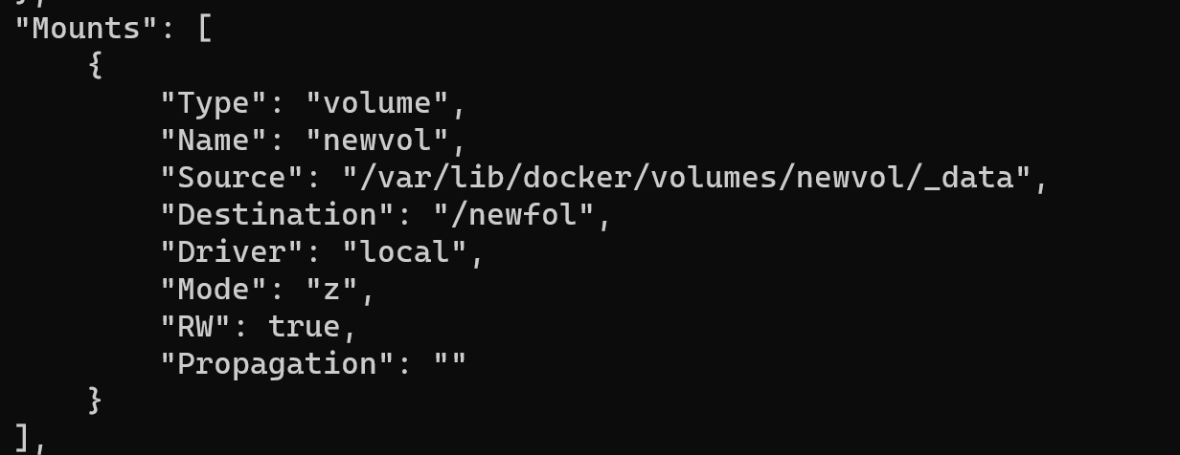

**Step-4:** Now in order to create a file inside the volume, we need to start an interactive shell session within the running docker container, “newcon”.

docker exec -it newcon bash

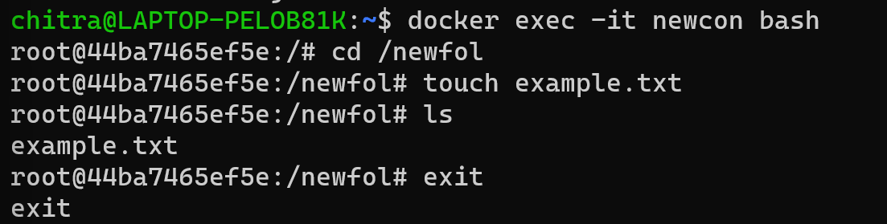

**Step-5:**After creating the file, exit from the interactive mode and then check whether the file is present in the respective folder or not using the command:

sudo ls /var/lib/docker/volumes/newvol/_data



**Step-6:** The file is present. So now stop the container, remove the container and then remove the volume.

docker stop newcon

docker rm newcon

docker volume rm newvol

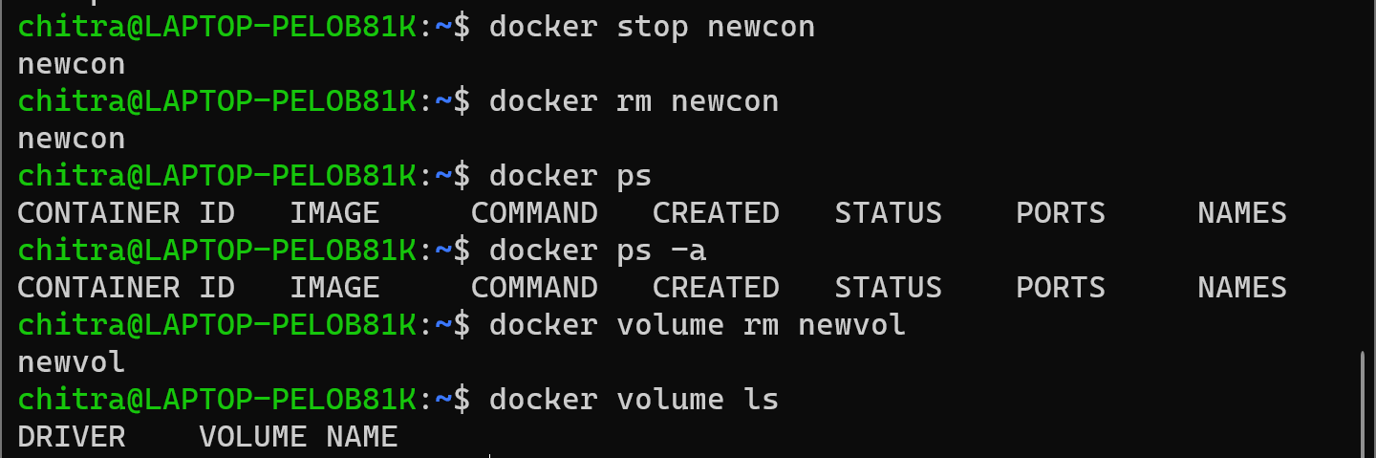

**2)Volumes - Using the “- v” flag**

**Step-1:** Again, we are creating and running the container named “newcon2” based on the “nginx:latest” image, while creating and using the docker volume, “newvol”, with the volume mounted at “/newfol2” using the -v flag.

docker run -d --name=newcon2 -v newvol2:/newfol2 nginx:latest



**Step-2:** Now using the following command we are retrieving the information about the container and checking whether the volume is mounted or not. In the “Mounts” section, we can see that the volume is successfully mounted into the container.

docker inspect newcon2

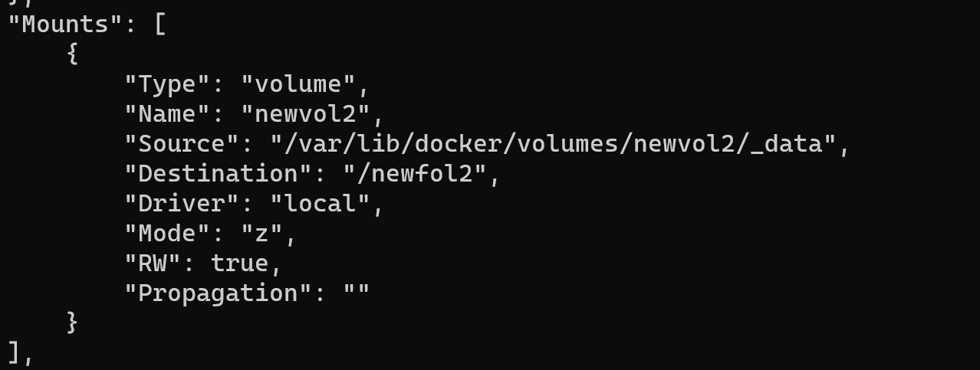

**Step-3:** Now in order to create a file inside the volume, we need to start an interactive shell session within the running docker container, “newcon2”.

docker exec -it newcon2 bash

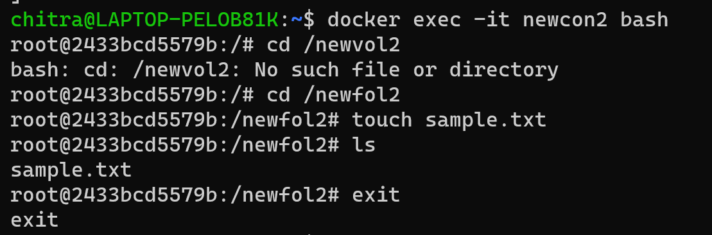

**Step-4:**After creating the file, exit from the interactive mode and then check whether the file is present in the respective folder or not using the command:

sudo ls /var/lib/docker/volumes/newvol2/_data



**Step-5:** The file is present. So now stop the container, remove the container and then remove the volume.

docker stop newcon2

docker rm newcon2

docker volume rm newvol2

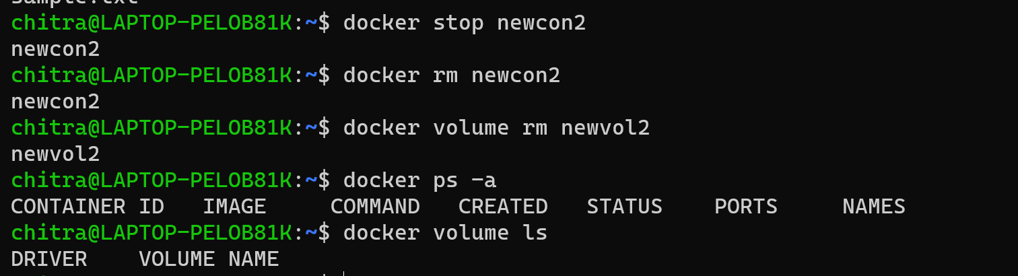

**Note:** In the context of data management in Docker through **volumes**, when you use **-v** or **--mount** to create a volume for a file or directory that does not exist on the Docker host, Docker automatically generates the endpoint. However, in the case of a **bind mount**, if you use **-v** to bind mount a file or directory that does not exist on the Docker host, Docker will create the endpoint. This endpoint is always created as a directory. Conversely, if you use **--mount** to bind mount a file or directory that does not exist on the Docker host, Docker will not create it for you; instead, it will generate an error.

Let's now observe this behaviour in action.

**1)Bind Mount - Using the “- - mount” flag**

**Step-1:** Firstly, we are simply creating a running the container and attaching a volume to it using the “- -mount” flag**.** Here the folder target is already made and we are using this folder.

docker run -d -it --name=chitra --mount type=bind, source="$(pwd)"/target,target=/newexp nginx:latest

docker inspect chitra



**Step-2:** In the “Mounts” section, we can see that the volume is mounted of type bind.

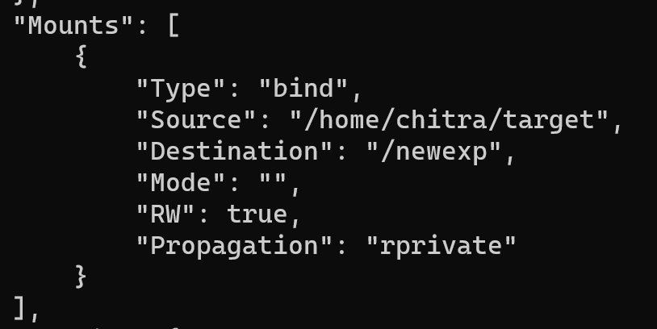

**Step-3:** Now we are again doing the same thing that we did in step 1 but not the folder that we are using i.e. “target2” does not exist. In this case, the error is generated.



Hence, we can say that if we use bind mount, we have to create a folder or directory beforehand in order to bind mount a folder or directory.

**2)Bind Mount - Using the “-v” flag**

**Step-1:** Here we are creating and running the container and using the -v flag to bind mount a folder that does not exist already.



**Step-2:** Now inspect the container and check the “Mounts” section whether it is mounted successfully or not.



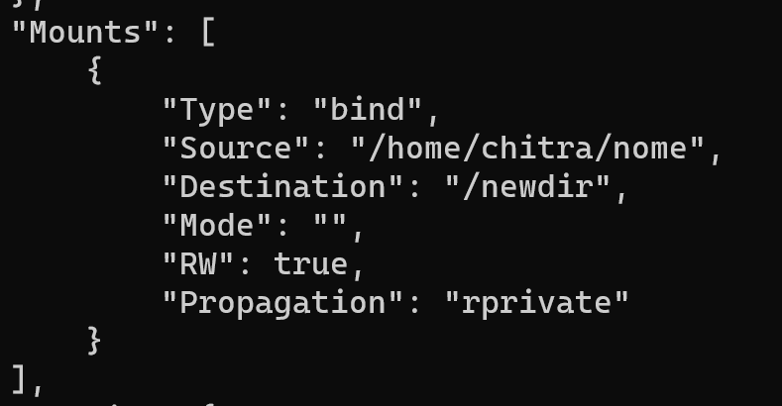

**EXPERIMENT -6: Docker Networking**

**Step-1:** Let’s first see the available network using the command:

docker network ls

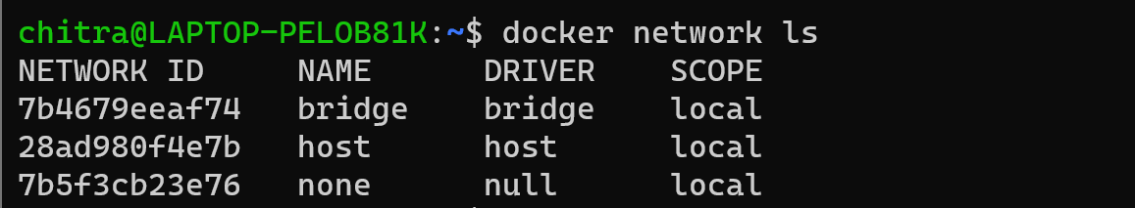

**Step-2:** Now let’s create a custom network of type bridge.

docker network create --driver=bridge my_network

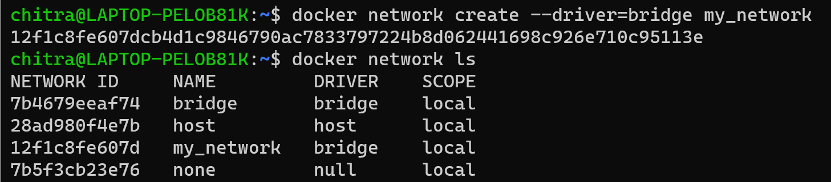

**Step-3:** Next let’s retrieve the information of the bridge network driver using the command:

docker network inspect bridge

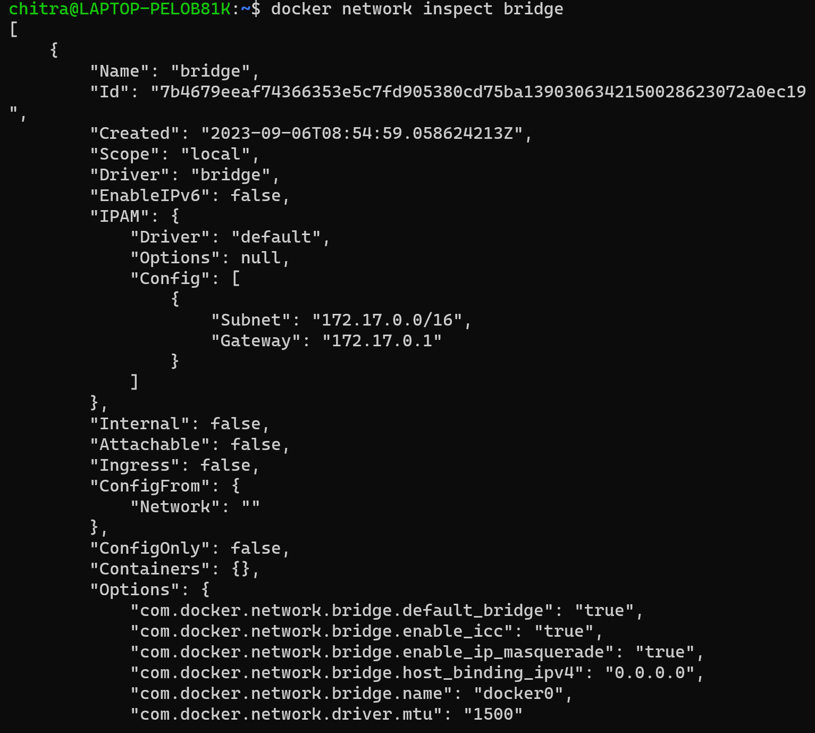

We can see in the “Containers” part that it is empty, it means that there are no containers associated to it till now. So firstly let’s create a new container.

**Step-4:** Here we are creating a new container of ubuntu image without specifying any network details.

docker run -dt --name=nettry2 ubuntu



**Step-5:** Now let’s again inspect the bridge network.

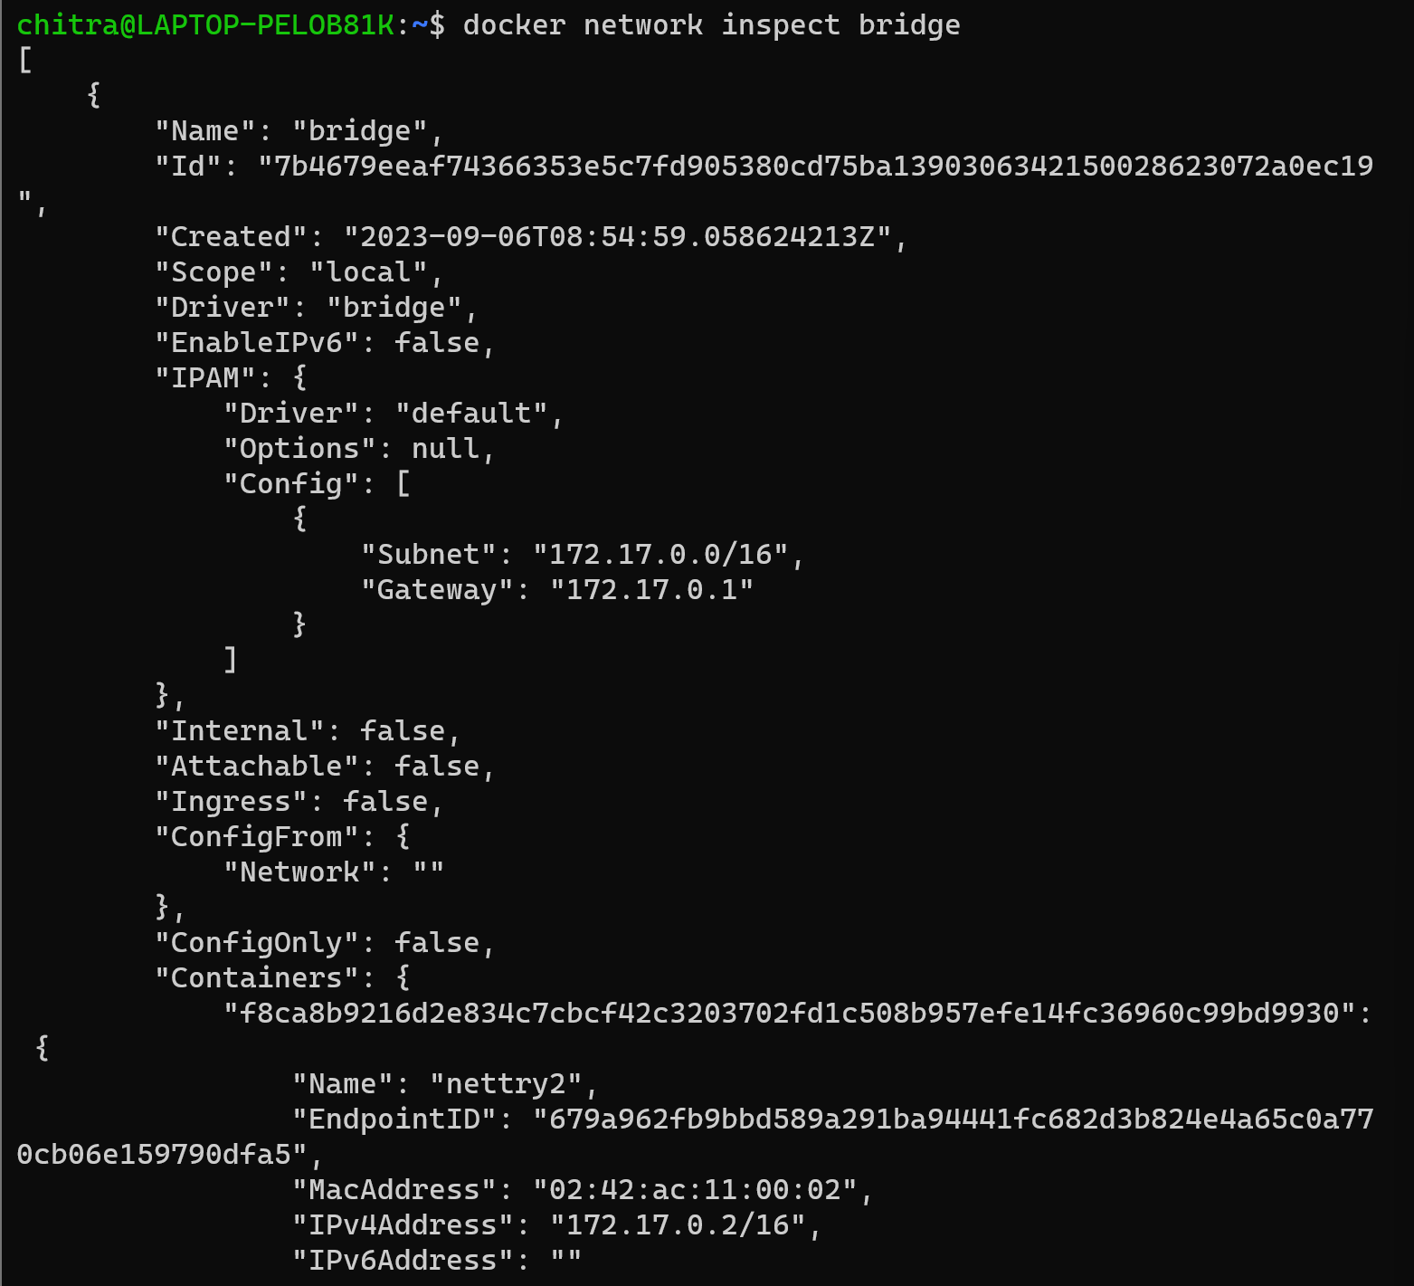

Here we can see that the container named “nettry2” is by default associated with this default bridge network.

**Step-6:** Now, check the network details of the container by inspecting it.



**Step-7:** We can see that a default IP address is assigned to the container from the bridge network.

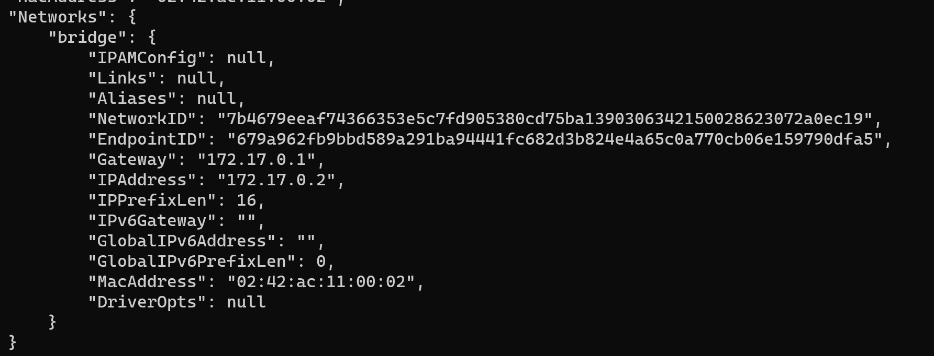

**Step-8:** Now run another container and check whether inspect the bridge network again whether the second container is associated with it or not.

docker run -dt --name=container1 ubuntu



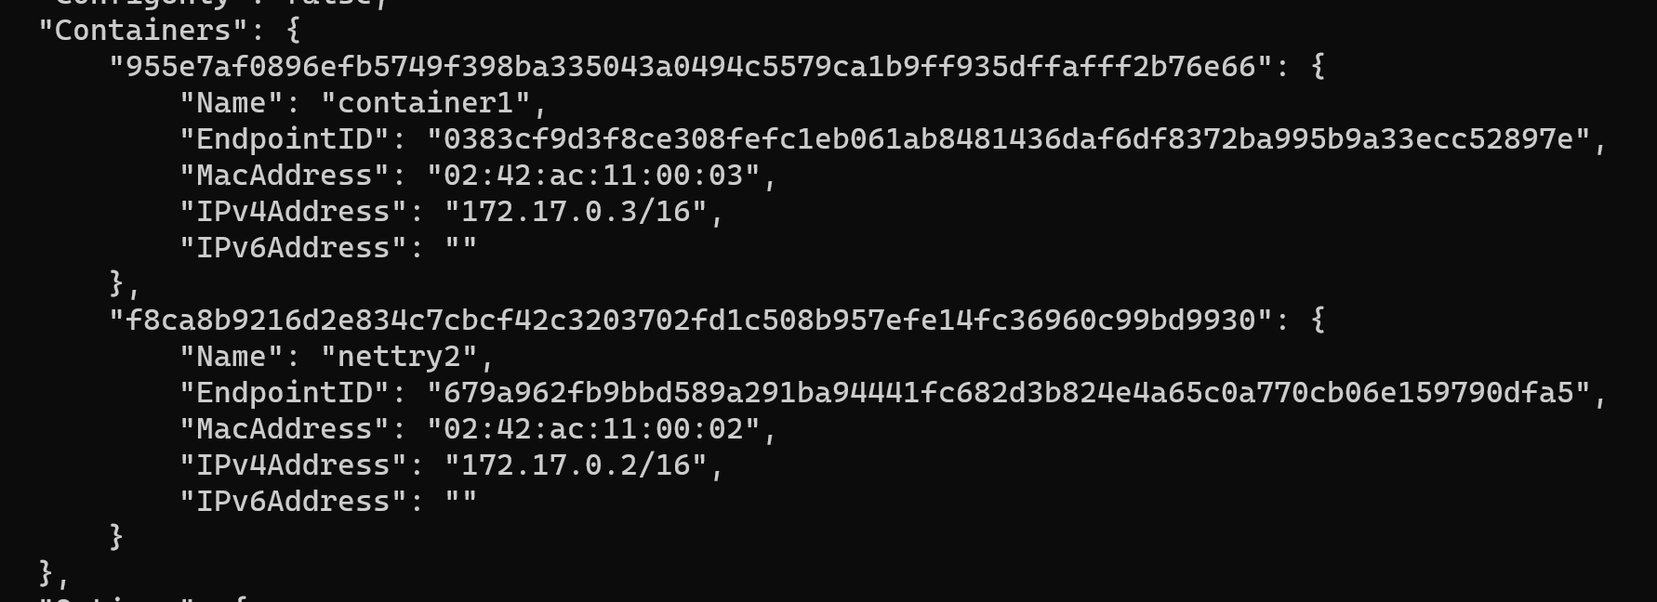

Here, we can clearly see that the two container that we just made are by default connected to the bridge network.

**Step-9:** Now, connect to the custom network, “my_network” that we created in step one using the command and then inspect.

docker network connect my_network nettry2



**Step-10:** We can observe here that the container “nettry2” is successfully connected to the new custom network and is assigned a different IP for this network.

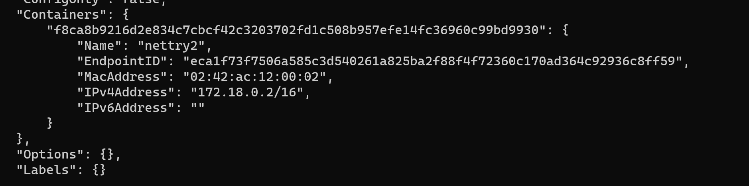

**Step-11:** We can disconnect a container from any network by using the following command

docker network disconnect bridge nettry2



**Step-12:** Here we can see that the container is successfully disconnected from the default bridge network.

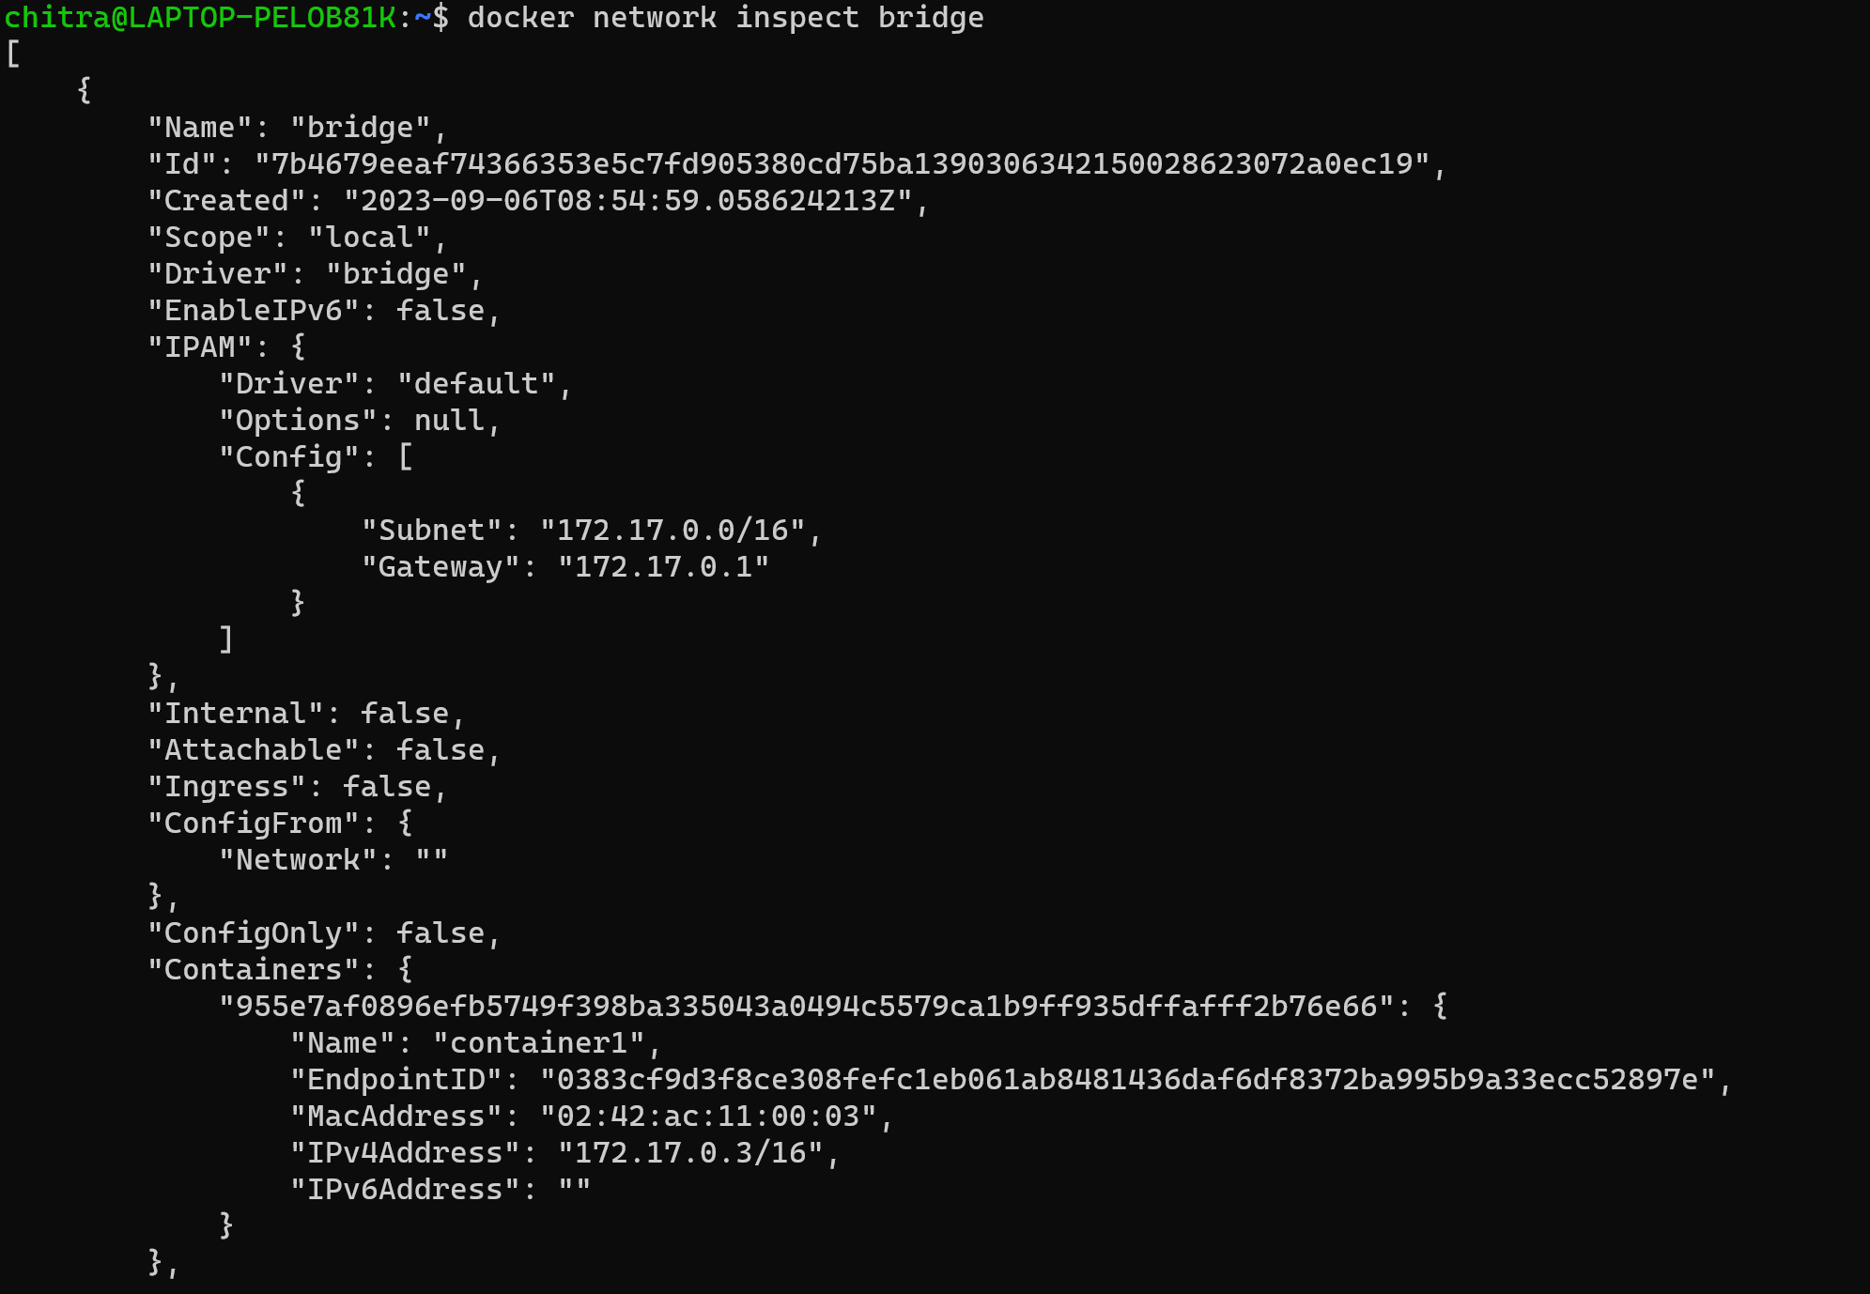

**Step-13:** Next, create a Docker network with a custom subnet range which can be further used to assign static IPs to the containers.

docker network create my_network_name --subnet=10.11.0.0/16



**Step-14:** Now let’s run a container and connect it to a custom network with a static IP address using the ubuntu image.

docker run -it --name=newcon --net=my_network_name --ip=10.11.0.10 ubuntu



**Step-15:** By running the inspect command, we can see that the newcon container that we just created is now associated with “my_network_name” and has the IP assigned to it that we specified.



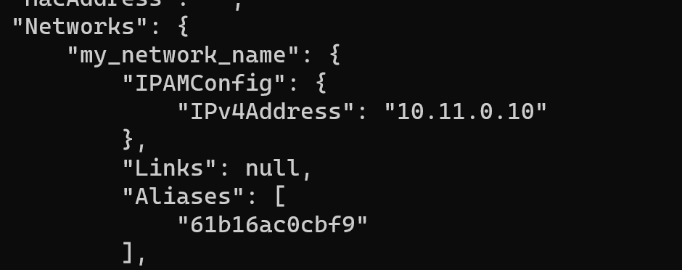

**Step-16:** Now let’s try to create a container of apache httpd image without specifying its name.

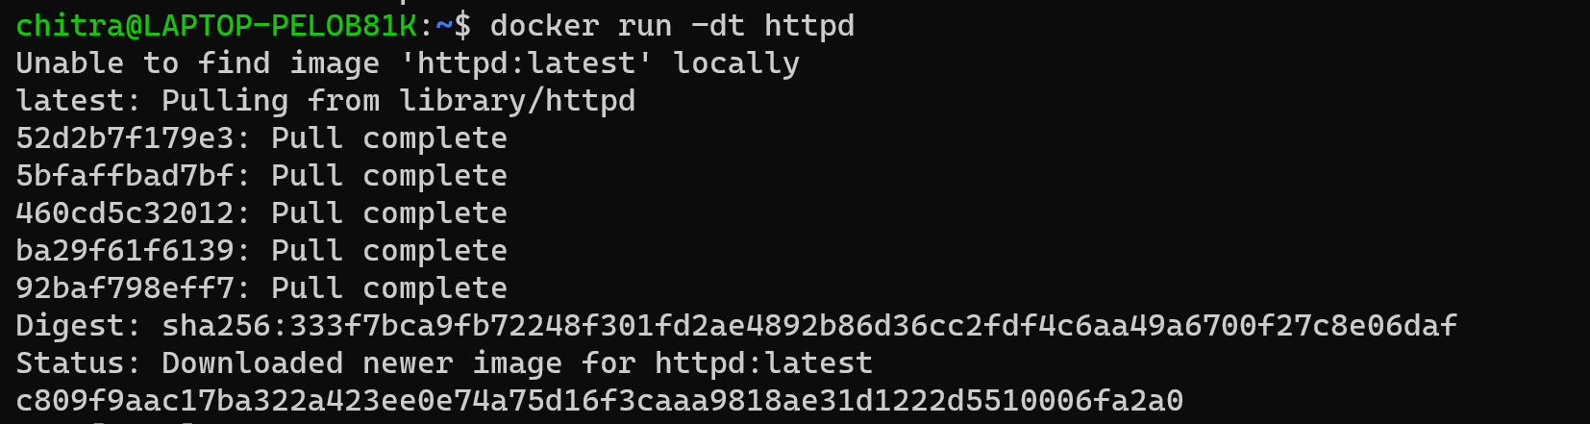

**Step-17:** Here we can see that it is given a default name.



**EXPERIMENT -7: Docker Compose(Python)**

**Prerequisites**

You need to have Docker Engine and Docker Compose on your machine. You can either:

* + Install Docker Engine and Docker Compose as standalone binaries
  + Install Docker Desktop which includes both Docker Engine and Docker Compose

**Steps**

**Step-1:** Firstly, create a directory for the project. Open a terminal and navigate to the folder where you want to make the project directory. After navigating to the project directory, make the directory using the command:

mkdir directory-name



**Step-2:** Now navigate to the folder/directory that you just created.

cd directory-name



**Step-3:** In the same project directory, create an “app.py” file and paste the following code inside it:

import time

import redis

from flask import Flask

app = Flask(__name__)

cache = redis.Redis(host='redis', port=6379)

def get_hit_count():

retries = 5

while True:

try:

return cache.incr('hits')

except redis.exceptions.ConnectionError as exc:

if retries == 0:

raise exc

retries -= 1

time.sleep(0.5)

@app.route('/')

def hello():

count = get_hit_count()

return 'Hello World! I have been seen {} times.\n'.format(count)

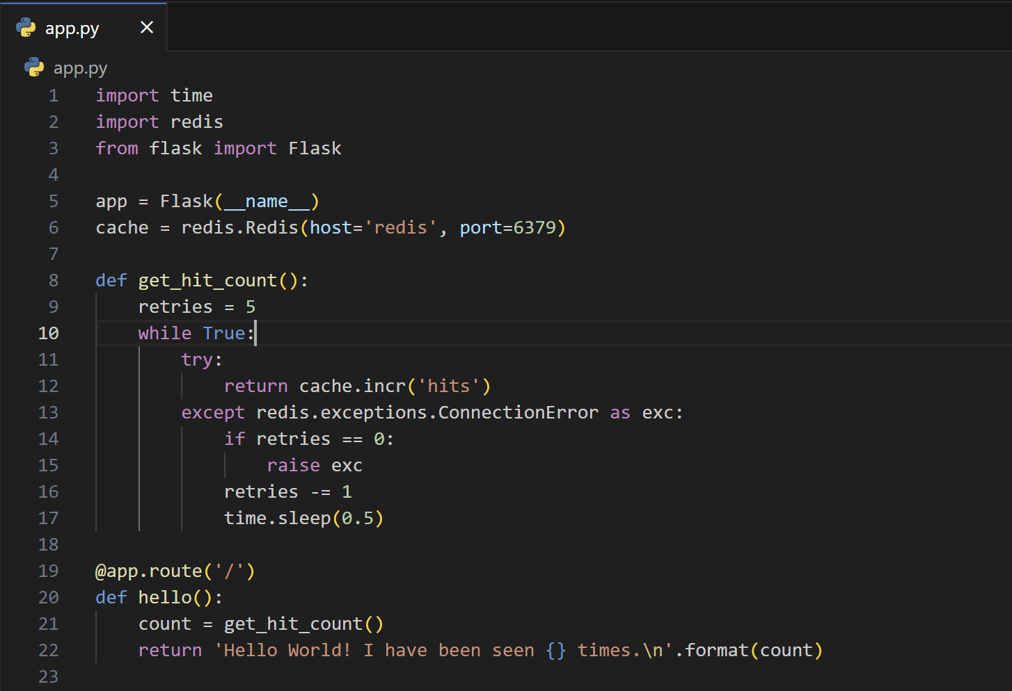

* This Python code sets up a Flask web application that, when accessed via a web browser, displays a simple message: "Hello World! I have been seen {} times," where the curly braces {} are replaced with the number of times the web page has been accessed.
* It uses a Redis database as a caching mechanism to store and increment a hit counter. The get_hit_count function increments this counter while handling potential connection errors to the Redis server with retries and sleeps. The web application's main route (/) invokes this function to retrieve and display the hit count in the response.

**Step-4:** Now, create the “requirements.txt” file in the project directory and paste the following code in:

flask

Redis

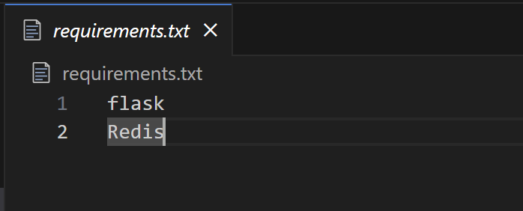

* This requirements.txt file is used in Python to specify and manage project dependencies.

**Step-5:** Now create a dockerfile. In the project directory, create a file named dockerfile; to be saved in all files format within the double quotes i.e. “dockerfile”. Then paste the following code in the file:

# syntax=docker/dockerfile:1

FROM python:3.7-alpine

WORKDIR /code

ENV FLASK_APP=app.py

ENV FLASK_RUN_HOST=0.0.0.0

RUN apk add --no-cache gcc musl-dev linux-headers

COPY requirements.txt requirements.txt

RUN pip install -r requirements.txt

EXPOSE 5000

COPY . .

CMD ["flask", "run"]

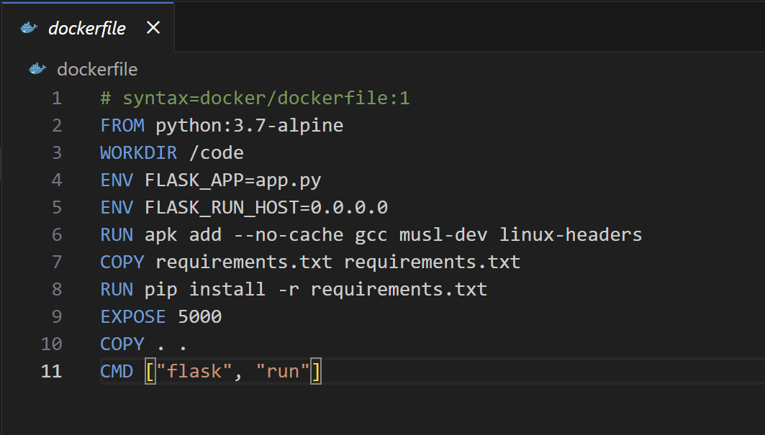

**This dockerfile tells Docker to:**

* Build an image starting with the Python 3.7 image.
* Set the working directory to /code.
* Set environment variables used by the flask command.
* Install gcc and other dependencies
* Copy requirements.txt and install the Python dependencies.
* Add metadata to the image to describe that the container is listening on port 5000
* Copy the current directory . in the project to the workdir . in the image.
* Set the default command for the container to flask run.

**Step-6:** At last, create a file named “compose.yaml” in the project directory and paste the following :

services:

web:

build: .

ports:

- "8000:5000"

redis:

image: "redis:alpine"

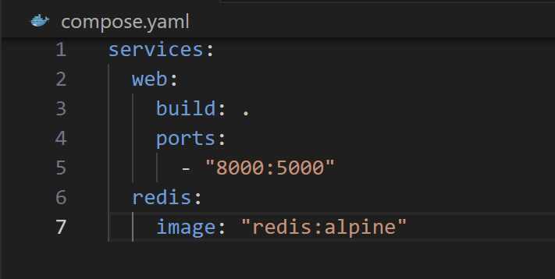

* This docker-compose.yaml file is used to define and manage multi-container Docker applications.
* This Compose file defines two services: web and redis.

**Step-7: Now from the project directory, start up the application by running**

docker compose up

**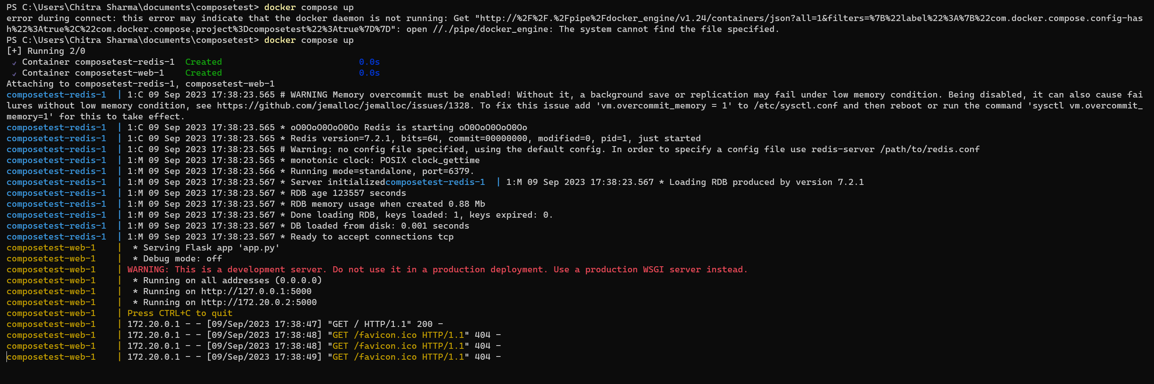  
  
Step-8:** Enter http://localhost:8000/ in a browser to see the application running. If this doesn't resolve, you can also try <http://127.0.0.1:8000>.

You should see a message in your browser saying:

**Hello World! I have been seen 1 times.**

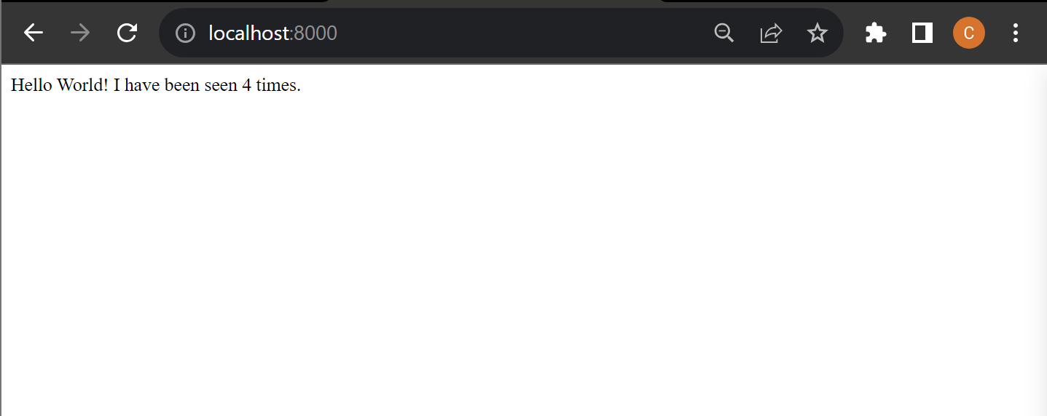

**Step-9:** Now, refresh the page and the number should increment.

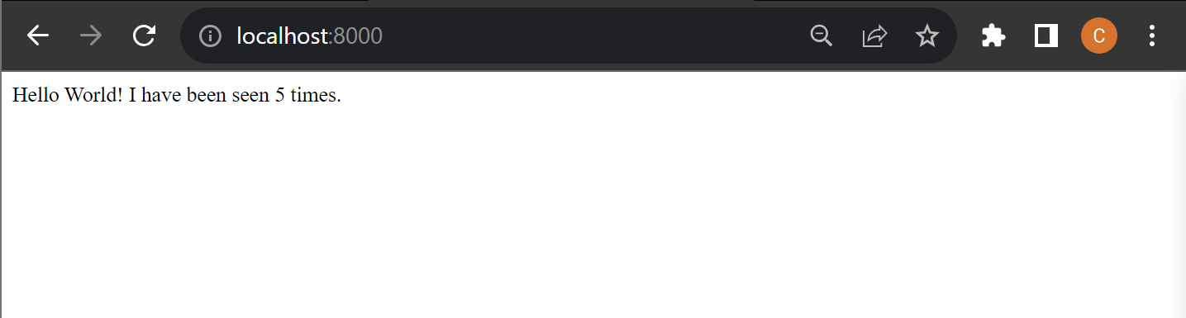

**Step-10:** Now switch to a different terminal window. Navigate to the project directory and list local images. Listing images at this point should return **redis** and **web**.

docker image ls

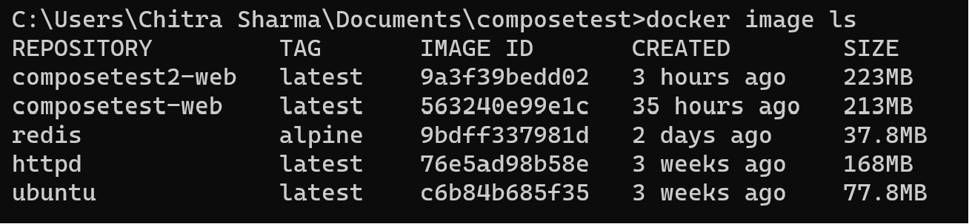

**Step-11**: Stop the application, either by running ***docker compose down***from within your project directory in the second terminal, or by hitting ***CTRL+C***in the original terminal where you started the app.

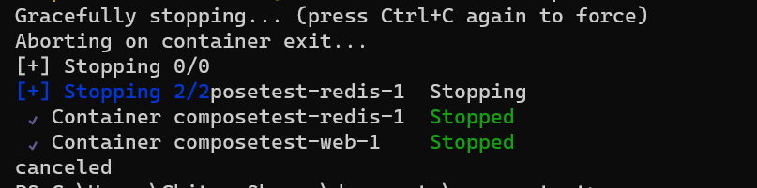

**Step-12:** Now, edit the Compose file to add a bind mount.

services:

web:

build: .

ports:

- "8000:5000"

volumes:

- .:/code

environment:

FLASK_DEBUG: "true"

redis:

image: "redis:alpine"

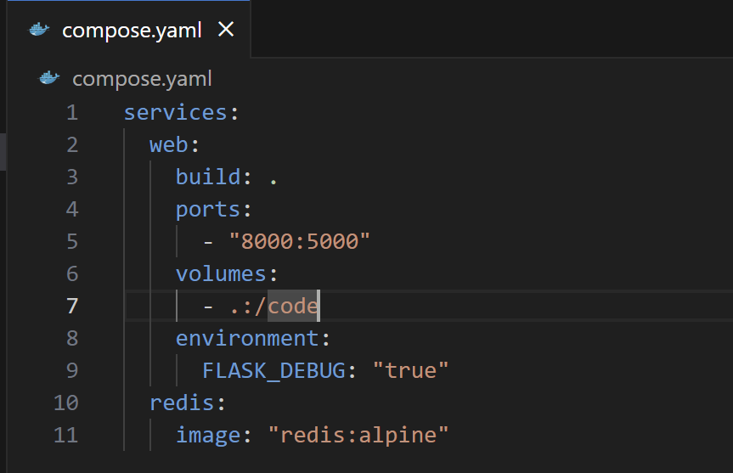

**Step-13:** Now from the project directory, build the app with the updated Compose file ,and run it.

docker compose up –build



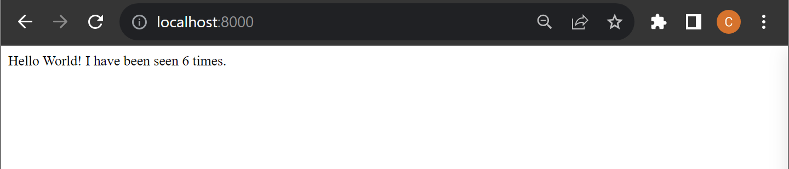

**Step-14:** Now, change the greeting in **app.py** and save it. Refresh the app in your browser. The greeting should be updated.

For example, change the Hello World! message **to Hello from Docker!!**

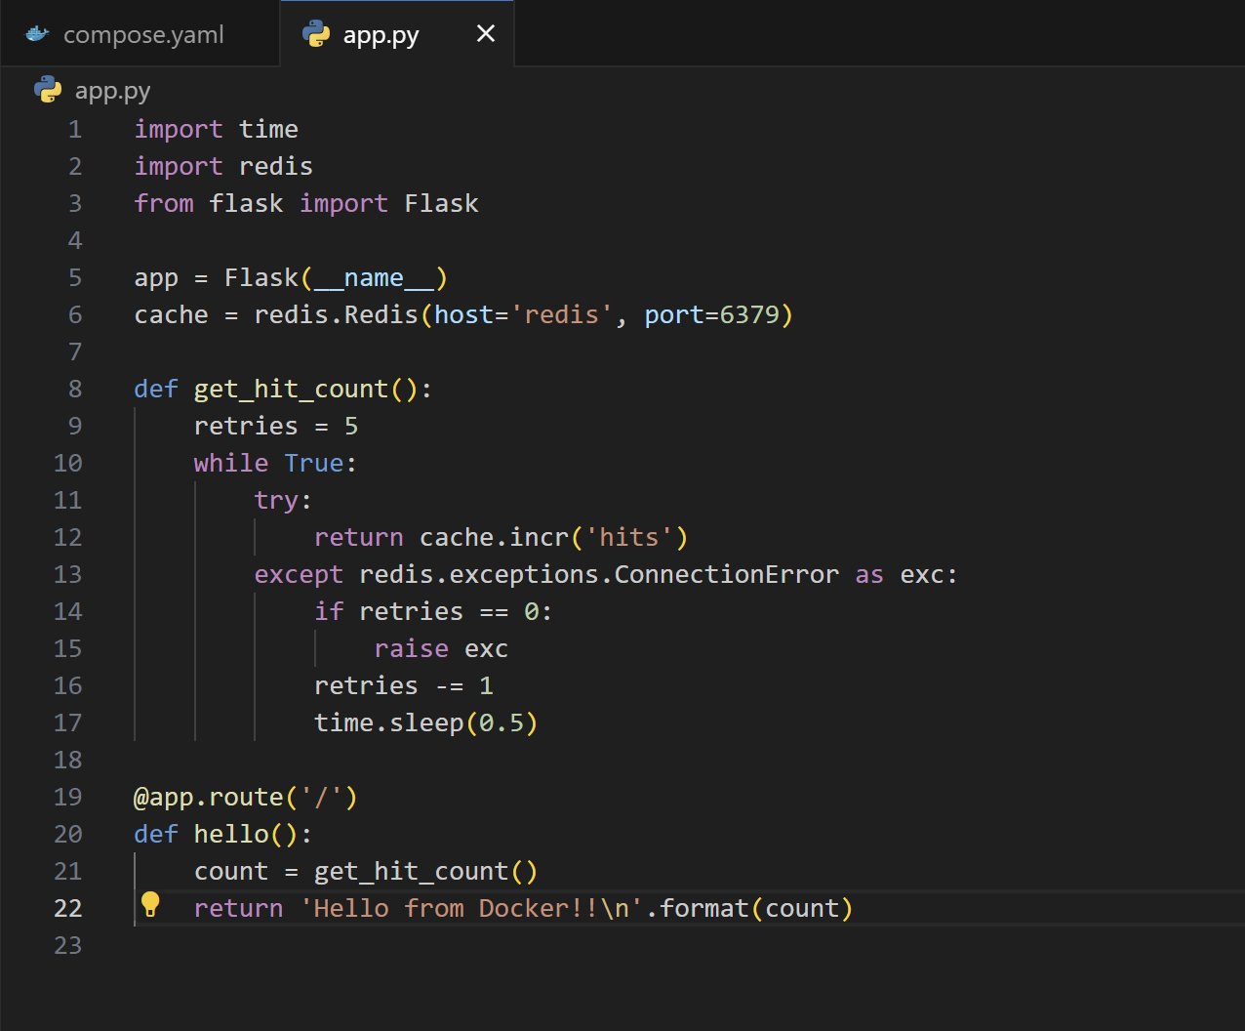

* As the application code is now mounted into the container using a volume, we can make changes to its code and see the changes instantly, without having to rebuild the image.

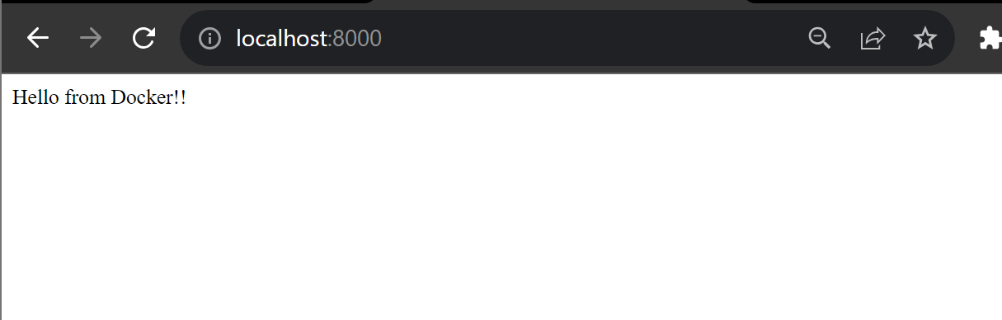

* We didn’t need to rebuild the application and run it since the application code is now mounted into the container using a volume

**Experiment-8:Docker Swarm**

Ques-1: Do the following:

1. Create 3 linux machines on AWS.
2. Install docker and check swarm is working on it or not.
3. Make first instance as Manager.
4. Make second and third machine as worker machines.
5. Check the current status of the swarm.
6. View the information of all the nodes.

**Step-1:** Go to aws management console and create three EC2 linux instances.

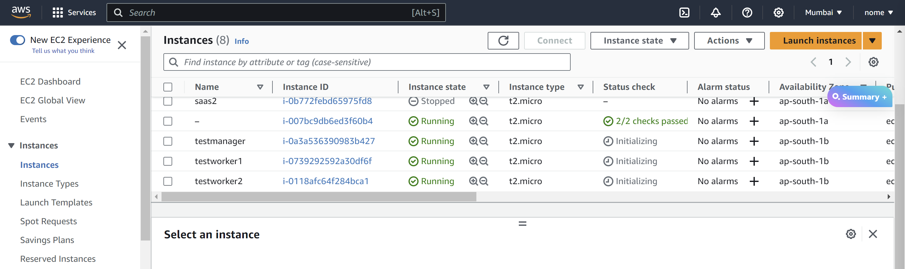

**Note:** Make sure you add “All TCP” and “All UDP” in the security groups of all the three instances.

**Step-2:** Now select the “testmanager” instance and click on connect.

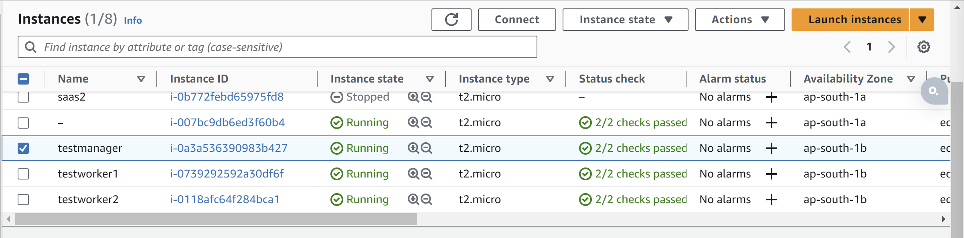

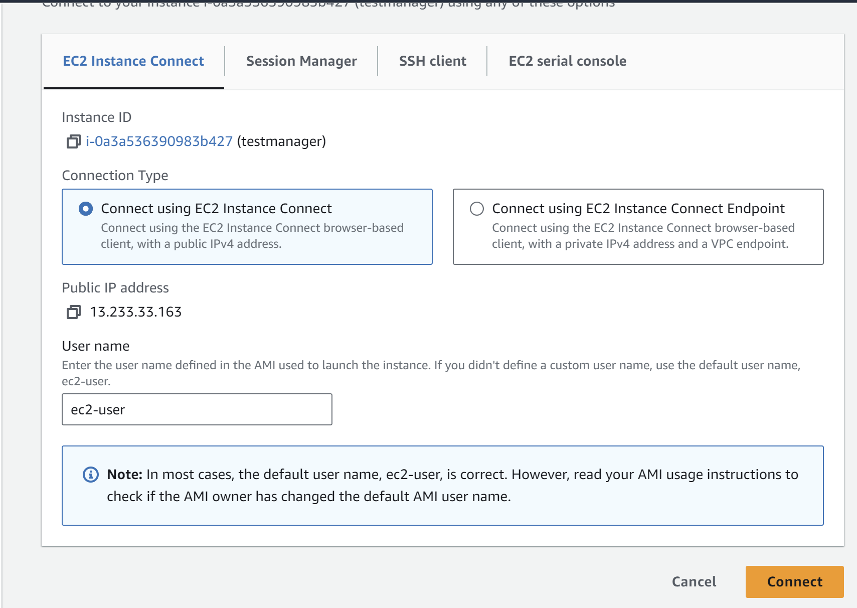

**Step-3:** After connecting to it successfully, update and upgrade the linux instance

sudo yum update

sudo yum upgrade

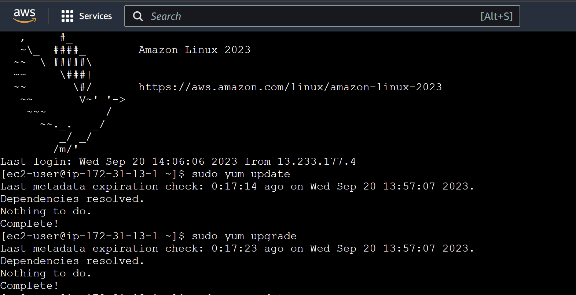

**Step-4:** Install docker in the instance.

sudo yum install docker -y

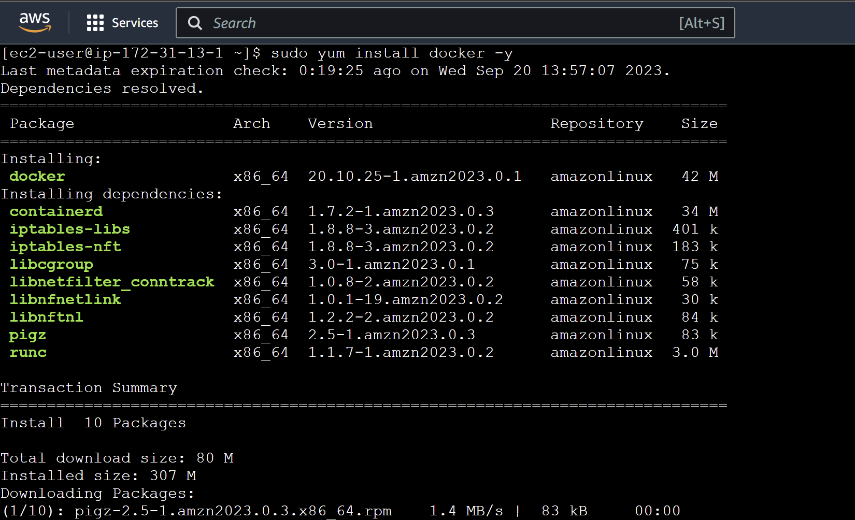

**Step-5:** Check the docker version and check whether it is installed successfully or not.

docker --version



**Step-6:** Start the docker service.

sudo service docker start



**Step-7:** Select the testmanager and then copy its “public IP”.

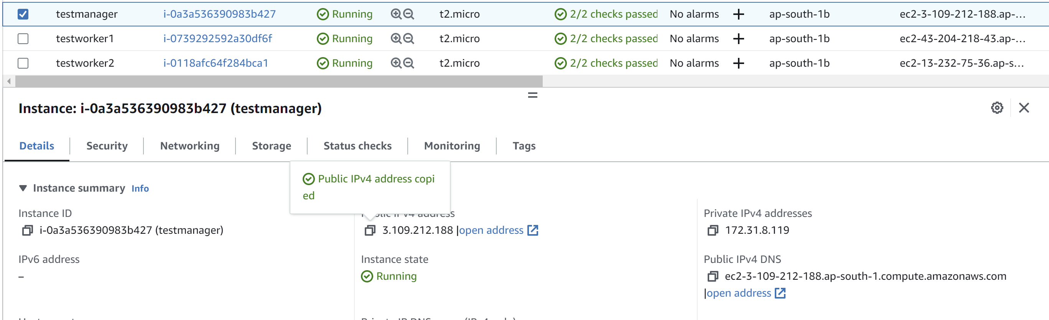

**Step-8:** Now initialise swarm and paste the IP address of the manager node that you copied in the following command:

sudo docker swarm init - -advertise-addr <public-ip-of-same-machine>

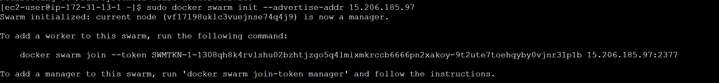

Here copy the docker swarm join command.

**Step-9:** Go to the worker instances and repeat the steps from 1-6 in the instances.

**Step-10:** Now after performing the above steps, paste the “docker swarm join …” command-**(testworker1)**

sudo service docker start



**Step-11:** Check the swarm status and the number of nodes in the testmanager.

sudo docker info



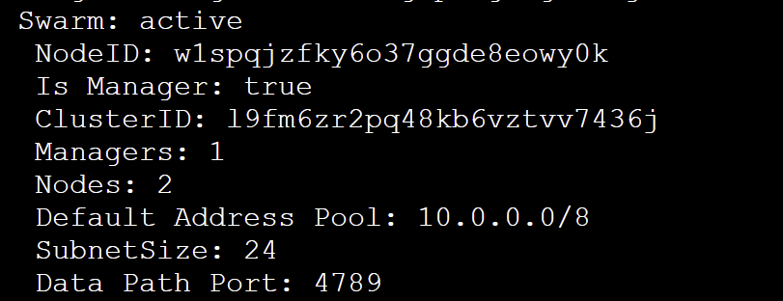

**Step-11: (testmanager)**Check the available nodes.

sudo docker node ls



**Docker swarm services**

**Step-1: (testmanager)**Firstly join another instance to the swarm service**.** For getting the join token again, type the following command:

sudo docker swarm join-token worker



**Step-2:** Start the service and type the docker swarm join command copied from the above **.(testworker2)**

sudo service docker start



**Step-3:** **(testmanager)**Go to the manager instance and check the available nodes. Here, both the worker nodes are added to the swarm service.

sudo docker node ls



**Step-4:** **(testmanager)** Run the below command. This command creates a Docker service named "new-service" with 3 replicas running the "nginx:latest" image, mapping port 80 from the host to port 80 in the container.

sudo docker service create - -name new-service - -replicas 3 -p 80:80 nginx:latest

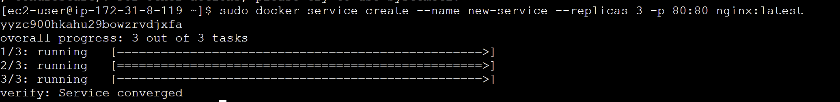

**Step-5:** **(testmanager)**Check whether the service is created or not.

sudo docker service ls



**Step-6:** **(testmanager)**Check whether the container is created or not.

sudo docker ps



**Step-7:** **(testworker1)**Check whether the container is created or not on worker nodes as well.

sudo docker ps



**Step-8:** **(testworker2)**Check whether the container is created or not.

sudo docker ps



**Note:** Now you can copy the public IPs of the instances and check them on browser whether they are accessible or not.

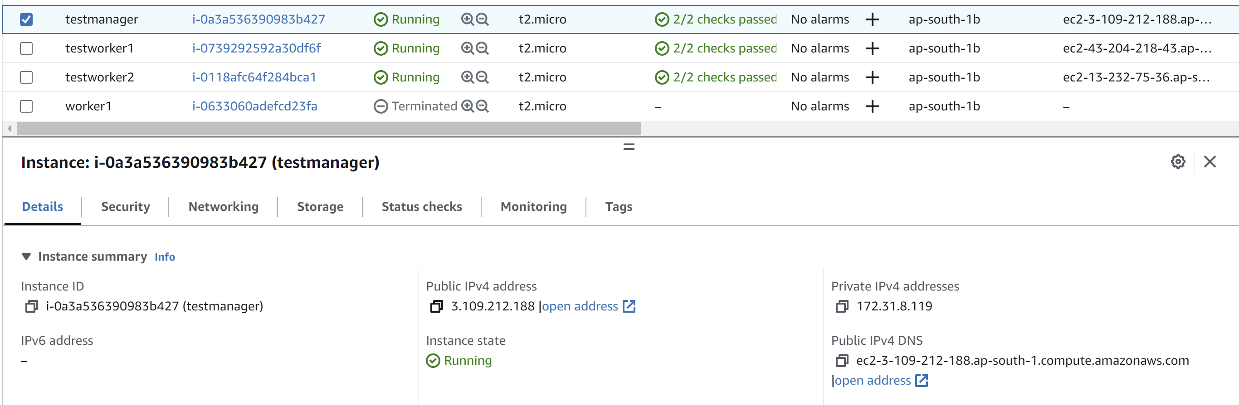

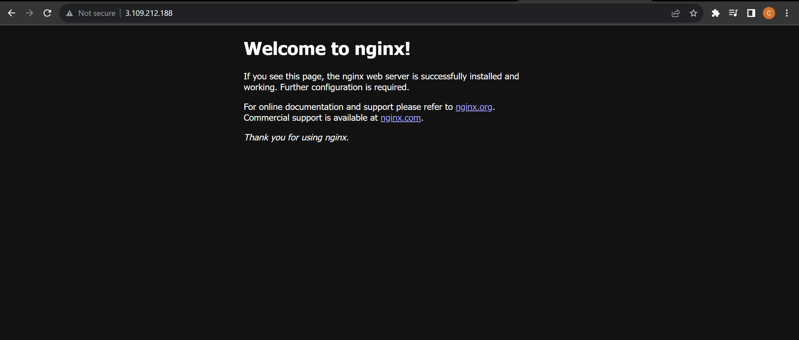

**Step-9**: **(testworker2)** Now let’s remove the container that is created on the worker2 node.

sudo docker rm -f <container-id>

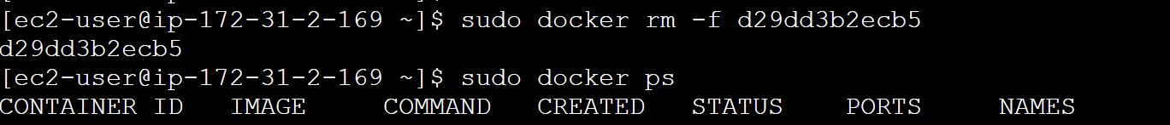

**Step-10:(testworker2)** After a few seconds, the manager detects that the container is stopped and not working on the worker node so it relaunches the container on that node.

sudo docker ps



**Step-11:(testmanager)** Now if we remove the service from the manager node, the container will be removed from all the nodes as well.

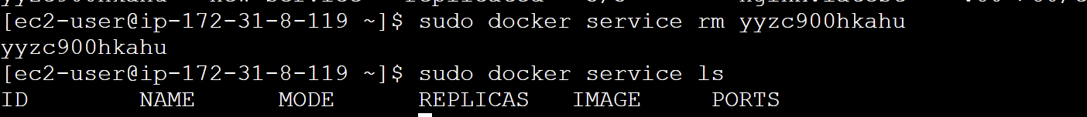

**Step-12:(testmanager)** Recreate the service with the same configuration because we have removed the previous one and inspect it.

sudo docker service create - -name old-service - - replicas 3 -p 80:80 nginx:latest

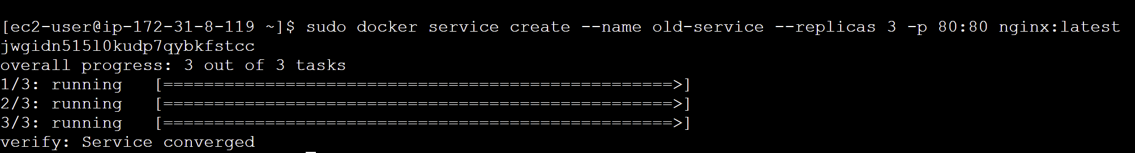

sudo docker service inspect - -pretty old-service

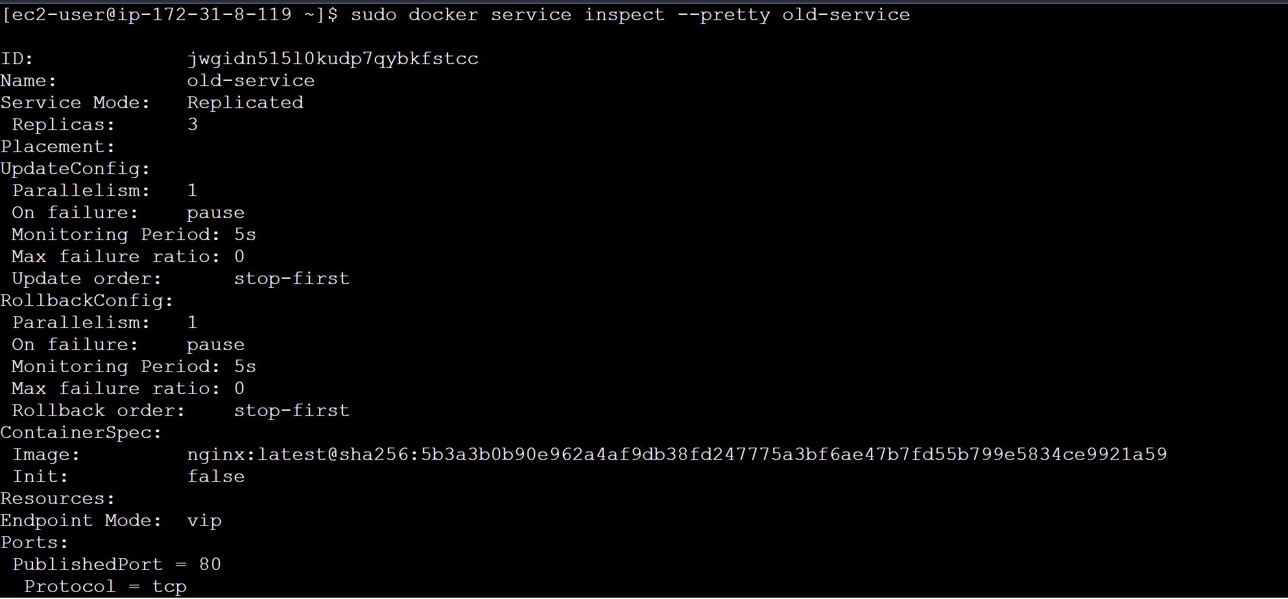

**Step-12:(testmanager)** Instead of going to each node and checking the service, we can do this:

sudo docker service ps old-service



**Deploy**

**Step-1:** In order to deploy services, make a yaml file listing all the services inside it. Open any text editor and enter the following code that includes two services: nginx and ubuntu.

sudo vim practice.yml



version: '3.3'

services:

sample1:

image: 'nginx:latest'

ports:

- "8000:8080"

sample2:

 image: 'ubuntu'

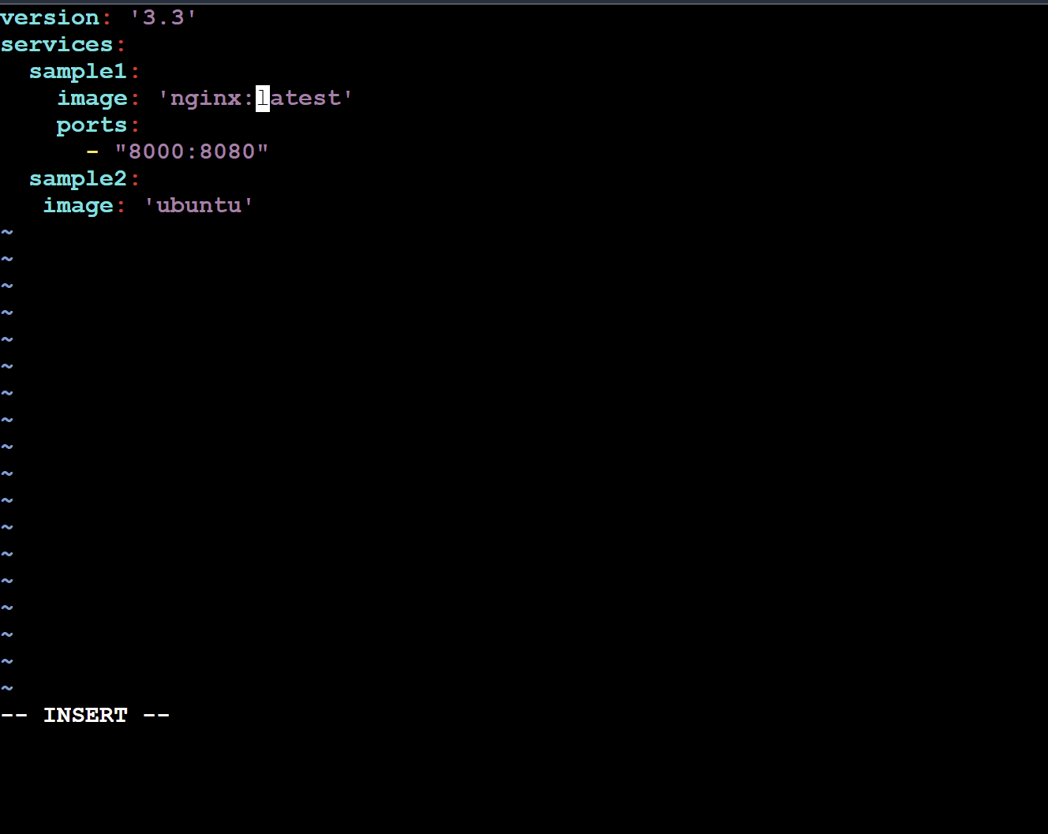

**Step-2: (testmanager)** Run the following command. This command deploys a Docker stack named "practice-stack" using the configuration defined in the "practice.yml" file.

sudo docker stack deploy -c practice.yml practice-stack



sudo docker ps



**Note:** In the yaml file, we didn’t mention the number of replicas and thus the default value for replica is 1 and hence the container are not created on the worker nodes.

**testworker1:** sudo docker ps



**testworker2:** sudo docker ps



**Step-3: (testmanager)** Here two services are created: one for ubuntu and one for nginx.

sudo docker service ls



**Step-4: (testmanager)** Using the scale command, we can increase the number of replicas for a particular service.

sudo docker service scale practice-stack_sample1=3

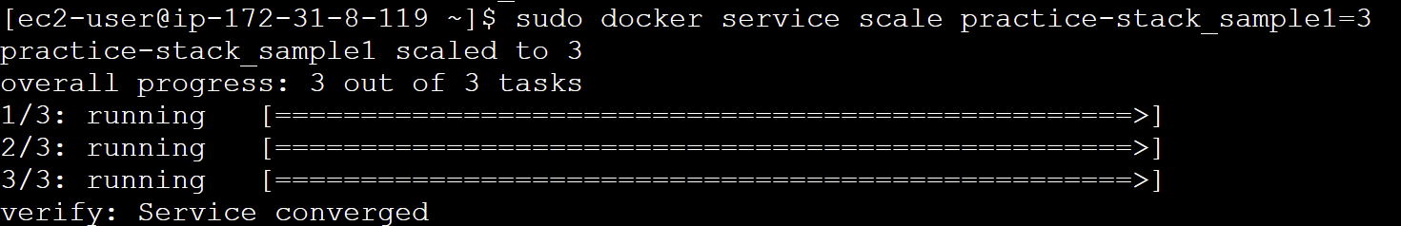

sudo docker ps



**Rolling updates**

**Step-1: (testmanager)** Firstly, remove the existing services using the following command:

sudo docker service ls

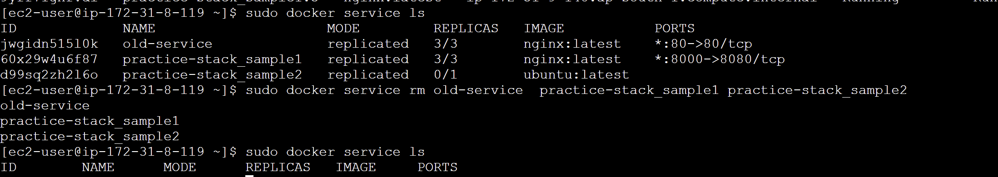

**Step-2: (testmanager)** Create a Docker Swarm service named "redis" with three replicas, using the "redis:3.0.6" container image.

sudo docker service create - -name redis - - replicas 3 redis:3.0.6

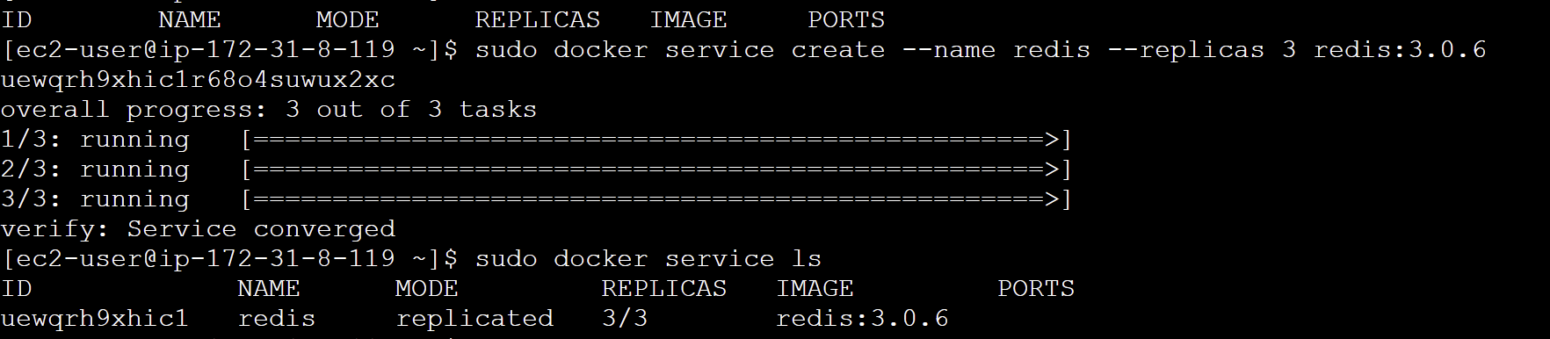

**Step-3: (testmanager)** Using the update command we can update the version of the redis service from 3.0.6 to 3.0.7

sudo docker service update - -image redis:3.0.7 redis

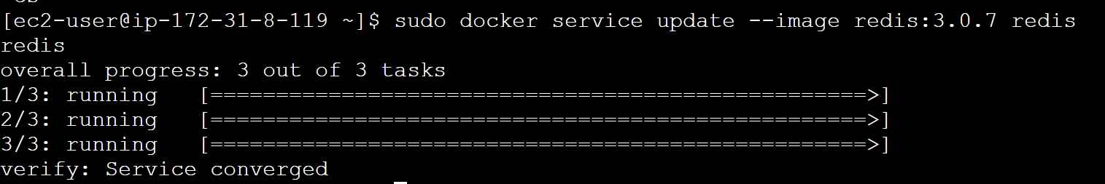

sudo docker ps



**Note:** It will automatically get updated on the nodes without stopping the service.

**Draining nodes**

**Step-1: (testmanager)** The below command sets a worker node's availability to "drain" in a Docker Swarm cluster, meaning it stops and reschedules containers on that node to prepare it for maintenance or removal.

sudo docker node update - - availability drain <workernode-id>



**Step-2: (testworker2)** Check the status of the node. It shows “Drain”

sudo docker node ls



**Note:** At this time no container will be running on the testworker1 because we have drained it.

**Step-3: (testmanager)** In the same way, we can set the status to “active” again.

sudo docker node update - - availability active <workernode-id>

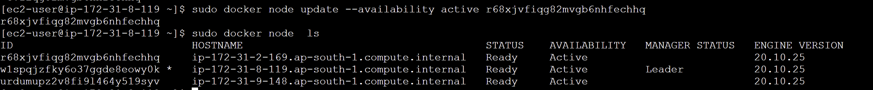

**Connecting to a network**

**Step-1:** Create an overlay network.

sudo docker network create - -driver overlay my-network



**Step-2:** While creating the service, we can specify the user-defined network using the “- - network” flag.

sudo docker service create - - replicas 3 - -network my-network - -name test nginx:latest

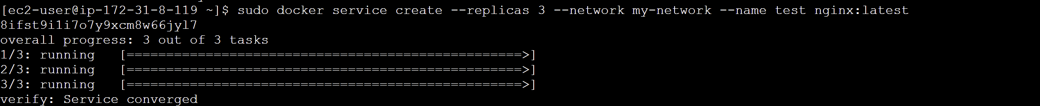

sudo docker service inspect - -pretty test

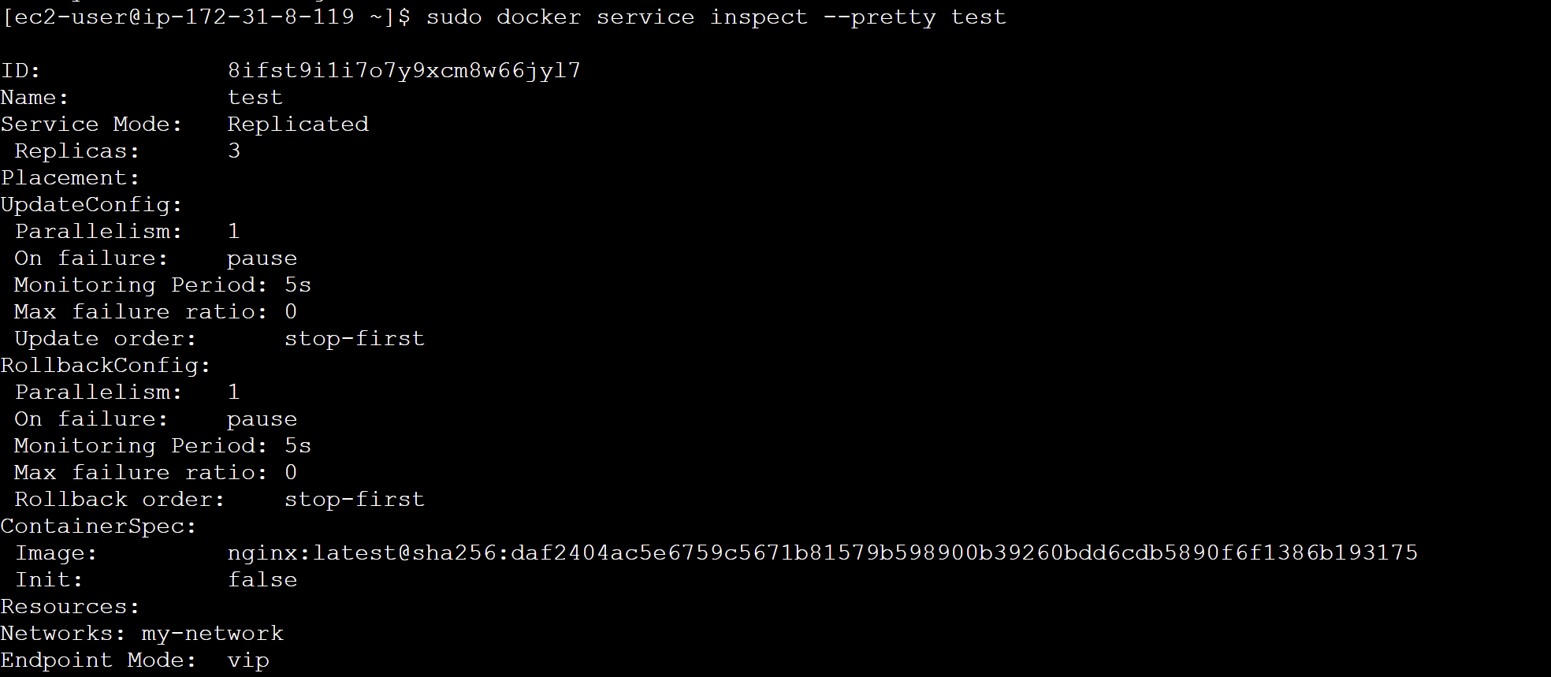

**Step-3:** While creating the below service, no network is attached to it by default.

sudo docker service create - - replicas 3 - -name demo-add nginx:latest

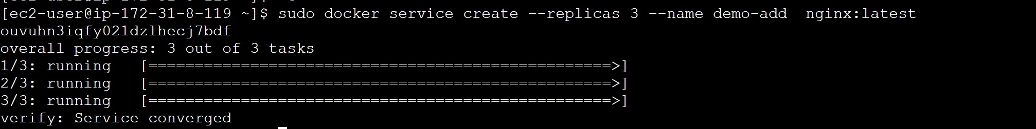

sudo docker service inspect - -pretty demo-add

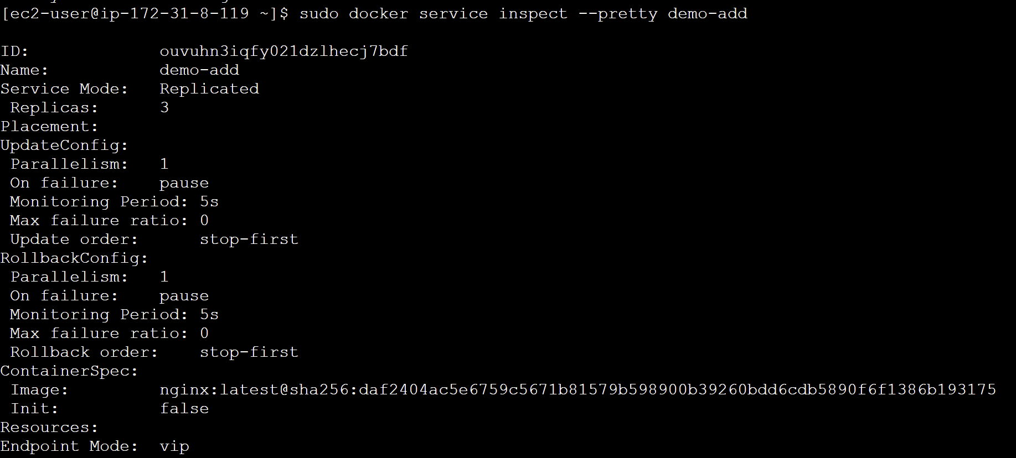

**Step-4:** We can attach a network to any existing service by using the “update” command

sudo docker service update - - network-add my-network demo-add

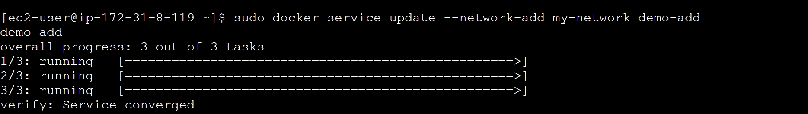

sudo docker service inspect - -pretty demo-add

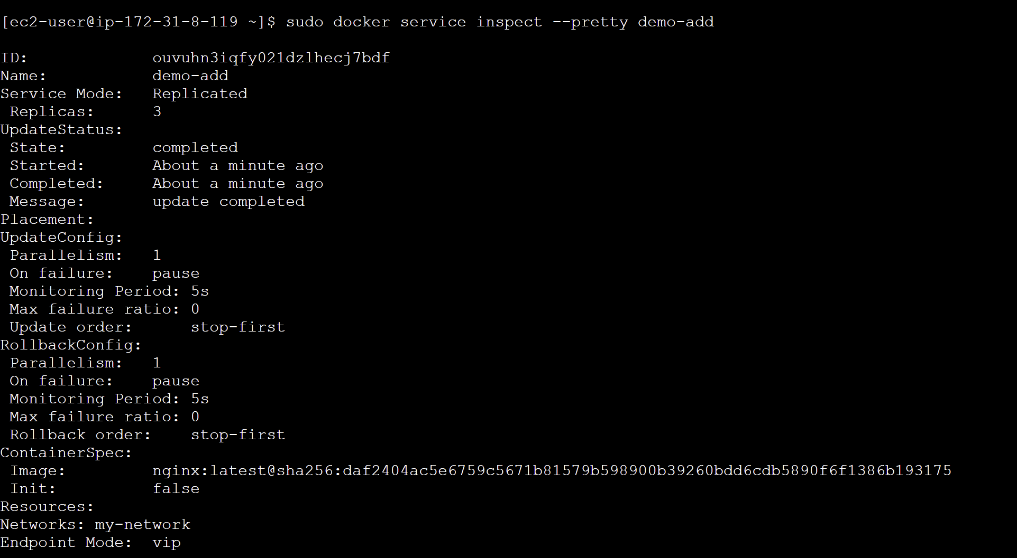

**Step-5:** We can also remove the network in the same way.

sudo docker service update - -network-rm my-network demo-add

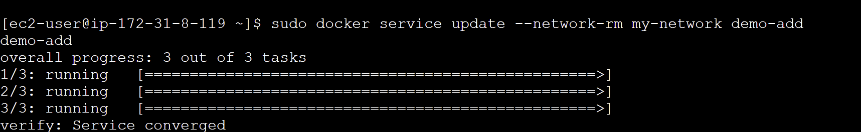

sudo docker service inspect - -pretty demo-add

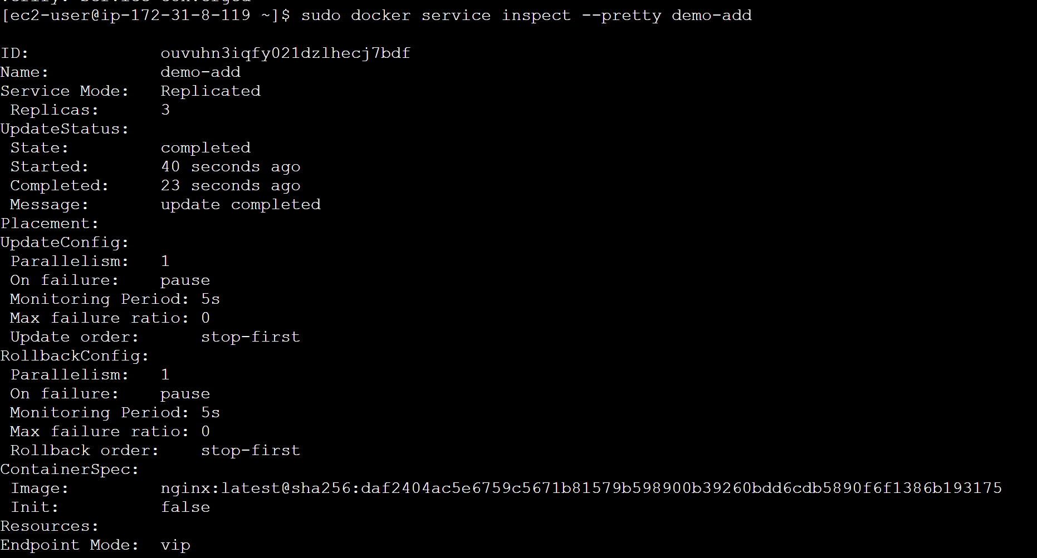

**Volume**

sudo docker service update --mount-add type=volume,source=new-vol,target=/apps test

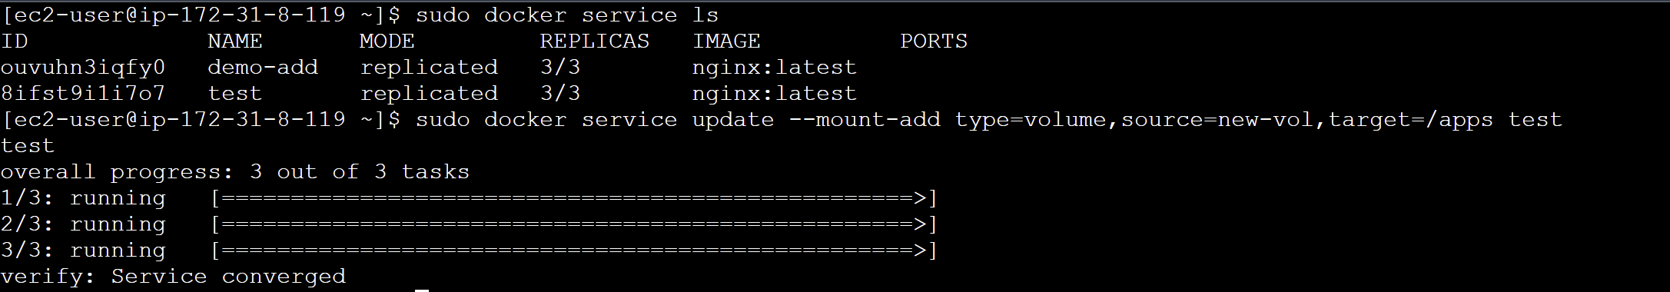

sudo docker service inspect --pretty test

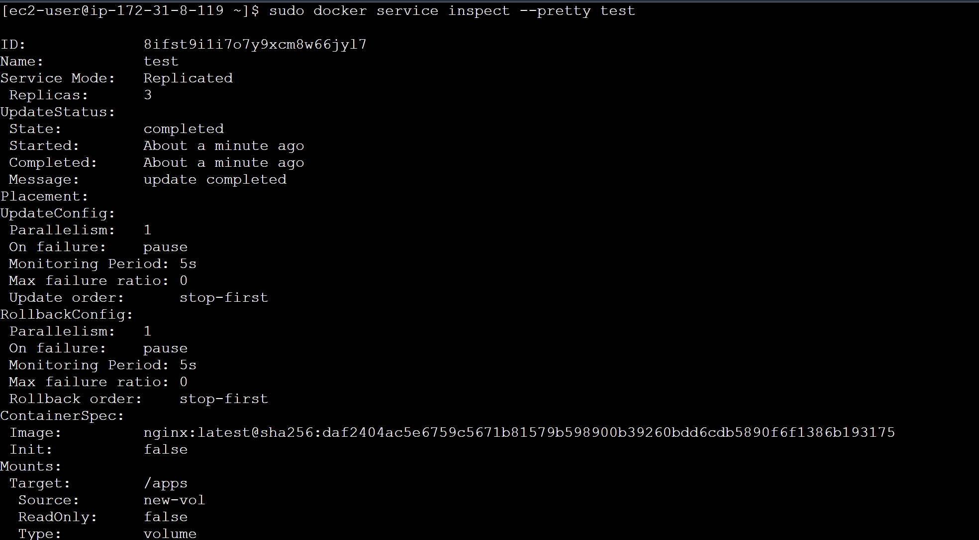

**Constraints**

**Step-1:** By using the update command, we can add constraints to the nodes. This command adds a label with the key "ID" and the value "1.1" to a Docker Swarm node specified by "<node_id>."

sudo docker node update --label-add ID=1.1 <node_id>

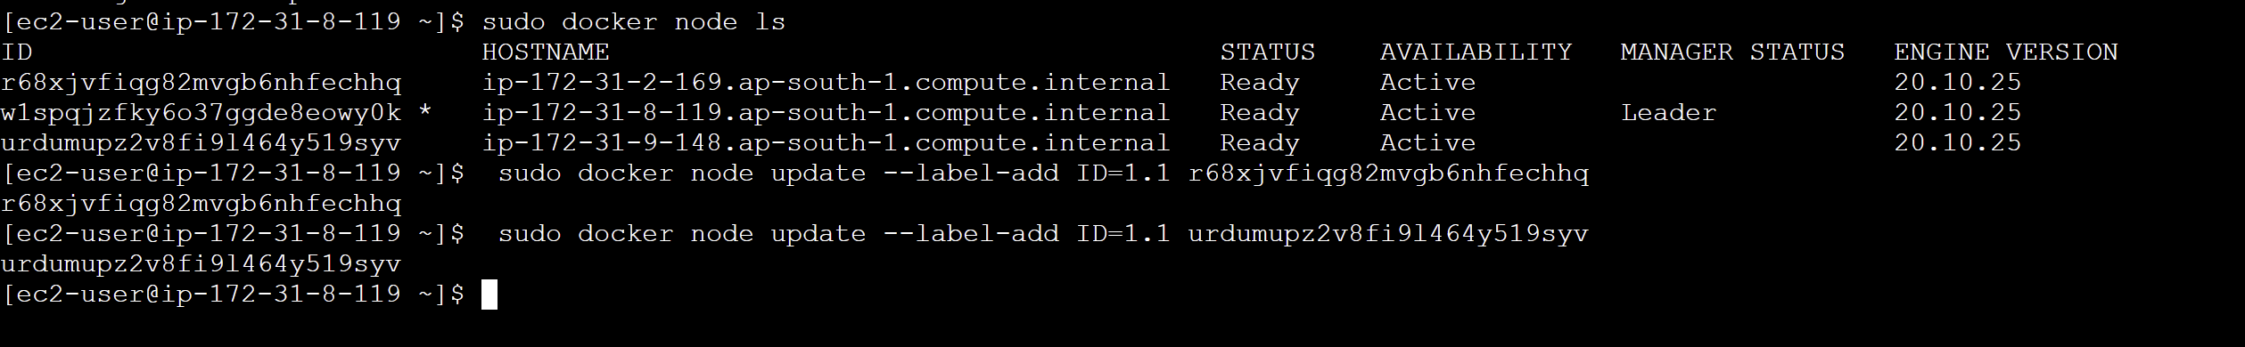

**Step-2:** This command creates a Docker service named "my-nginx" with 6 replicas, and it restricts these replicas to nodes labeled with "ID" equal to "1.1," using the "nginx:latest" image.

sudo docker service create --name my-nginx --replicas 6 --constraint node.labels.ID==1.1 nginx:latest

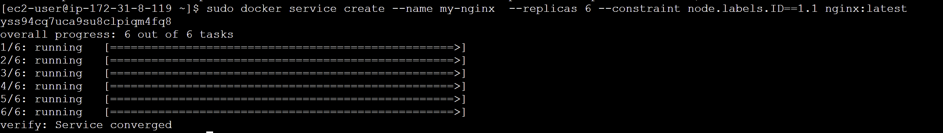

**Note:** No containers running in the manager node because its id is not 1.1



If we go to worker1 node and run “docker ps” we can see that the 6 replicas defined in the service are divided between the 2 nodes with the specified ID:

sudo docker ps

**(testworker1)**



**(testworker2)**



**Step-3:** (testworker) Using the swarm leave command, nodes can be forced to leave the swarm.

sudo docker swarm leave --force

**Step-4:** (testmanager) To remove a node from the swarm, the below command is used:

sudo docker node rm <node-id>



**Experiment-9: CI CD Docker**

1. Go to your project directory and open git bash in the directory.
2. Initialise an empty git repository in the terminal using the command:

git init

1. Check the status of your current files using the command:

git status

1. Now before committing the changes, add the files to the staging area using the command:

git add .

1. Now commit the changes:

git commit -m “initial commit”

1. Go to your github account and create a repository for the project.
2. After creating the repository, copy the repository url from the “**code**” section (highlighted in blue) and go back to the git bash terminal.
3. Run the command:

git remote add origin “paste the url that you copied”

1. Push the code files to the github

git push -u origin master

1. Go to your repository, refresh the page and check whether the files are uploaded or not.
2. Now go to “**Add file**” and then “**Create new file**” option
3. Create a dockerfile and include the following instructions:

FROM node:latest

WORKDIR /usr/src/app

COPY package.json ./

RUN npm install

COPY . .

EXPOSE 3000

CMD ["node", "index.js"]

This dockerfile contains the code for node.js application.

1. After making the dockerfile commit changes in it and save.
2. Go to “**Settings**” and go to “**Secret and Variables**” in the left panel.
3. Choose the “**Actions**” and then click on “**New Repository Secret**”.
4. Add your docker hub username and passwords in the repository secret with the name:

**DOCKER_USERNAME**

**DOCKER_PASSWORD**

1. Go to actions and click on “**set up a workflow yourself**” highlighted in blue at the top.
2. A **main.yaml** file will be opened. Inside the **main.yaml** file, copy the following code:

name: Publish Docker image

on:

push:

branches: ['master']

jobs:

push_to_registry:

name: Push Docker image to Docker Hub

runs-on: ubuntu-latest

steps:

- name: Check out the repo

uses: actions/checkout@v3

- name: Log in to Docker Hub

uses: docker/login-action@f054a8b539a109f9f41c372932f1ae047eff08c9

with:

username: ${{ secrets.DOCKER_USERNAME }}

password: ${{ secrets.DOCKER_PASSWORD }}

- name: Extract metadata (tags, labels) for Docker

id: meta

uses: docker/metadata-action@98669ae865ea3cffbcbaa878cf57c20bbf1c6c38

with:

images: chitra2409/testjodejsapp

- name: Build and push Docker image

uses: docker/build-push-action@ad44023a93711e3deb337508980b4b5e9bcdc5dc

with:

context: .

push: true

file: ./Dockerfile

tags: ${{ steps.meta.outputs.tags }}

labels: ${{ steps.meta.outputs.labels }}

**Note:** Make sure you change your docker hub username, image name and your dockerfile location.

1. After adding the code, commit the changes in the main.yaml file.
2. Go to “**Actions**” and see whether the file is being created or not. If yes, then the instructions that are included in the yaml file will be executed and the image will be pushed to the docker hub.
3. Login to your docker hub and check whether the image is pushed or not.
4. Now if that works fine, make some changes in the dockerfile.
5. Go to dockerfile, click on edit and then change it. Eg: change the port from 3000 to 4000.
6. Go to “**Actions**”. You can see that the dockerfile will be updating automatically and the updated image will be pushed to the docker hub.

**Experiment-10: Minikube**

**Prerequsites:**

* 2 CPUs or more
* 2GB of free memory
* 20GB of free disk space
* Internet connection
* Container or virtual machine manager, such as: [Docker](https://minikube.sigs.k8s.io/docs/drivers/docker/), [QEMU](https://minikube.sigs.k8s.io/docs/drivers/qemu/), [Hyperkit](https://minikube.sigs.k8s.io/docs/drivers/hyperkit/), [Hyper-V](https://minikube.sigs.k8s.io/docs/drivers/hyperv/), [KVM](https://minikube.sigs.k8s.io/docs/drivers/kvm2/), [Parallels](https://minikube.sigs.k8s.io/docs/drivers/parallels/), [Podman](https://minikube.sigs.k8s.io/docs/drivers/podman/), [VirtualBox](https://minikube.sigs.k8s.io/docs/drivers/virtualbox/), or [VMware Fusion/Workstation](https://minikube.sigs.k8s.io/docs/drivers/vmware/)

**Note:** I will be using Docker in this document. Make sure you have Docker Desktop installed in your system.

**Steps**

1. Open windows powershell and install minikube. Run the following commands one by one:

New-Item -Path 'c:\' -Name 'minikube' -ItemType Directory -Force

Invoke-WebRequest -OutFile 'c:\minikube\minikube.exe' -Uri 'https://github.com/kubernetes/minikube/releases/latest/download/minikube-windows-amd64.exe' -UseBasicParsing

1. Set environment variables using the following command:

$oldPath = [Environment]::GetEnvironmentVariable('Path', [EnvironmentVariableTarget]::Machine)

if ($oldPath.Split(';') -inotcontains 'C:\minikube'){

[Environment]::SetEnvironmentVariable('Path', $('{0};C:\minikube' -f $oldPath), [EnvironmentVariableTarget]::Machine)

**Start Your cluster**

1. Now open windows powershell in admin mode and run the command: (will take few minutes)

minikube start --driver=docker

// use this if you are using **docker** or write the hypervisor or container engine that you are using in its place.

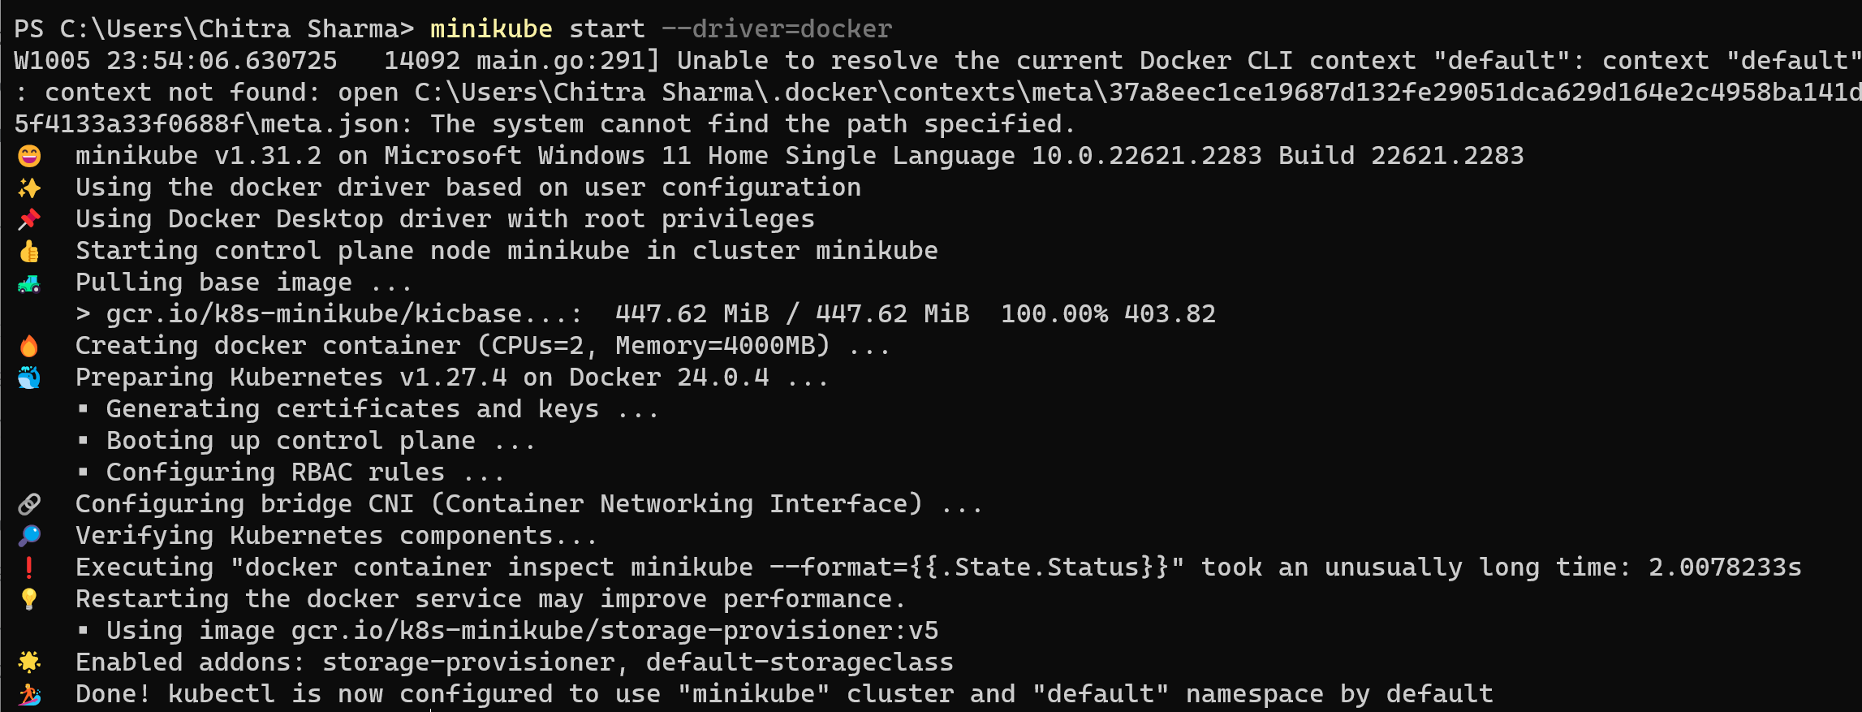

**Interact with your cluster**

1. Now, you can interact with the cluster using the kubectl command line tool.

kubectl get po -A

The command "**kubectl get po -A**" is used with Kubernetes, a container orchestration platform. It does the following:

* "**kubectl**" is the command-line tool for interacting with Kubernetes clusters.
* "**get**" is the action, indicating that you want to retrieve information.
* "**po**" is short for "pods," which are the smallest deployable units in Kubernetes.
* "**-A**" or **"--all-namespaces**" specifies that you want to get information about pods in all namespaces (i.e., across the entire Kubernetes cluster), not just in the default namespace.

So, the command retrieves a list of all pods running in all namespaces of the Kubernetes cluster.

1. This command retrieves a list of all pods running in all namespaces within the Minikube Kubernetes cluster.

minikube kubectl -- get po -A

1. The command "alias kubectl="minikube kubectl --"" creates an alias for the "kubectl" command, which is commonly used to interact with Kubernetes clusters.

alias kubectl="minikube kubectl --"

By creating this alias, whenever you type "kubectl" in your terminal, it will actually execute "minikube kubectl --" followed by any additional arguments or commands you provide.

1. This command opens a web-based interface for managing a local Kubernetes cluster created with Minikube.

minikube dashboard

**Deploy Applications**

**i)Service**

* 1. Create a sample deployment and expose it on port 8080:

kubectl create deployment hello-minikube --image=kicbase/echo-server:1.0

kubectl expose deployment hello-minikube --type=NodePort --port=8080

These two "kubectl" commands create a Kubernetes deployment named "hello-minikube" with a specified Docker image and expose it as a NodePort service on port 8080 within the cluster.



* 1. The above command will take a moment but the deployment will soon show up when you run:

kubectl get services hello-minikube

The "kubectl get services hello-minikube" command is used to retrieve information about the service named "hello-minikube" in the current Kubernetes context, which includes details such as the service's name, type, cluster IP, external IP (if applicable), and ports.



* 1. Now, the easiest way to access this service is to let the minikube launch a web browser for you:

minikube service hello-minikube

This command is used to open a web browser and access the service named "hello-minikube" running in a Minikube Kubernetes cluster.

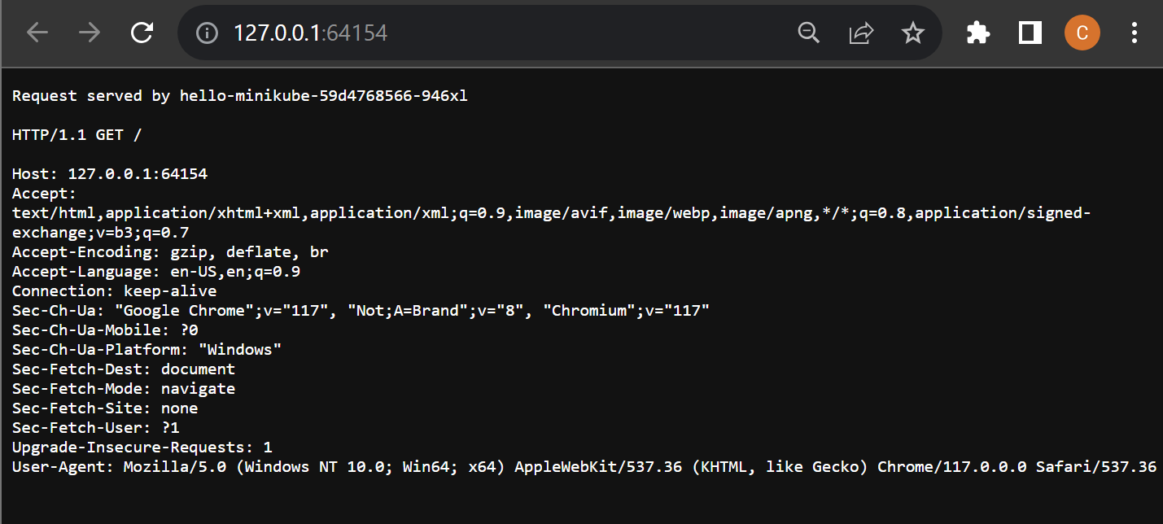

* 1. Alternatively, we can use kubectl to forward the port:

kubectl port-forward service/hello-minikube 7080:8080

Now we can access the application at:

<http://localhost:7080/>

**ii)Load Balancer**

1. To use a LoadBalancer deployment, use the “minikube tunnel” command:

kubectl create deployment balanced --image=kicbase/echo-server:1.0

kubectl expose deployment balanced --type=LoadBalancer --port=8080

These two "kubectl" commands create a Kubernetes deployment named "balanced" with a specified Docker image and expose it as a LoadBalancer service on port 8080 within the cluster,

1. In another window, start the tunnel to create a routable IP for the ‘balanced’ deployment:

minikube tunnel

1. To find the routable IP, run this command and examine the EXTERNAL-IP column:

kubectl get services balanced



Your deployment is now available at <EXTERNAL-IP>:8080

Here in my case the External IP will be replaced by : 127.0.0.1

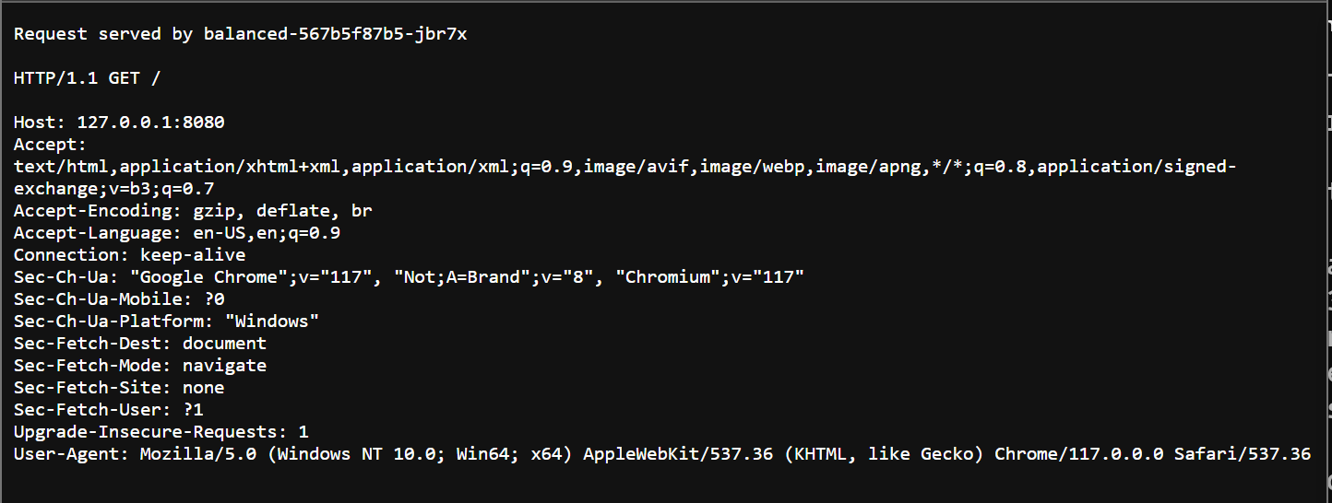

**Manage Your Cluster**

1. To pause Kubernetes without impacting deployed applications, run:

minikube pause

1. To unpause the paused instance, run:

minikube unpause

1. To halt the cluser, run:

minikube stop

1. To change the default memory limit(requires to restart), run:

minikube config set memory 9001

1. To browse the catalog of easily installed Kubernetes services,run:

minikube addons list

1. To create a second cluser running an older Kubernetes release, run:

minikube start -p aged --kubernetes-version=v1.16.1

1. To delete all the minikube clusters, run:

minikube delete –all

**Experiment-11:AWS ECS**

**Step: 1-** Firstly using the dockerfile, build the image of the setup.

**Dockerfile:**

# Use an official Node.js runtime as a base image

FROM node:14

# Set the working directory inside the container

WORKDIR /app

# Copy package.json and package-lock.json to the working directory

COPY package.json ./

# Install application dependencies

RUN npm install

# Copy the rest of the application code to the working directory

COPY . .

# Expose the port your application will run on

EXPOSE 3000

# Define the command to run your application

CMD ["node", "index.js"]

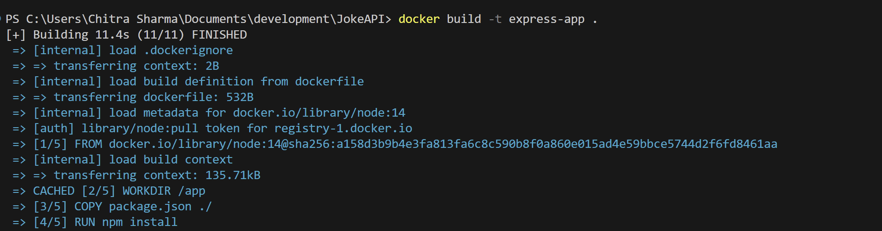

**Step-2:** Inspect whether the image is built or not.



**Step-3:** Now run a container from this image and check whether the application is running fine locally or not.



**Step-4:** Access the application at localhost:3000. Since the application is working fine on localhost, proceed to the next step.

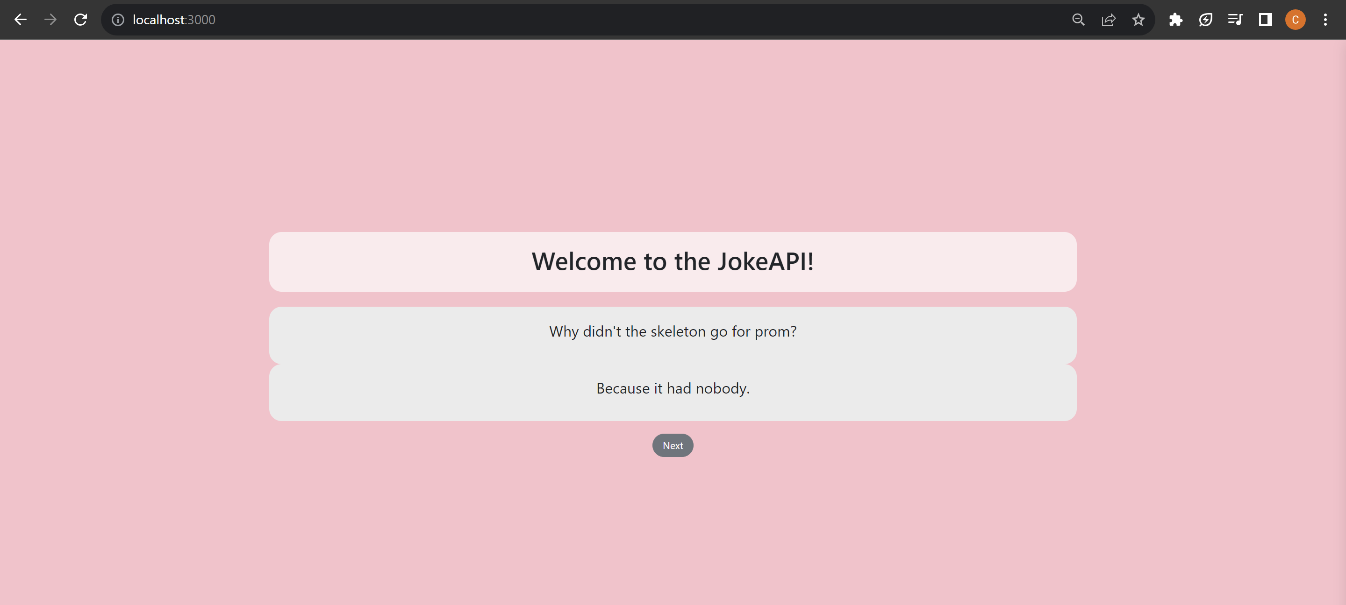

**Steps:**

1. Now log in to your aws account and search for ECS.
2. First thing that we need to do is to get that image that we created locally using dockerfile into AWS.
3. It will be done through **Amazon ECR**(Elastic Container Registry) where we register all our images. This is similar to something like docker hub where we store our images.
4. Go to **“Repositories”** and click on **“Create repository”.**

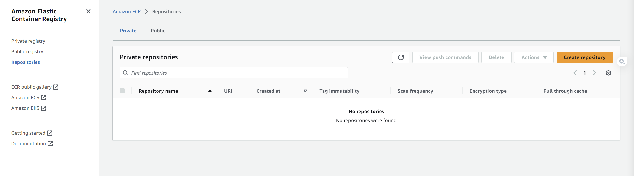

1. Make it a **“Public repository”** and give your repository a name.

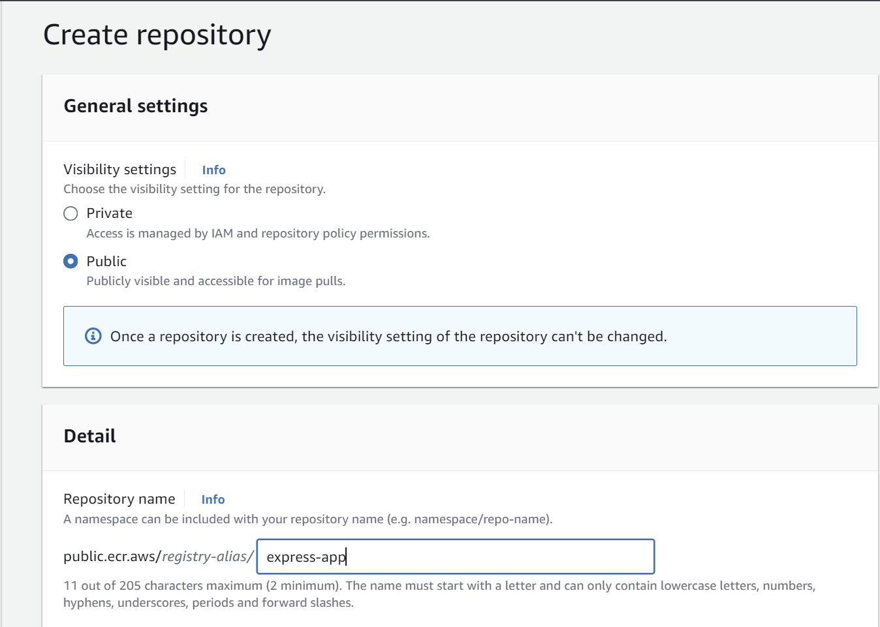

1. Then click on create repository and proceed.
2. This is just the repository. Now what we need to do is to push our docker image into the **express-app** repository just we just created.
3. Click on **express-app** repository.

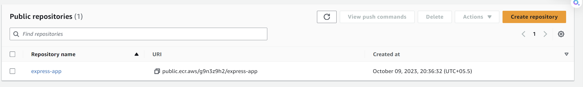

1. Click on view push commands on top right corner.

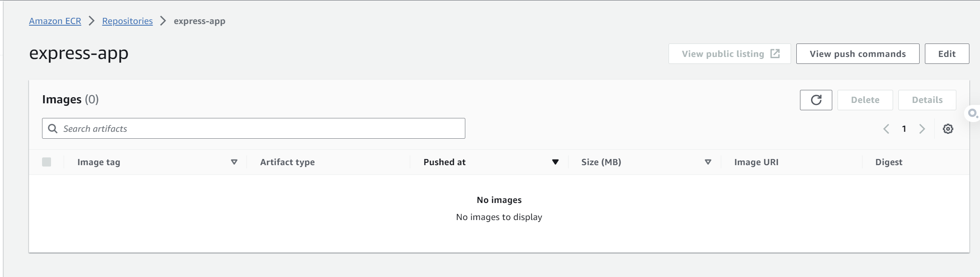

1. This contains all the commands in order to push the local image into this repository on AWS.

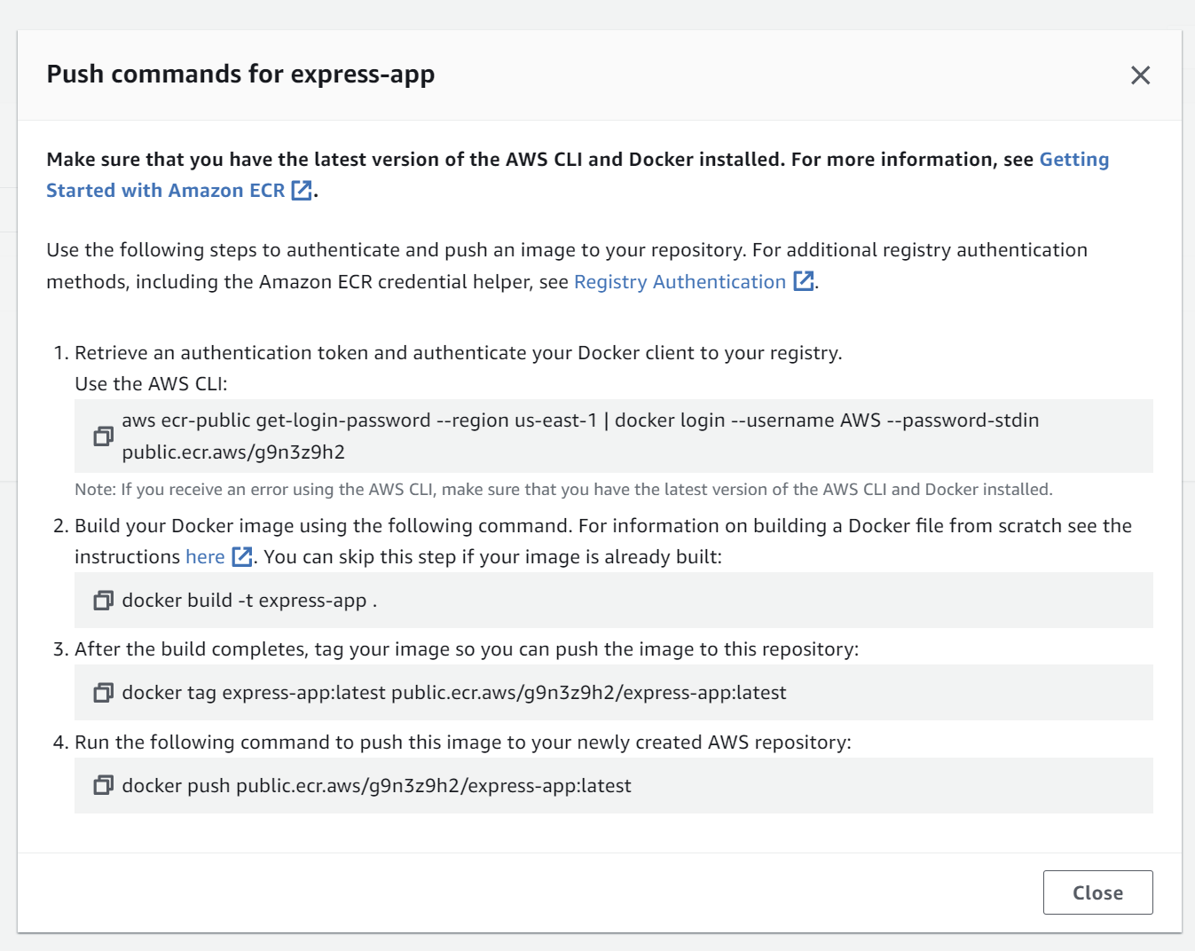

1. Before running these commands, you need to install AWS CLI and configure it if you haven’t already: <https://aws.amazon.com/cli/>
2. In order to configure **AWS cli**, Go to **AWS console** -> **IAM** -> **Users** -> **Add users**
3. Specify the user details, add a user name and proceed with the following check boxes given in the image.

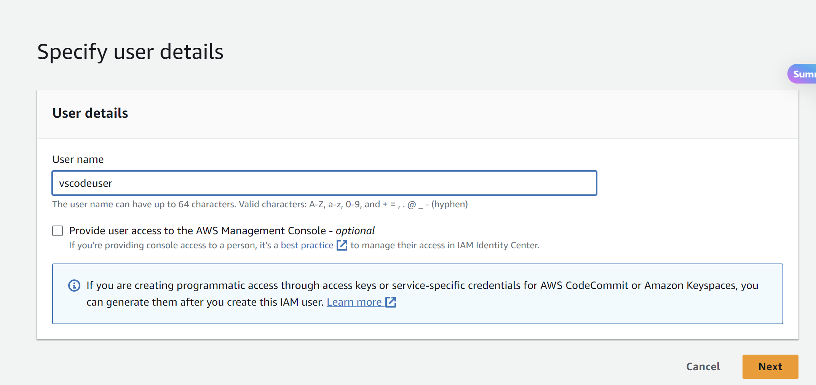

1. Click on next- next and “**Create user**”.
2. Select the user.
3. Click on “**Create access key**”

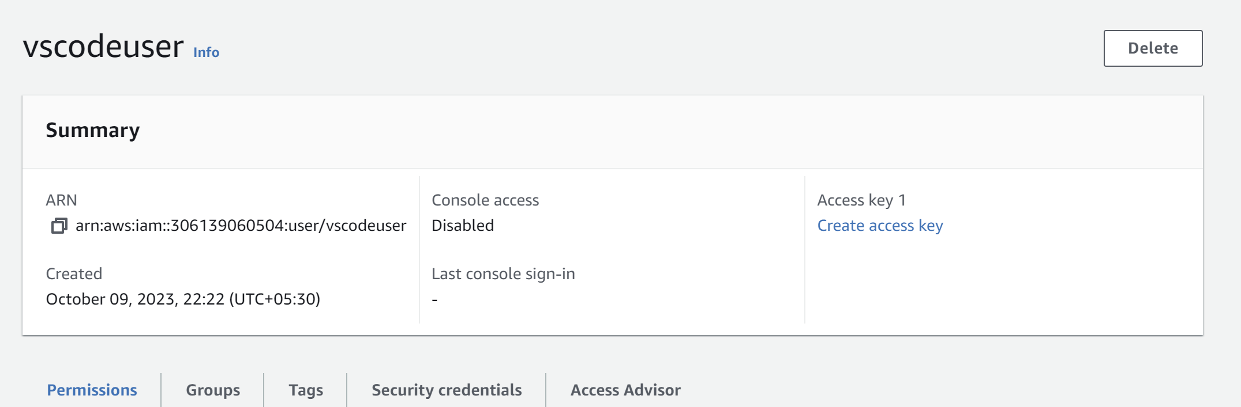

1. Select “**Other**” and proceed

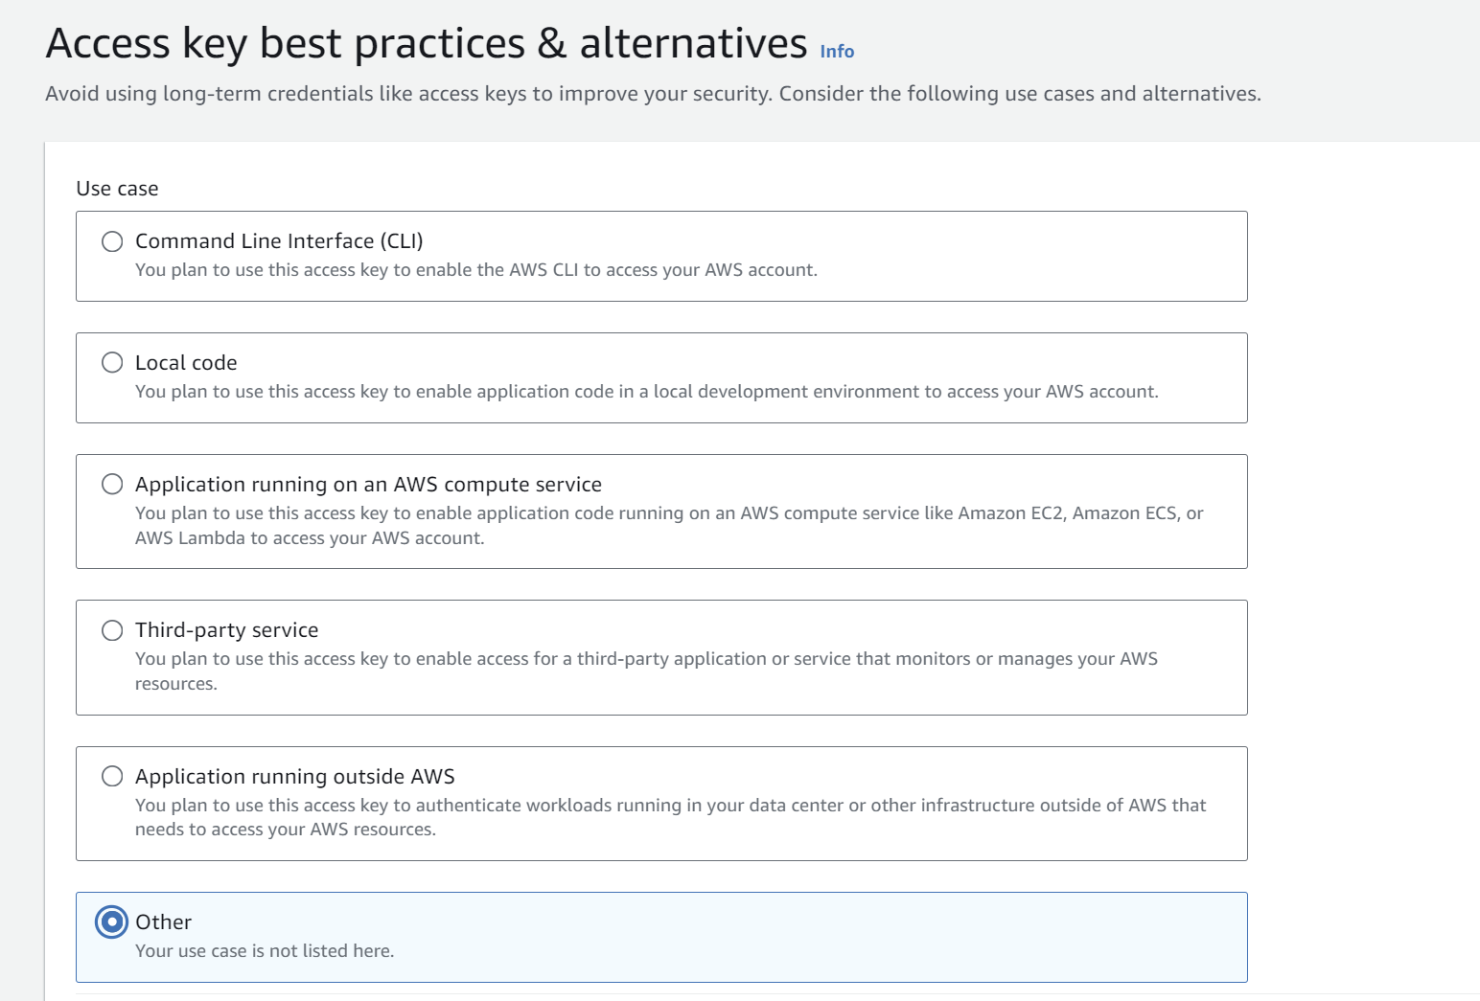

1. Note these **Access key** and **Secret access key**.

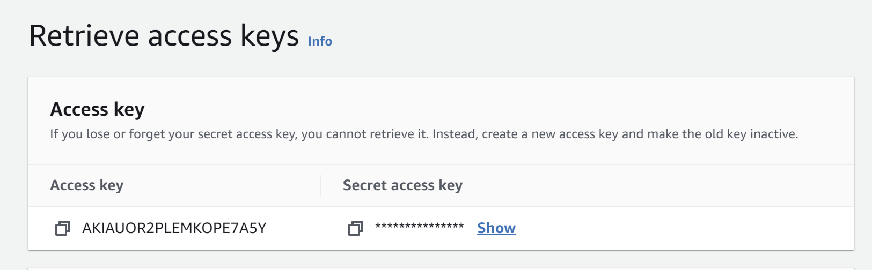

1. Now add permissions to the user. Go to **“Add permissions”** . Click on “**Create inline policy**”

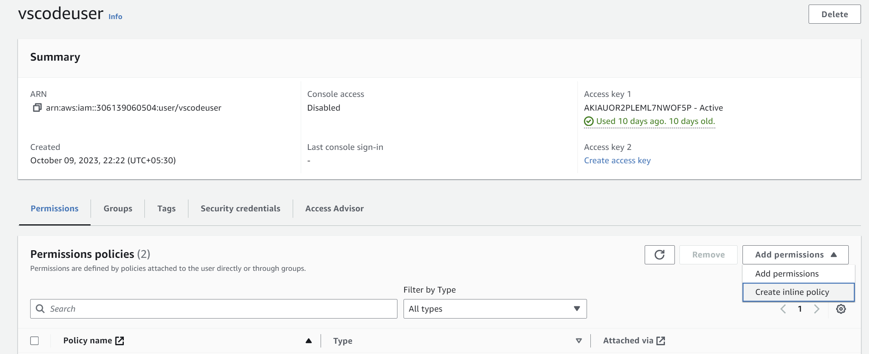

1. Add the following json in the policy and save.

{

"Version": "2012-10-17",

"Statement": [

{

"Effect": "Allow",

"Action": [

"ecr-public:GetAuthorizationToken",

"sts:GetServiceBearerToken"

],

"Resource": "*"

}

]

}

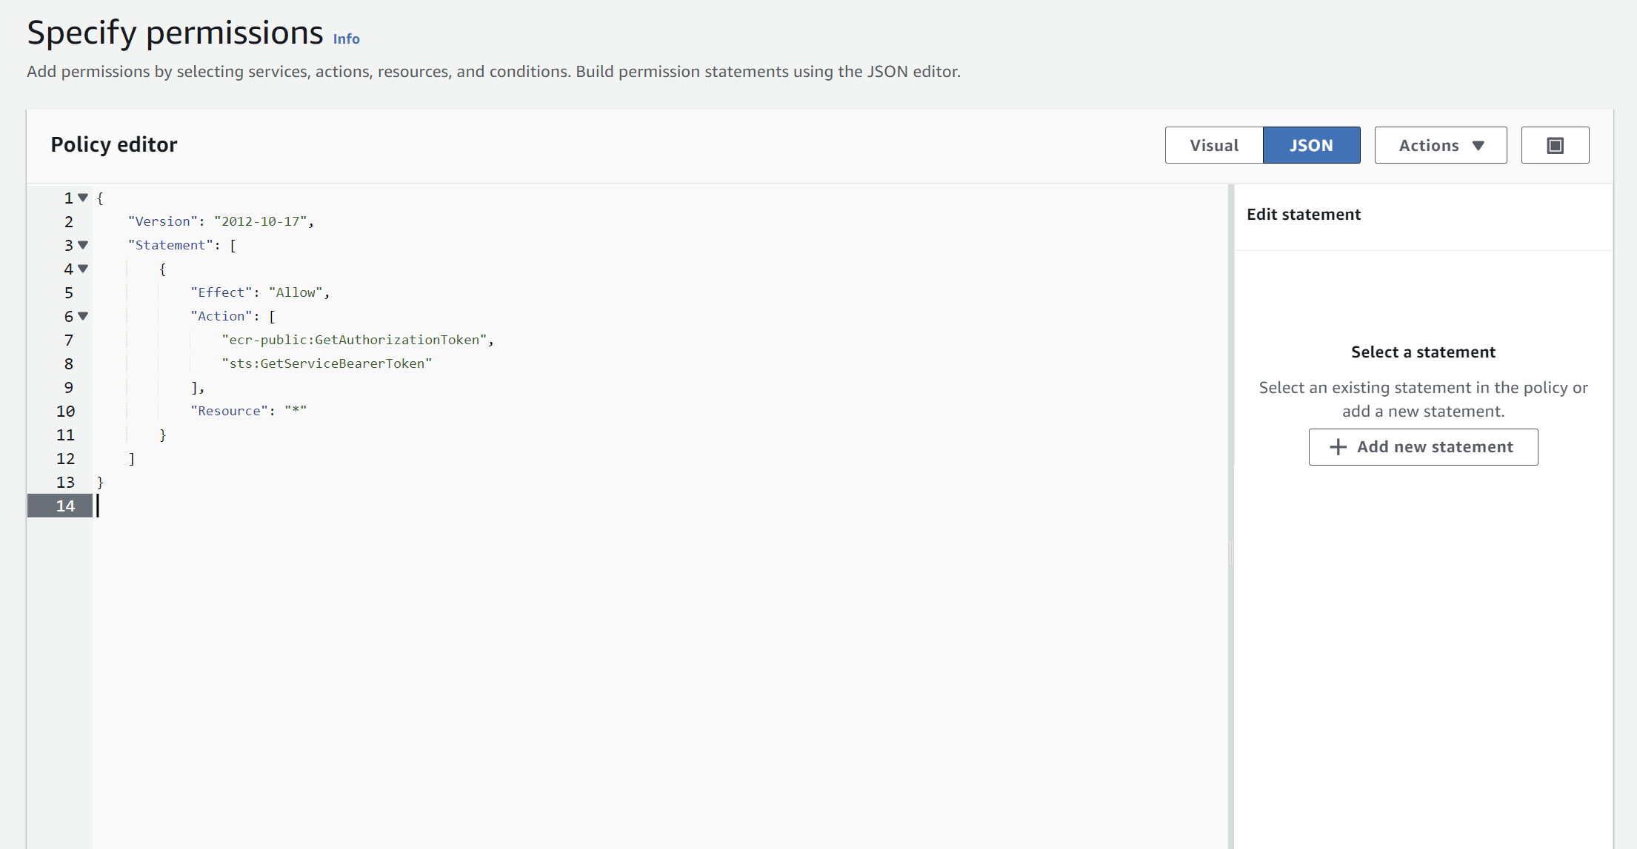

1. Name the Policy and click on create.

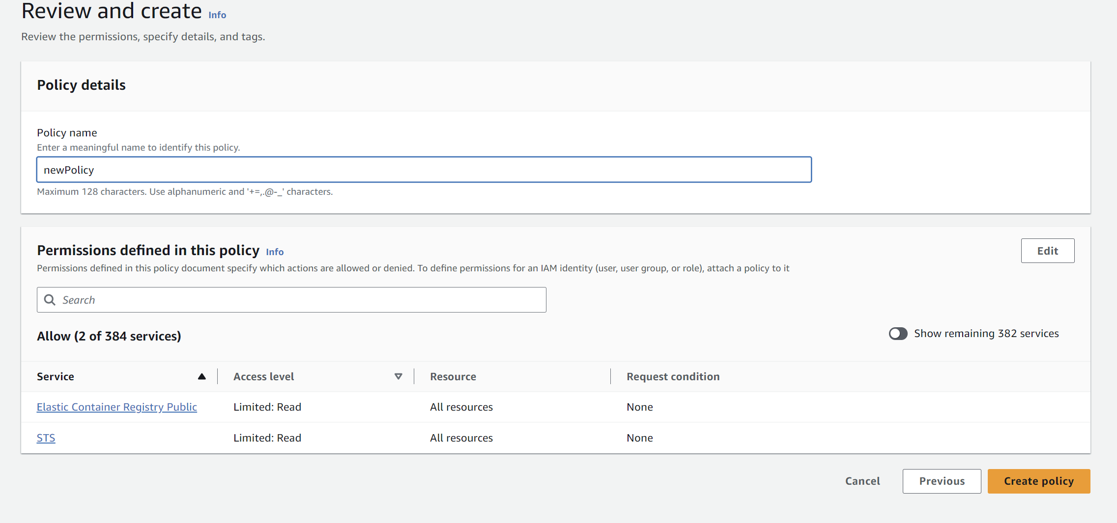

1. Now attach other permissions. Click on “**Attach Policy directly”.**

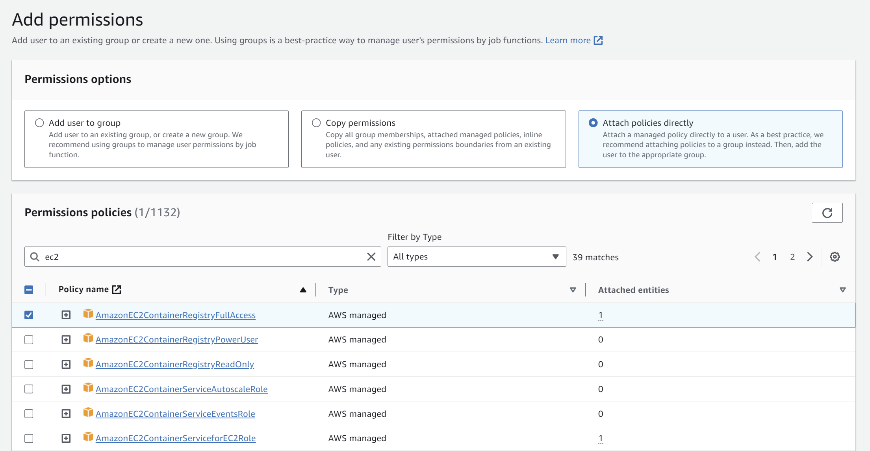

1. Make sure the permissions are attached.

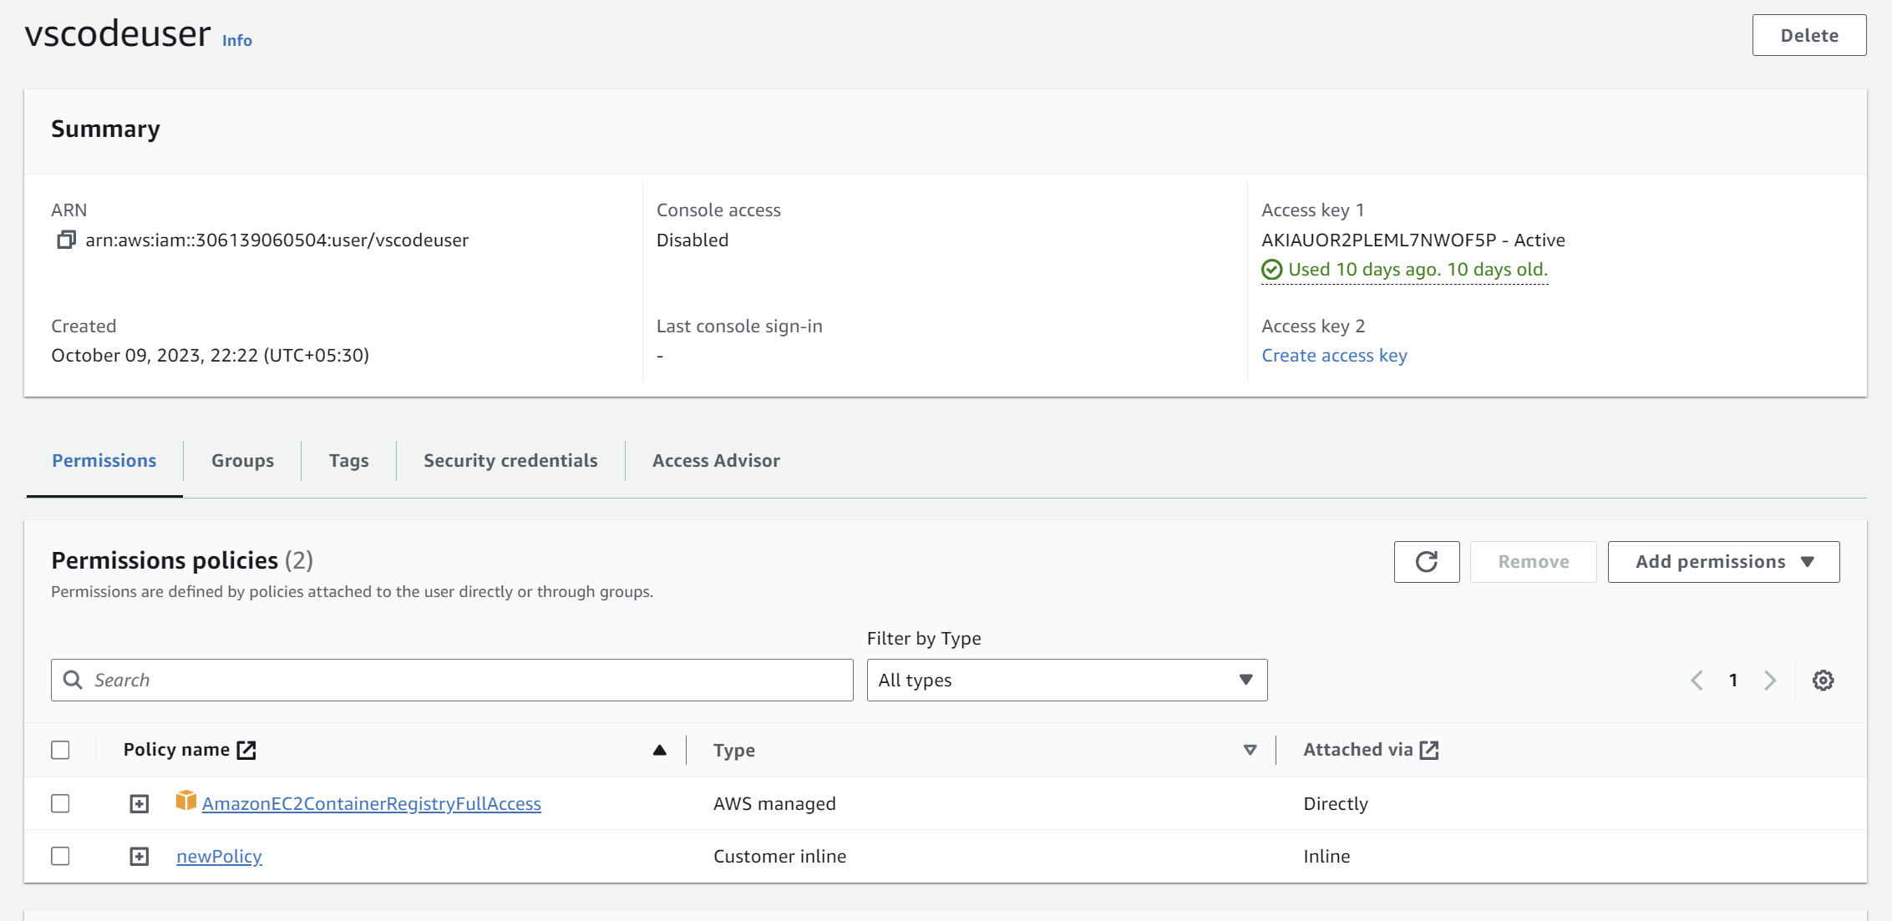

1. Now configure AWS in your IDE. I am using VS Code.

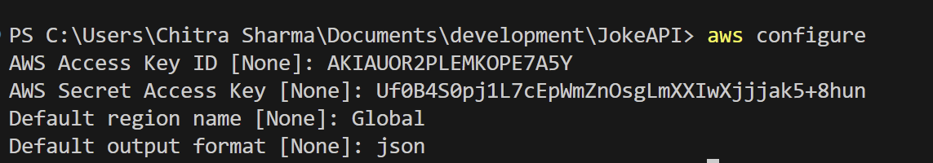

1. After successfully configuring, run these command one by one in the terminal in your project directory.
2. While running the first command from the commands given, if it gives error like:

Error saving credentials: error storing credentials - err: exit status 1, out: `The stub received bad data.`

Follow the following steps:

Go to: c:\Users\chitra\.docker\config.json

And remove the "credsStore": "wincred" key from the json file.

1. Run the command again and it will show Login succeeded. If it does not work try to repeat the steps.
2. Then run the rest of the commands one by one.
3. After running all the commands, check whether the image is pushed successfully or not:

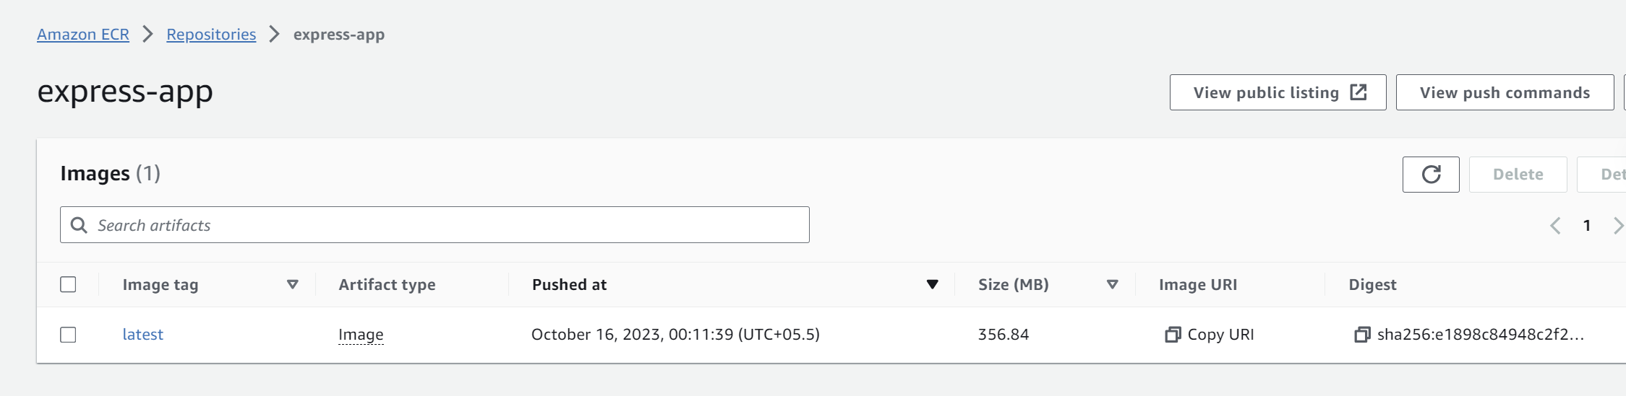

**Creating Cluster**

1. Next step is to create the cluster. Go to ECS and click on “**Create cluster**”

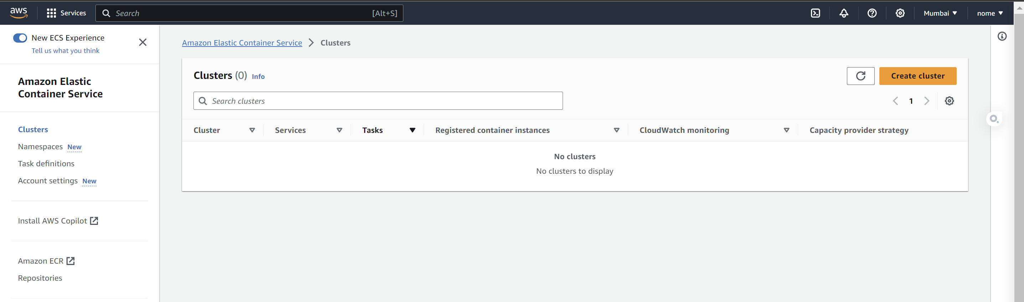

1. Set the settings in the respective fields:

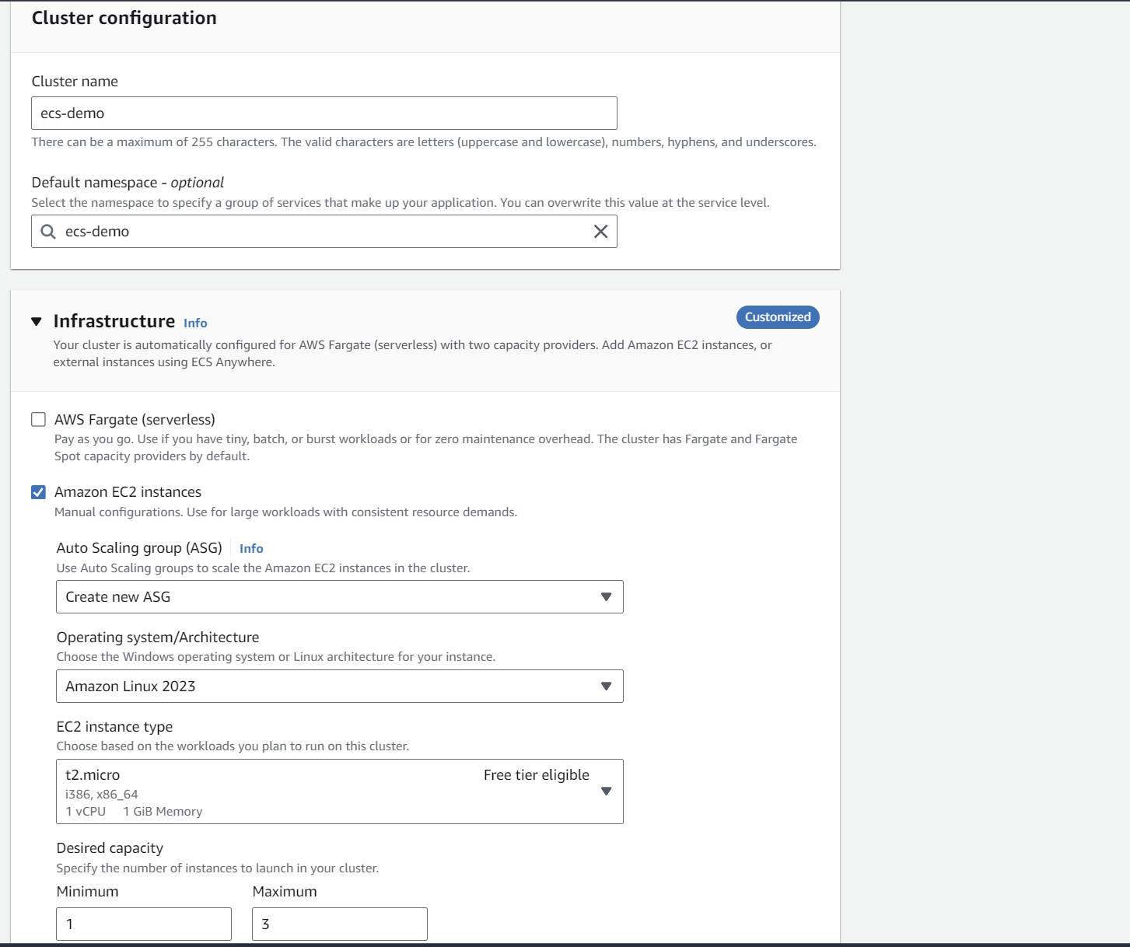

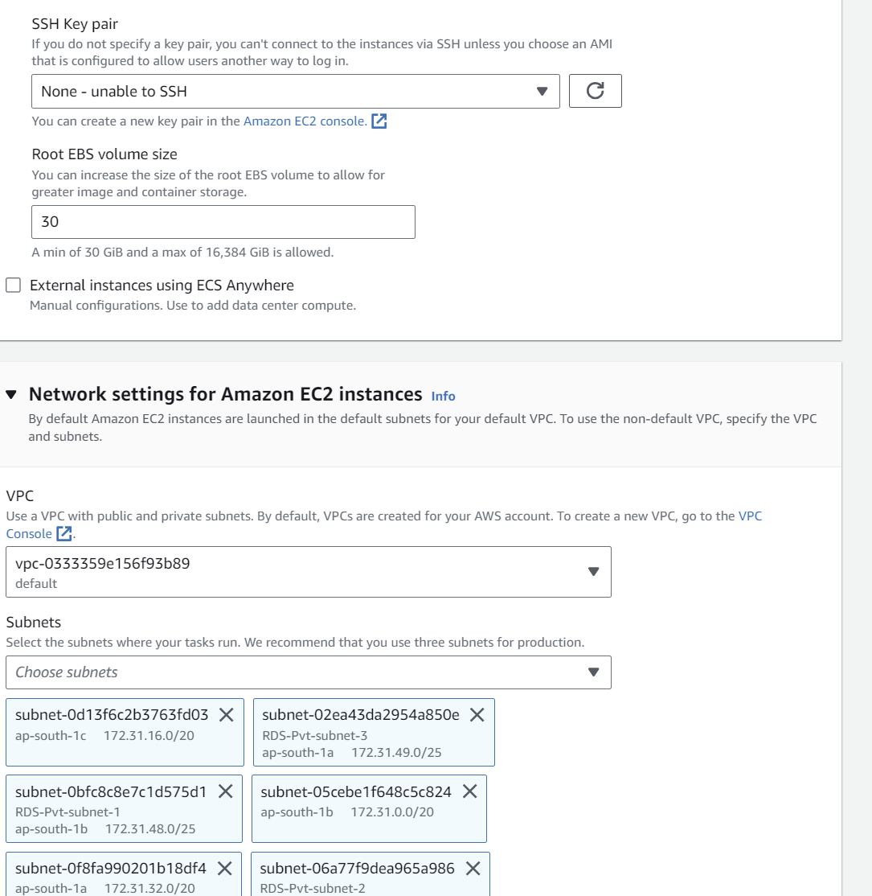

1. The “**ecs-demo**” cluster is created successfully

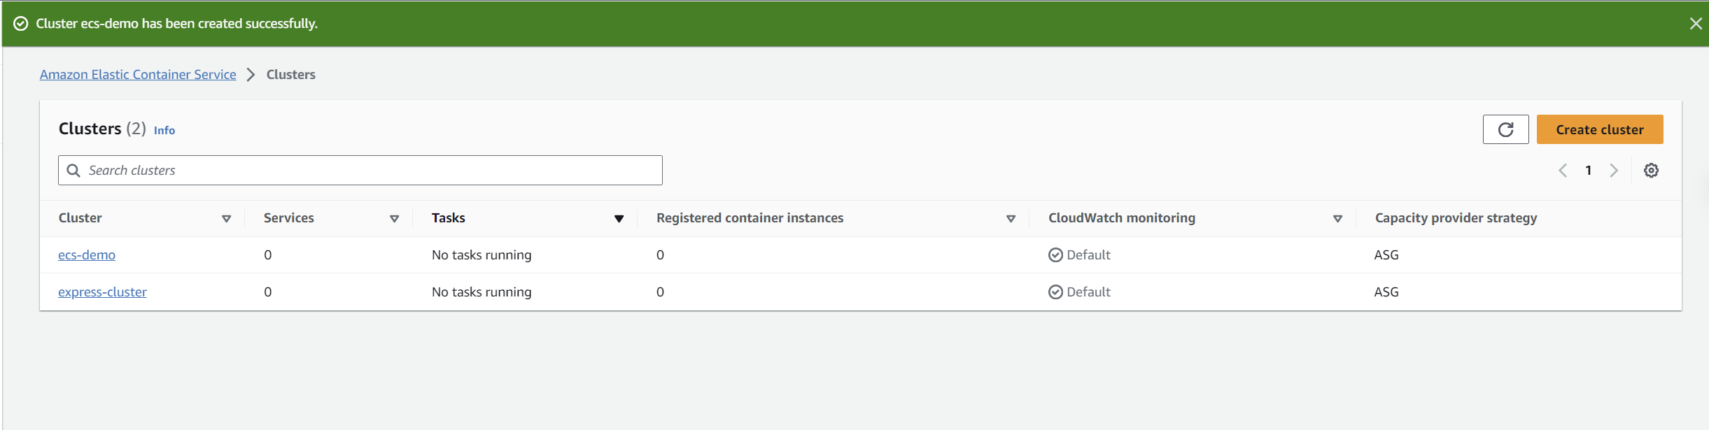

1. Go to EC2 and check whether the minimum number of instances that we gave(min 1)

are running or not.

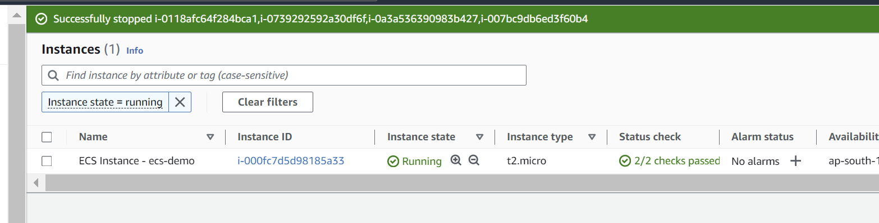

**Role Creation**

1. Go to IAM and create a new role. It will be used further while creating the task definitions

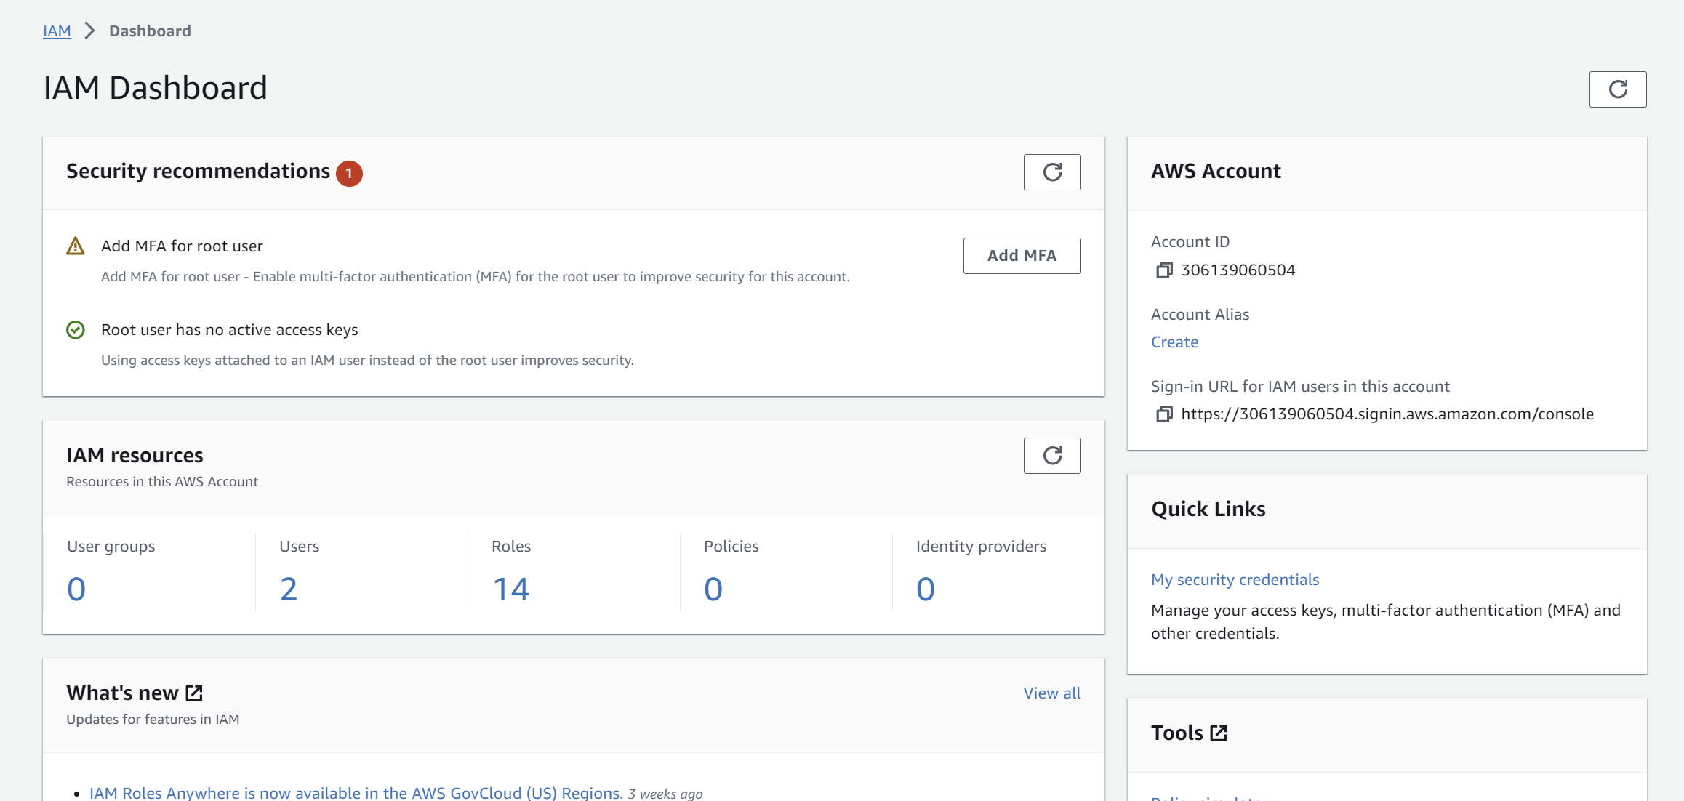

1. Choose the following options:

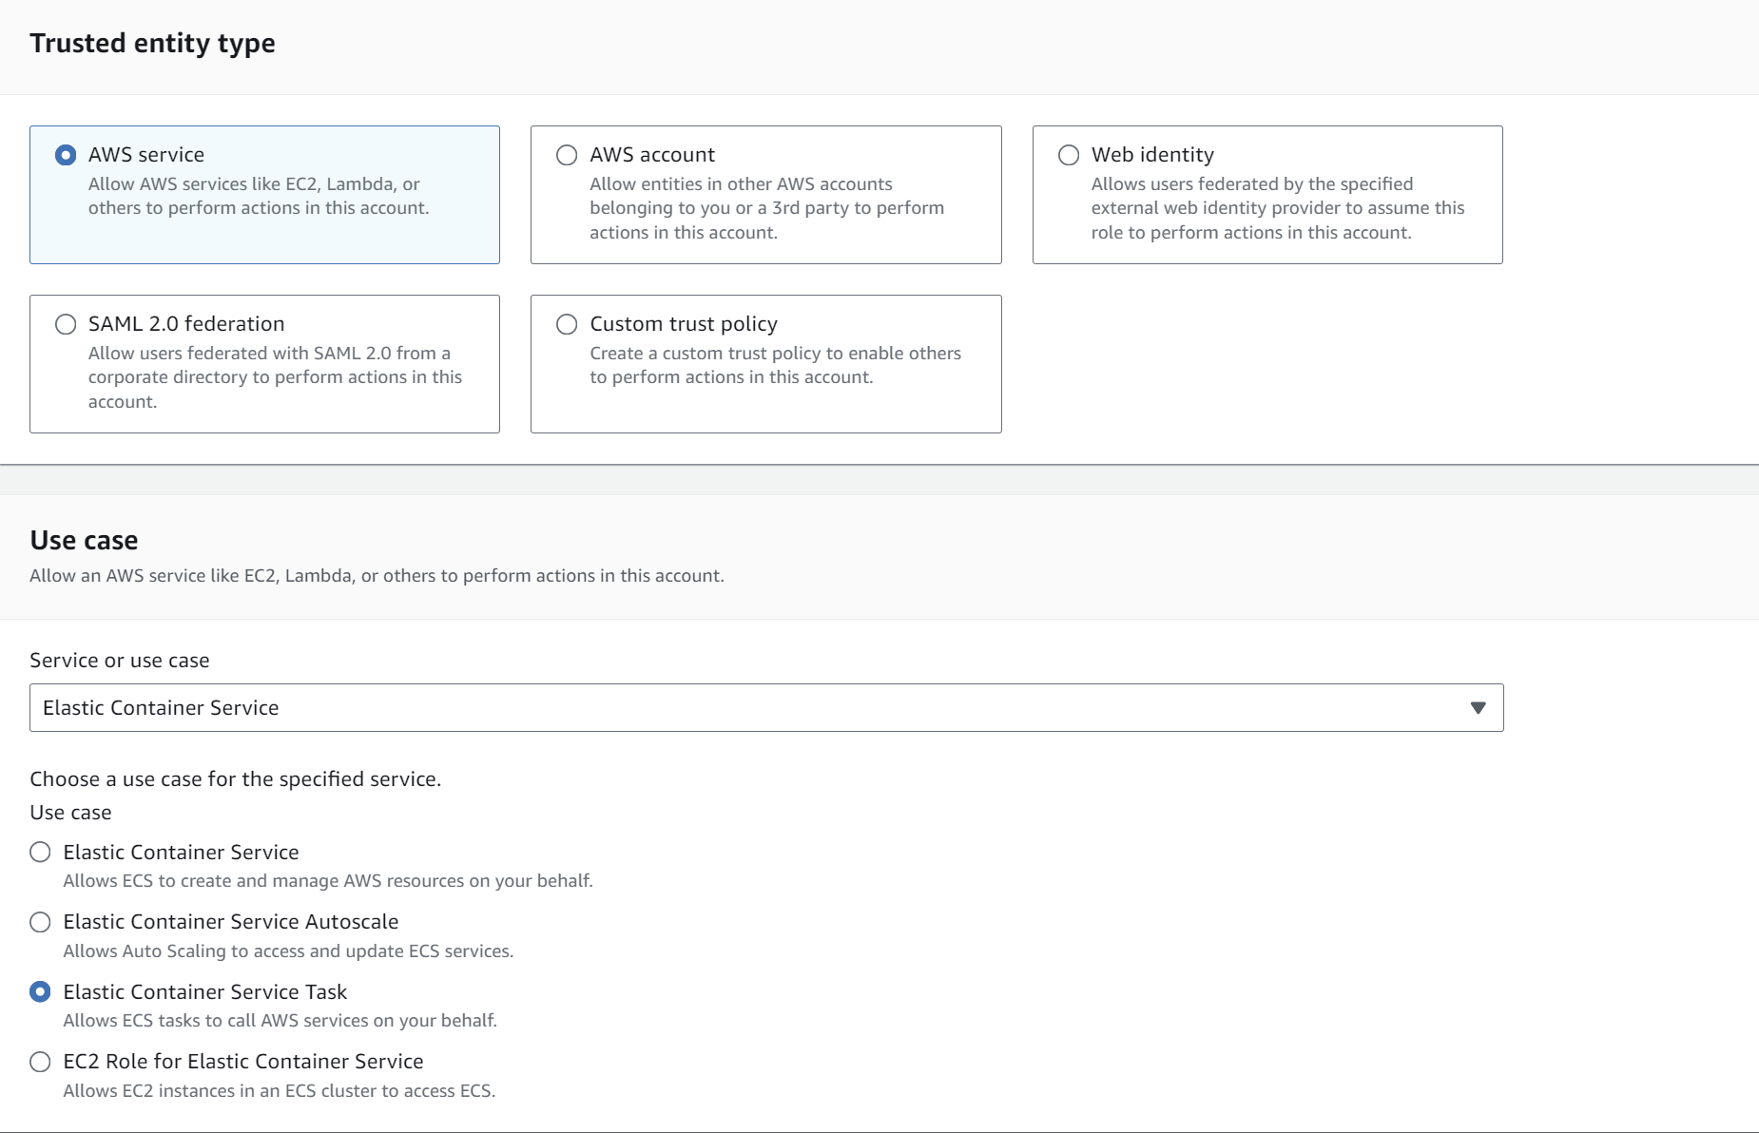

1. Add permissions and choose **“AmazonECSTaskExecutionRolePolicy**”

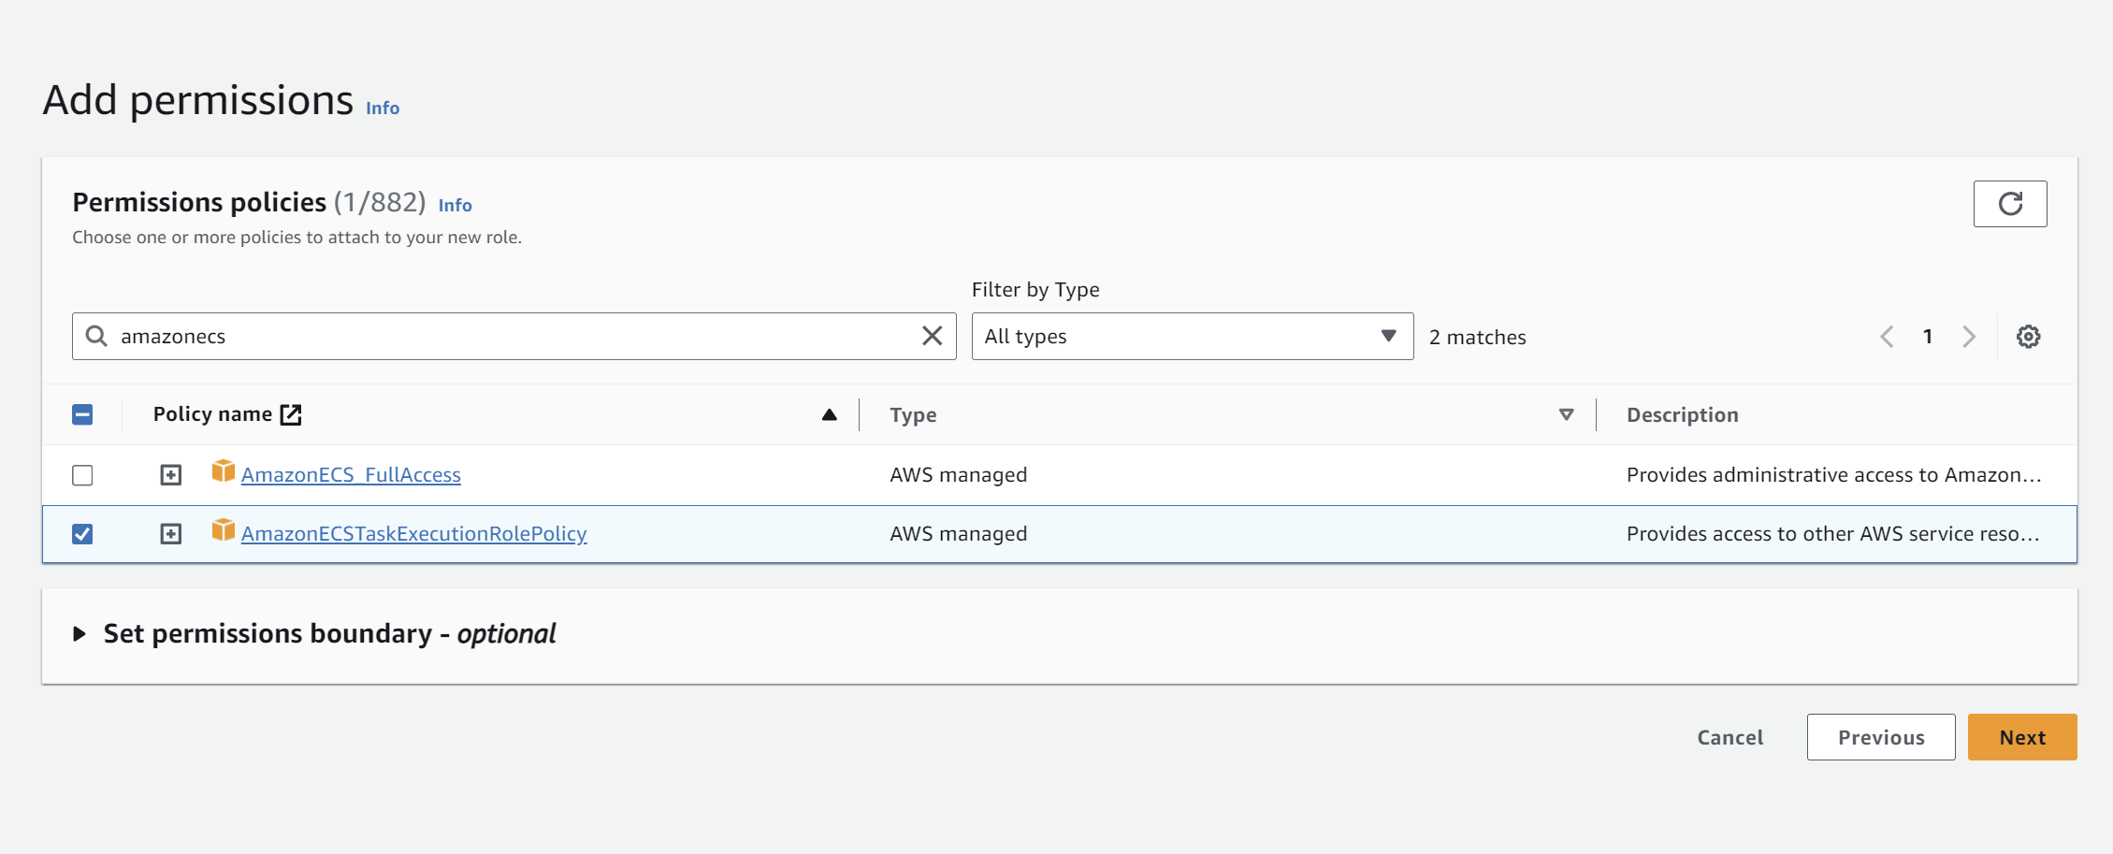

1. Click on next and fill the role name and proceed with “**Create role**”

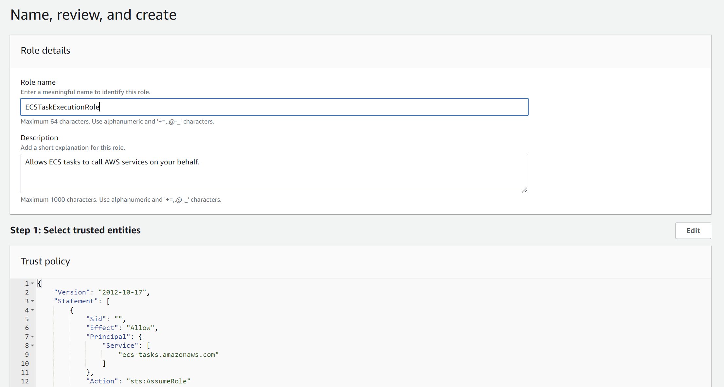

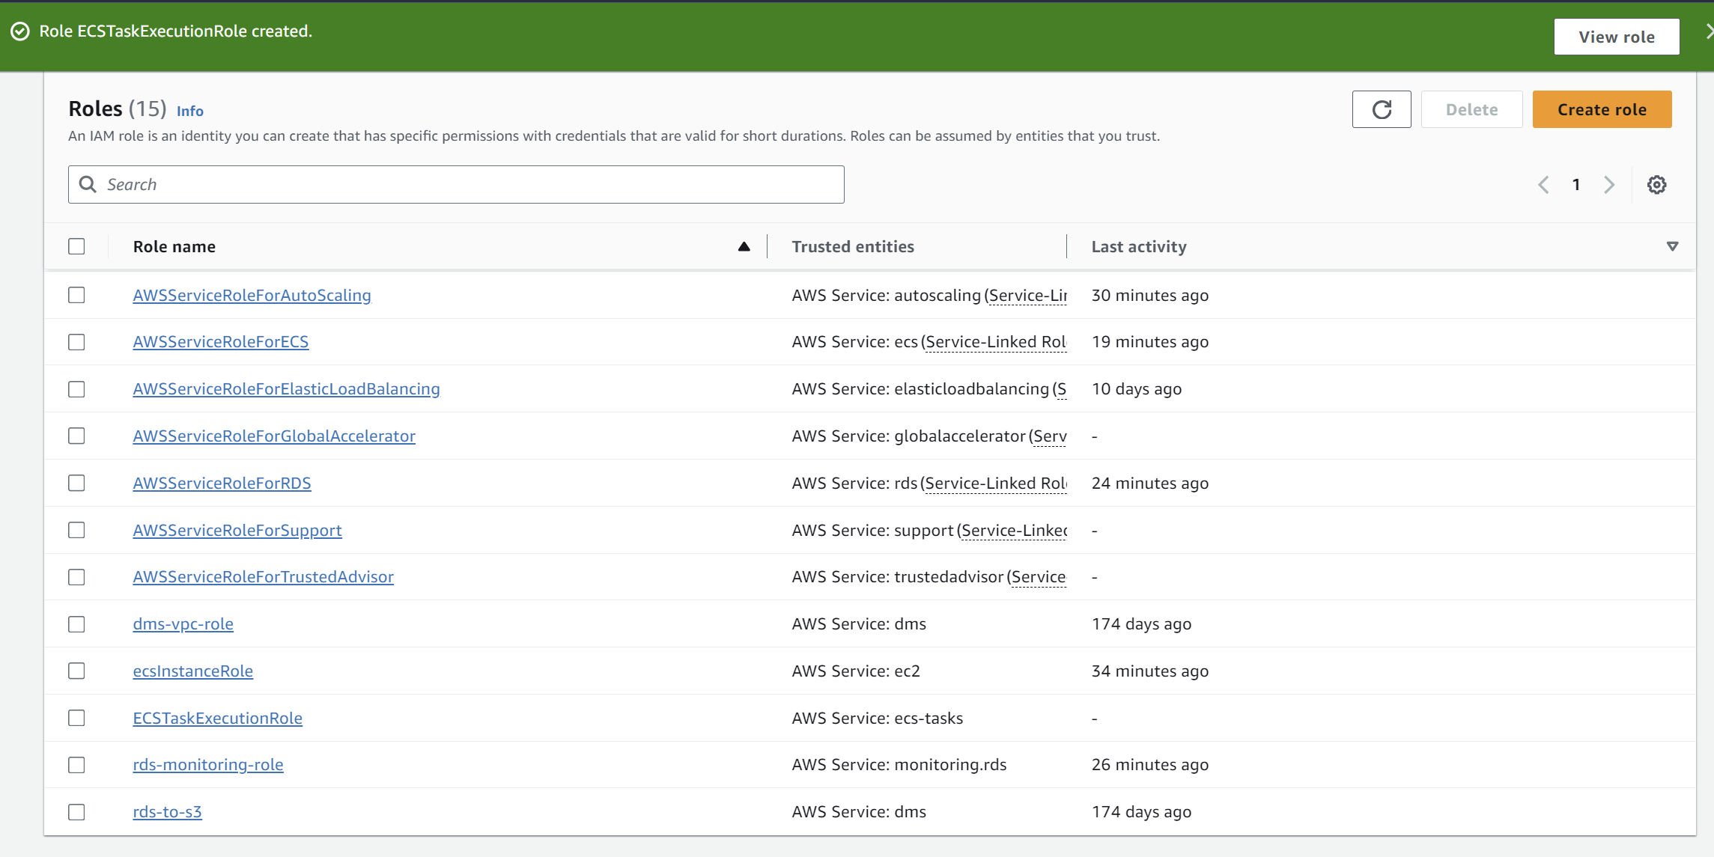

**Task Definition**

1. Firstly switch to the Old ECS Experience

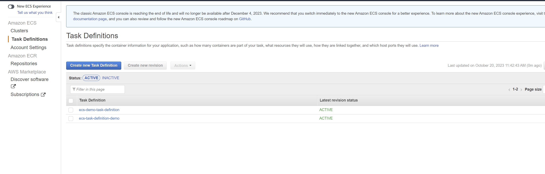

1. Go to ECS again, and go to **“Task definitions”.**
2. Click on **“Create new task definition”.**
3. Choose the “**EC2 ”** option.

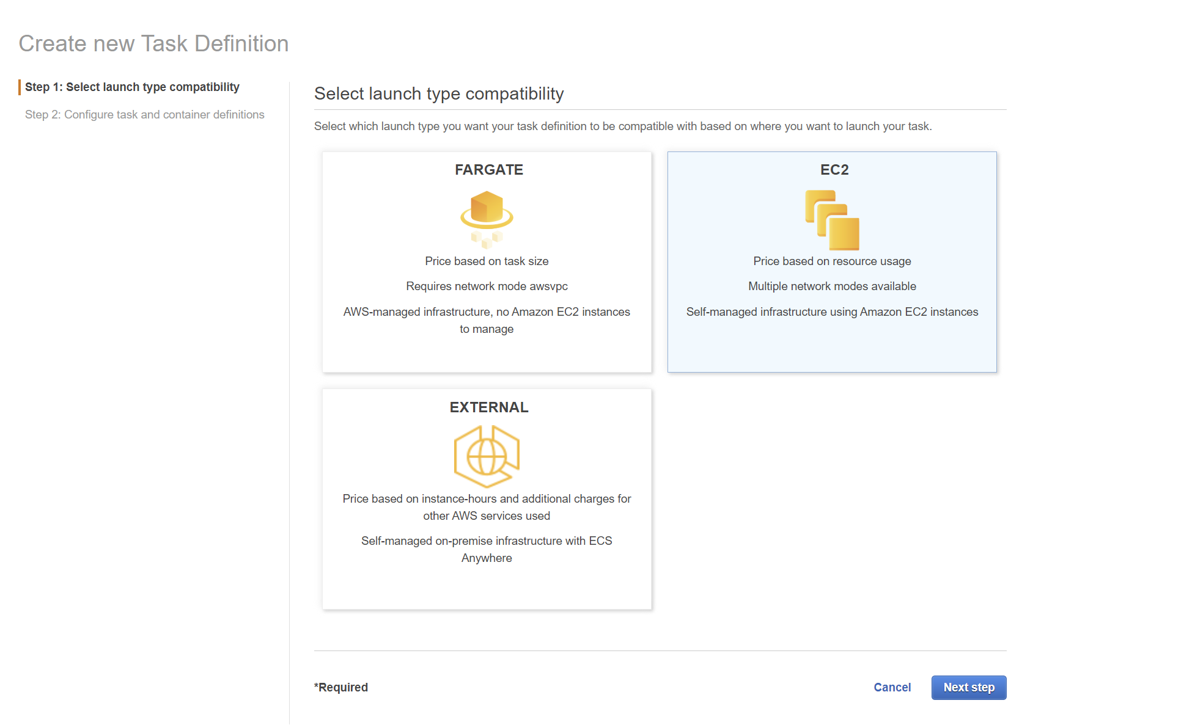

1. Now configure task and container definitions. Fill the task definition name, task role(attach the role you created earlier), select the network mode as bridge and proceed.

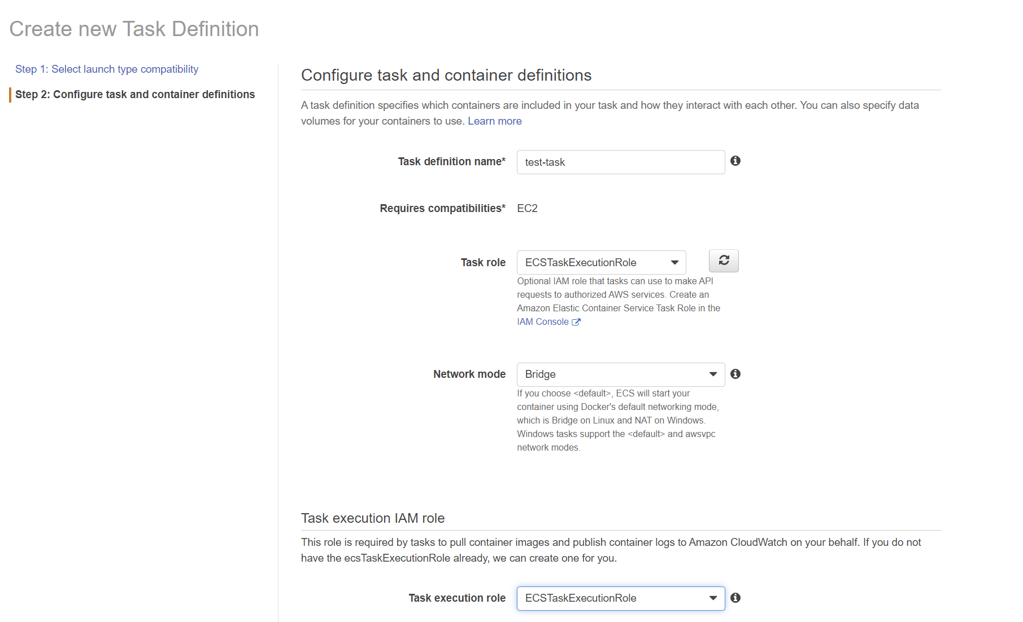

1. Fill the Task memory and Task CPU(unit).

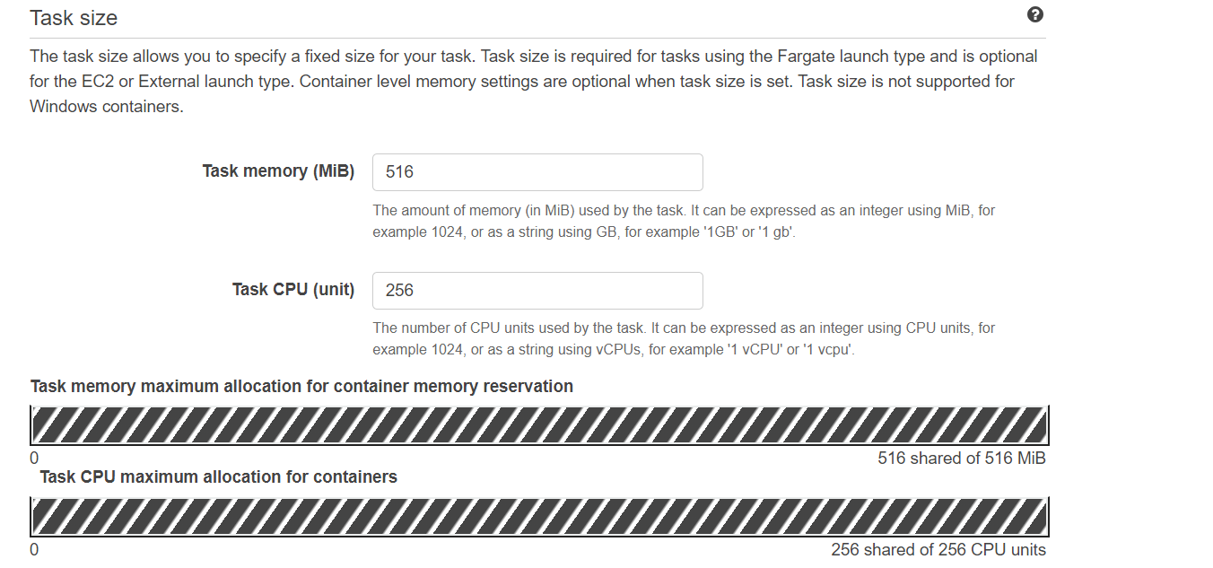

1. Add the container and copy the image URI(the image that you pushed to ecr) and all the necessary details. Assign the Host post as 8080 and Container port as 80.

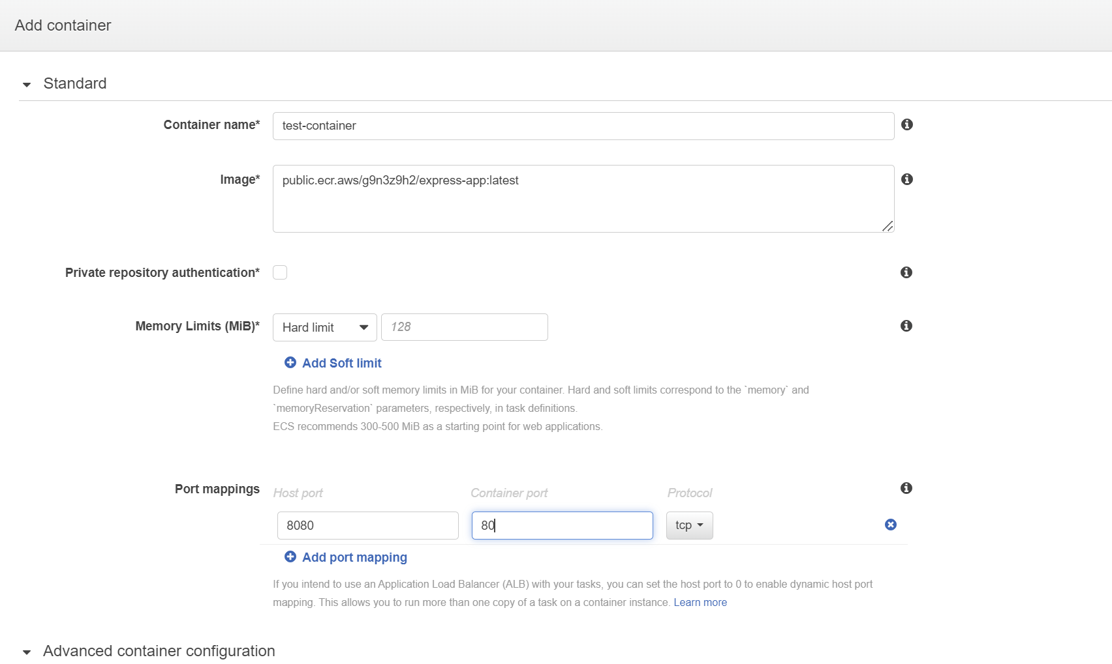

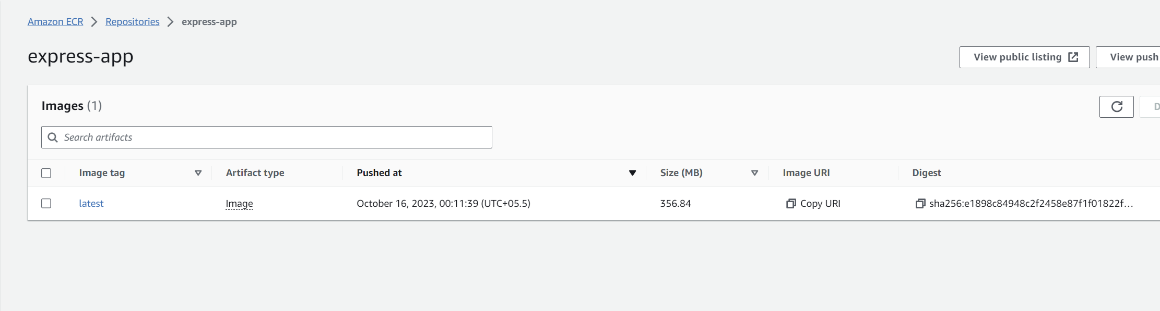

1. Task definition is created successfully.

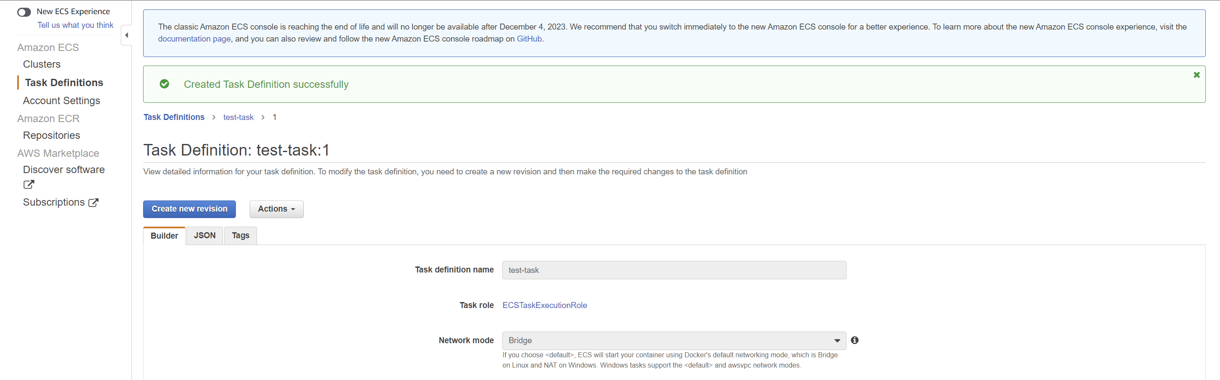

**Service Deployment**

1. Now go to the cluster and choose the “**Services**” tab and click on “**create**”

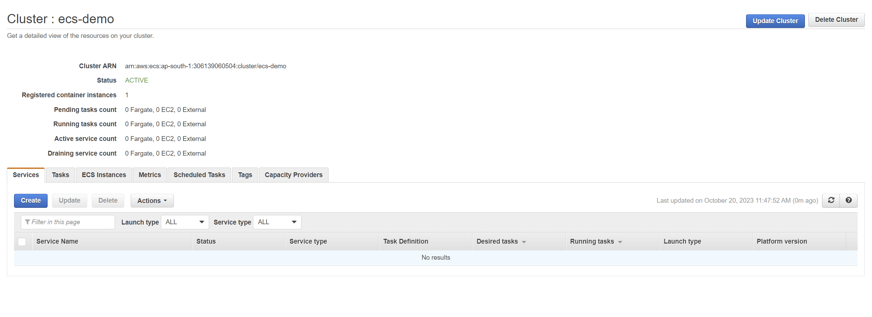

1. Choose the EC2 option and select the task definition that you just created.

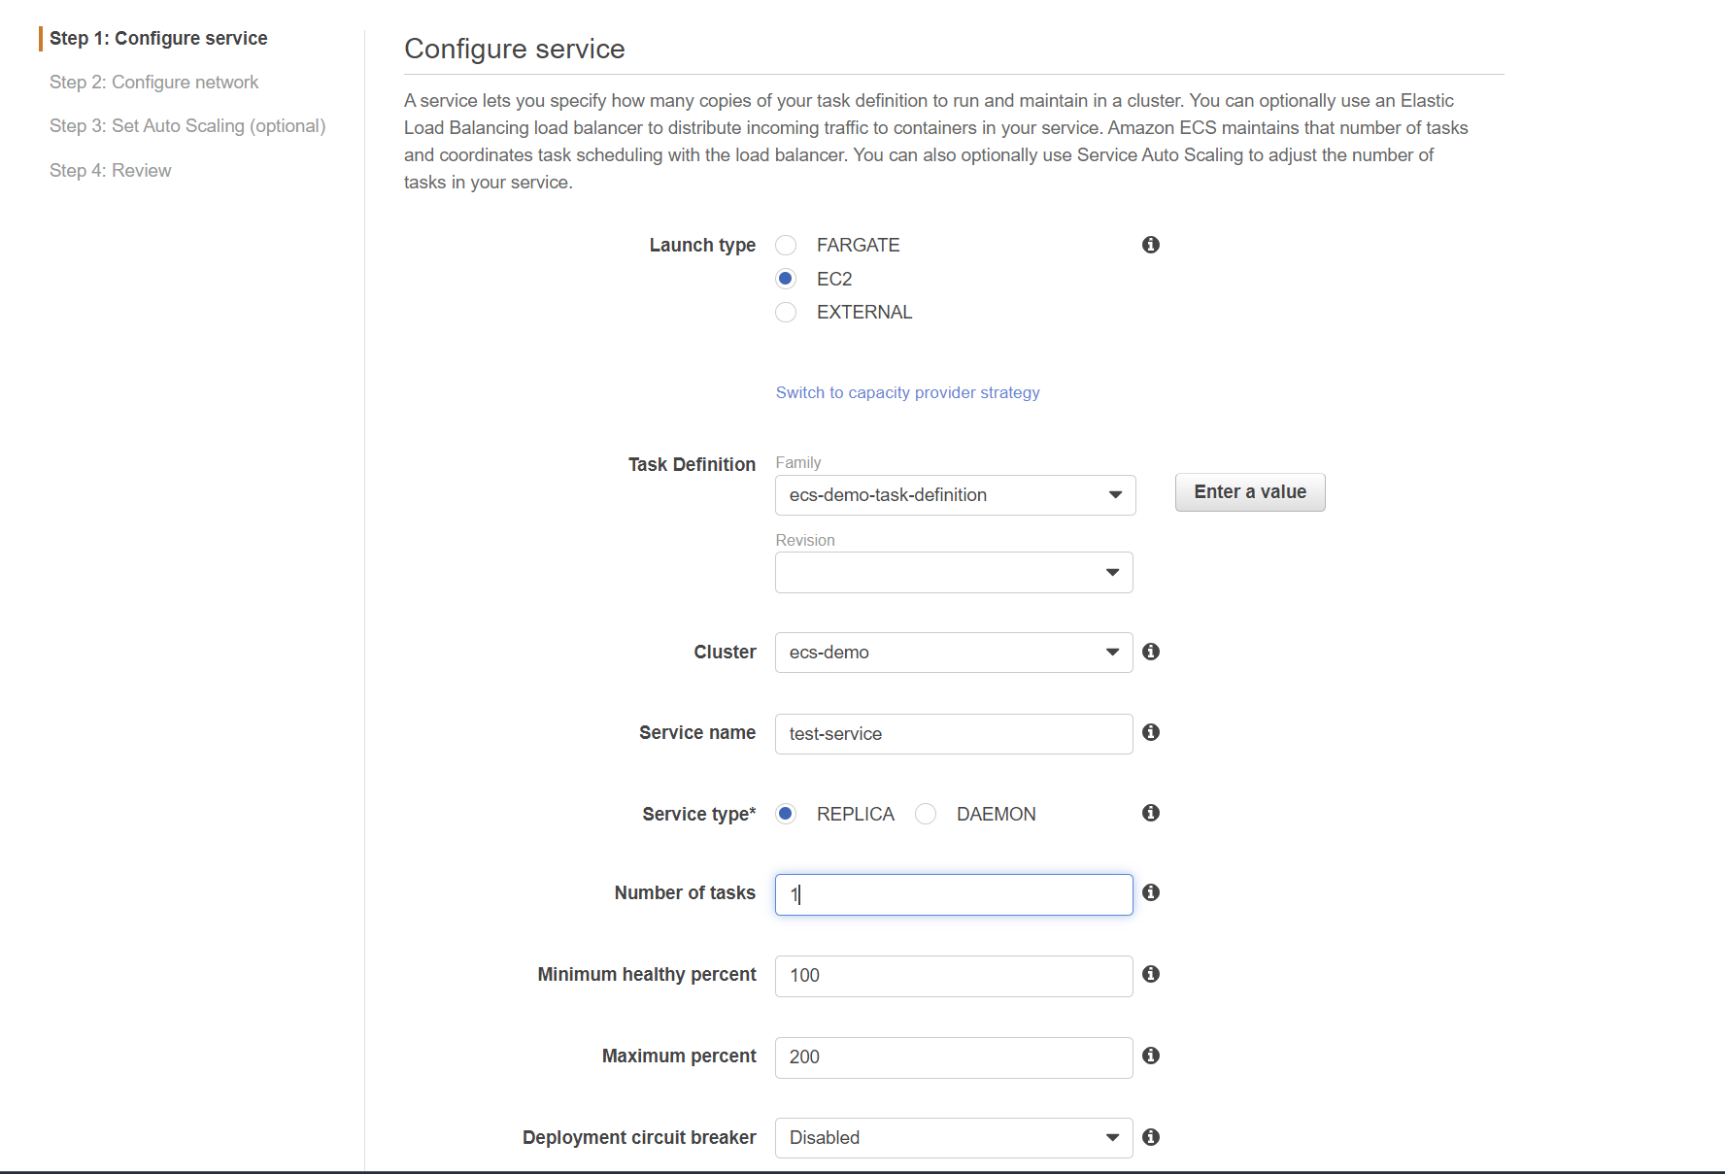

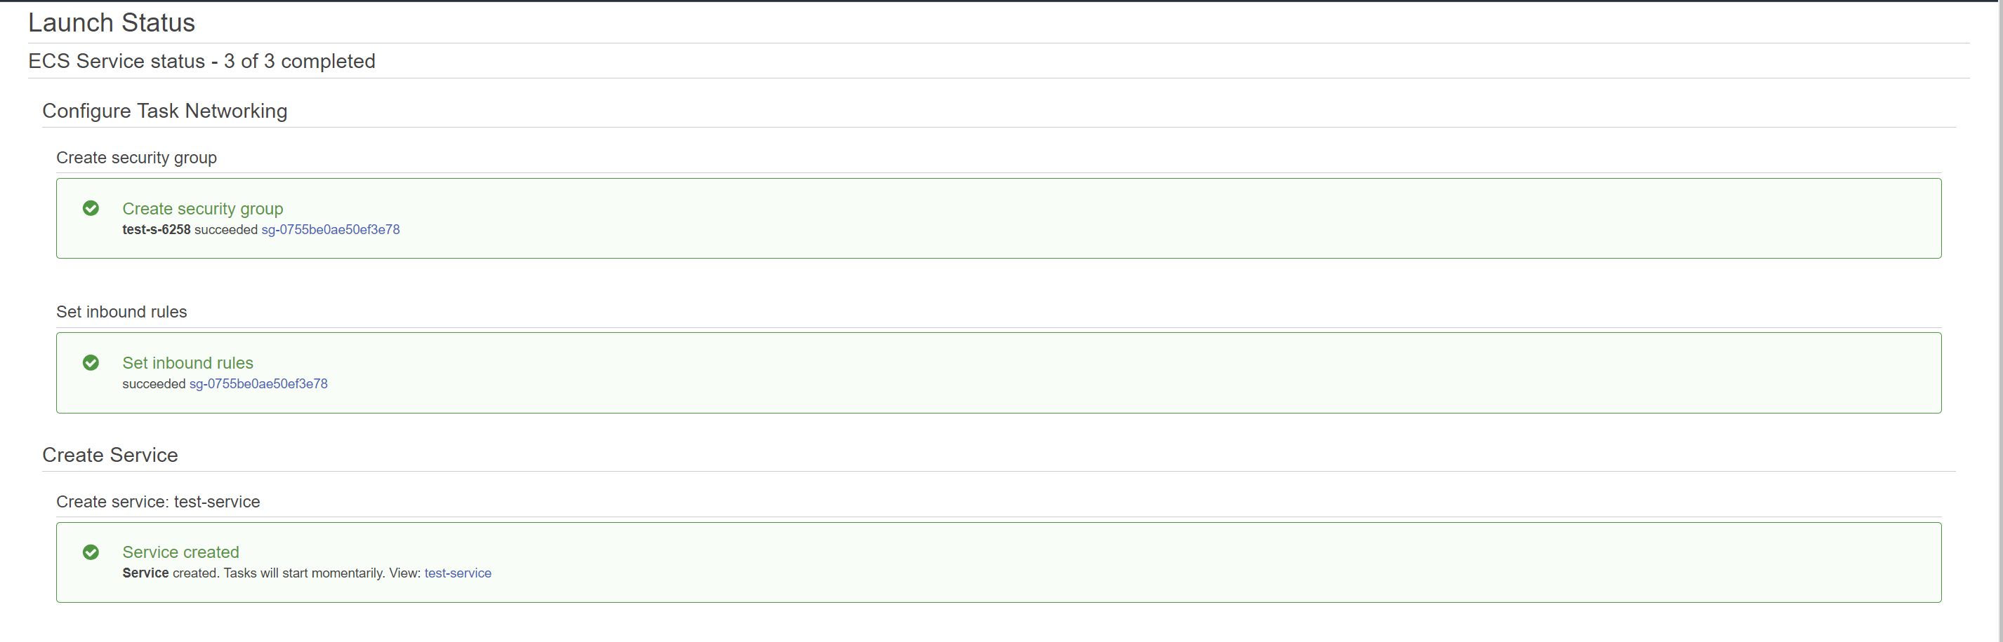

**Experiment-12:AWS EKS**

**Step-1:** Go to **IAM console** and create a user.

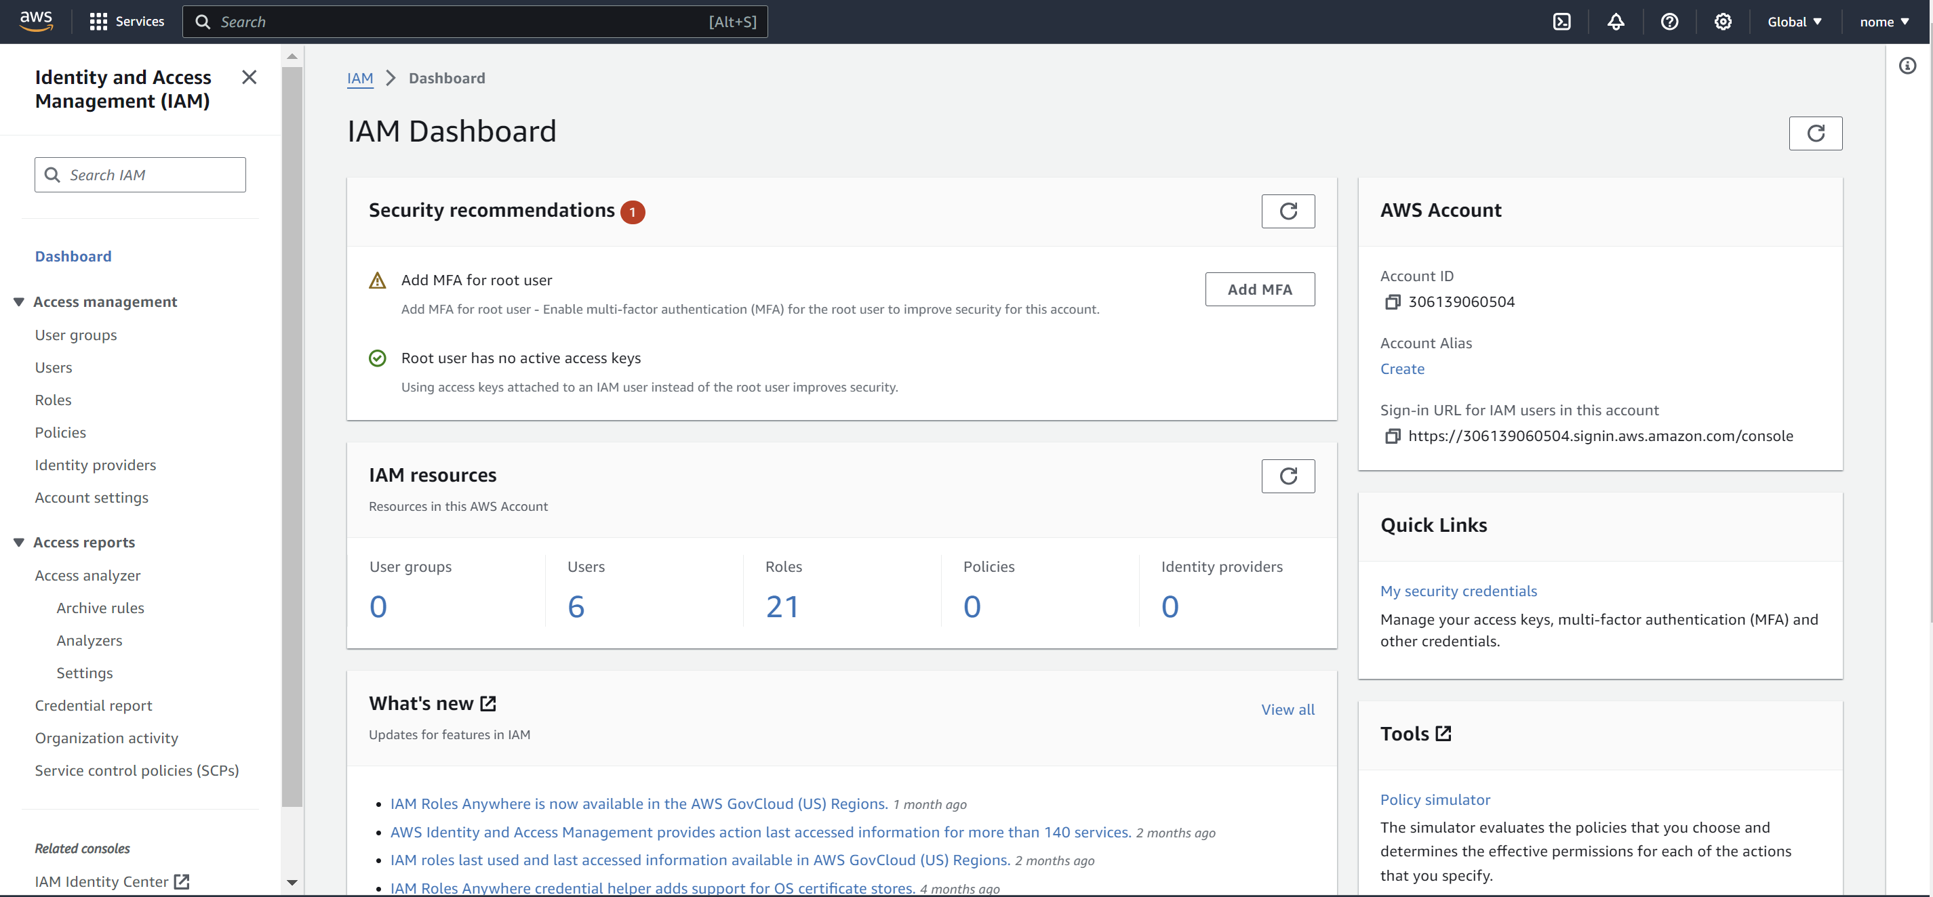

**Step-2:** Name the user.

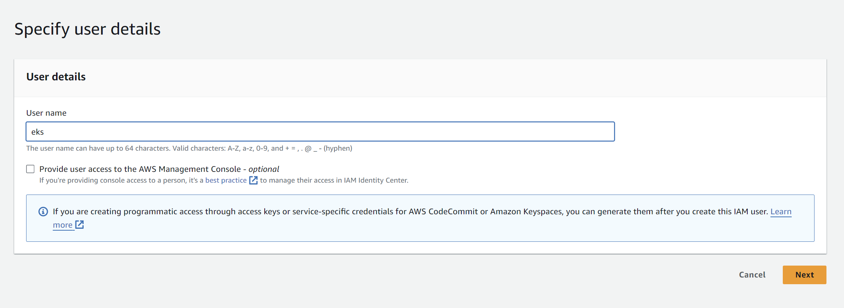

**Step-3:** Now click on the user that you just created. Here it is “**eks**”.

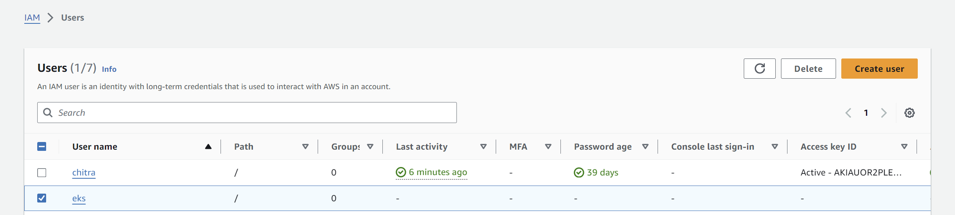

**Step-4:** Click on “**Create access key**”.

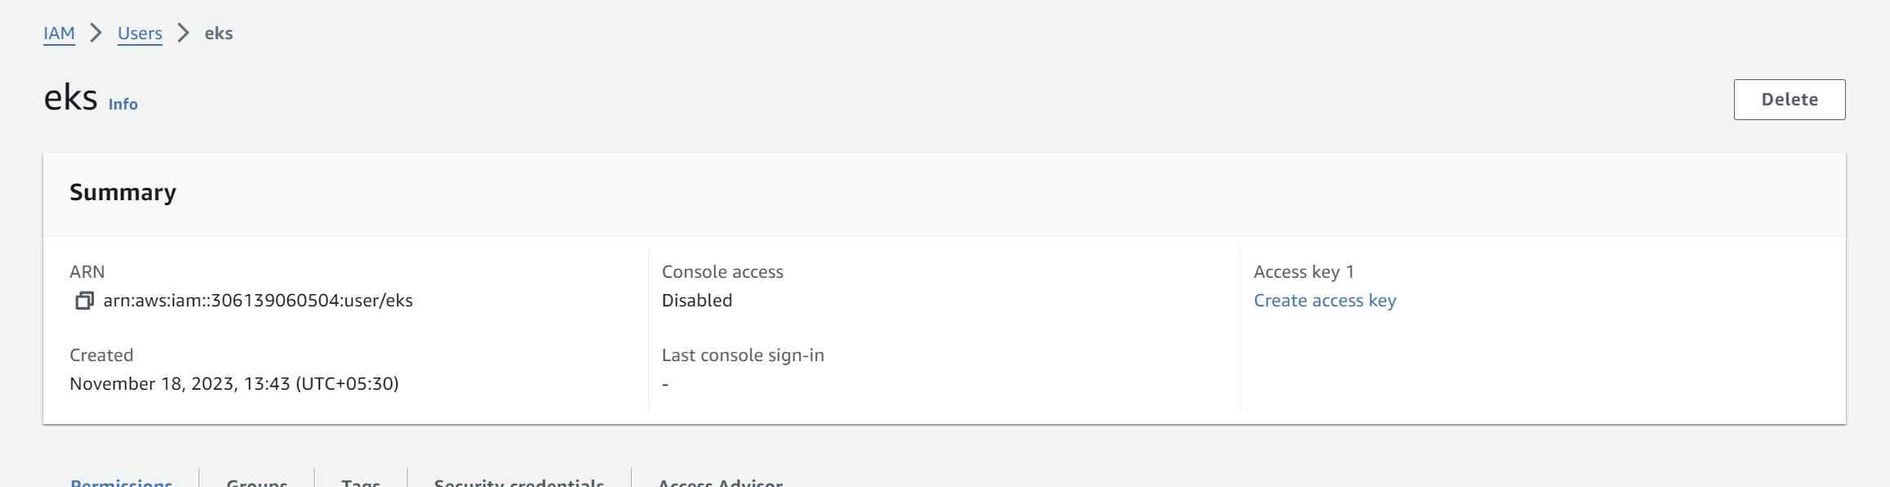

**Step-5:** Choose the option “**Other**” and click on next. Leave the other details as default.

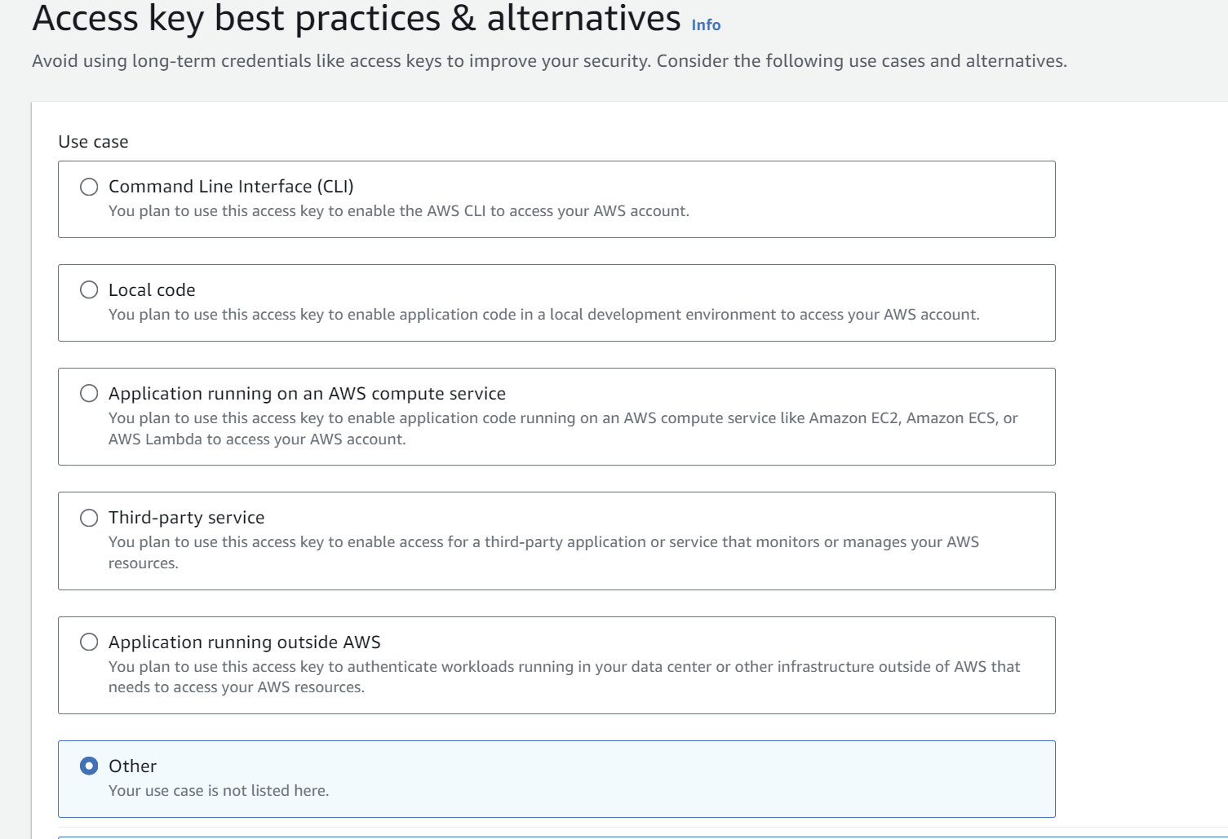

**Step-6:** Now copy the “**Access key**” and “**Secret Access Key**” and save it somewhere as it can’t be retrieved later.

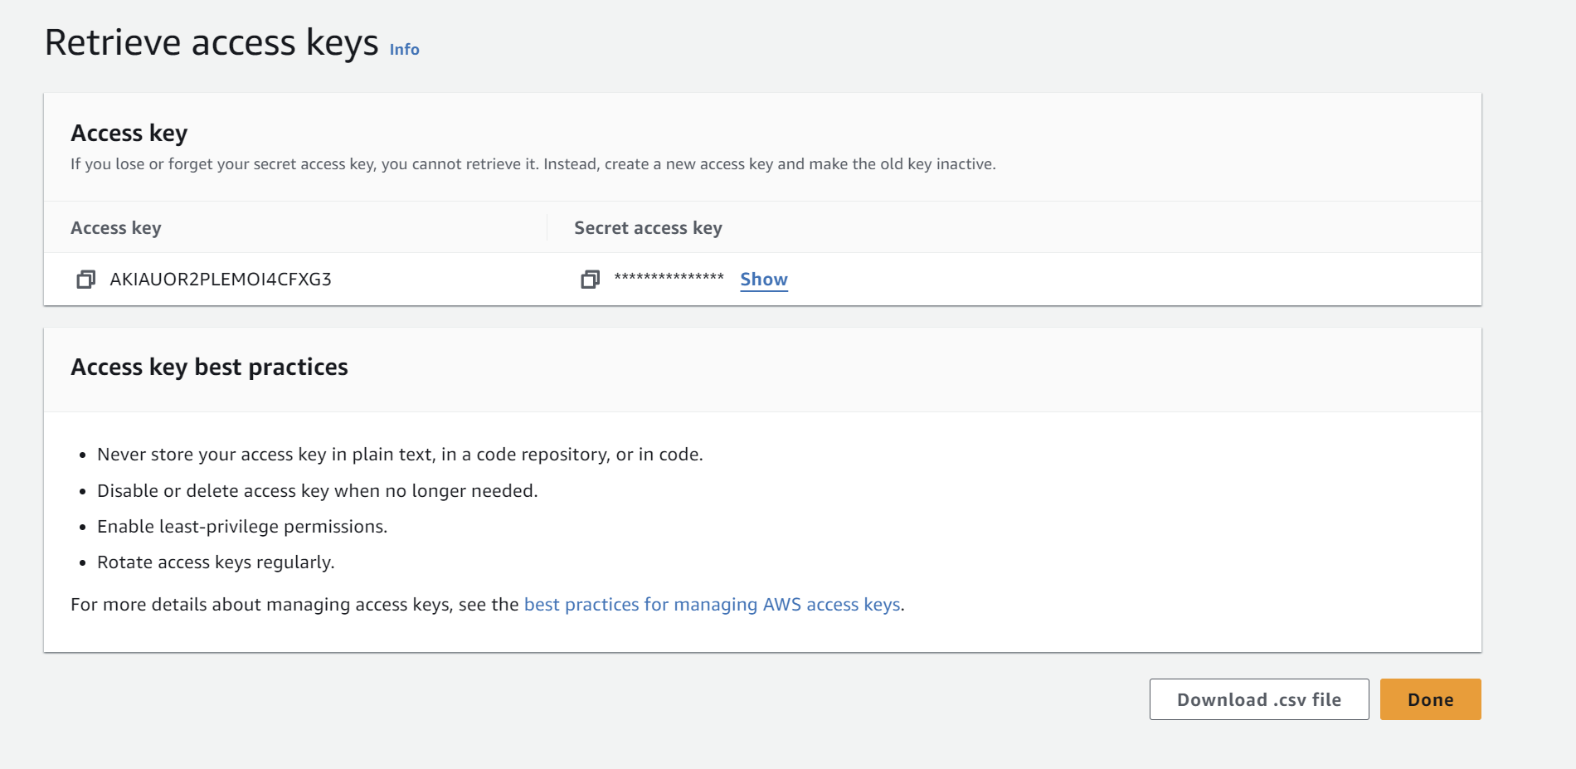

**Step-7:** Now go to “**Add Permissions**”.

**Note:** You can attach the policies while creating the user or after creating the user as well.

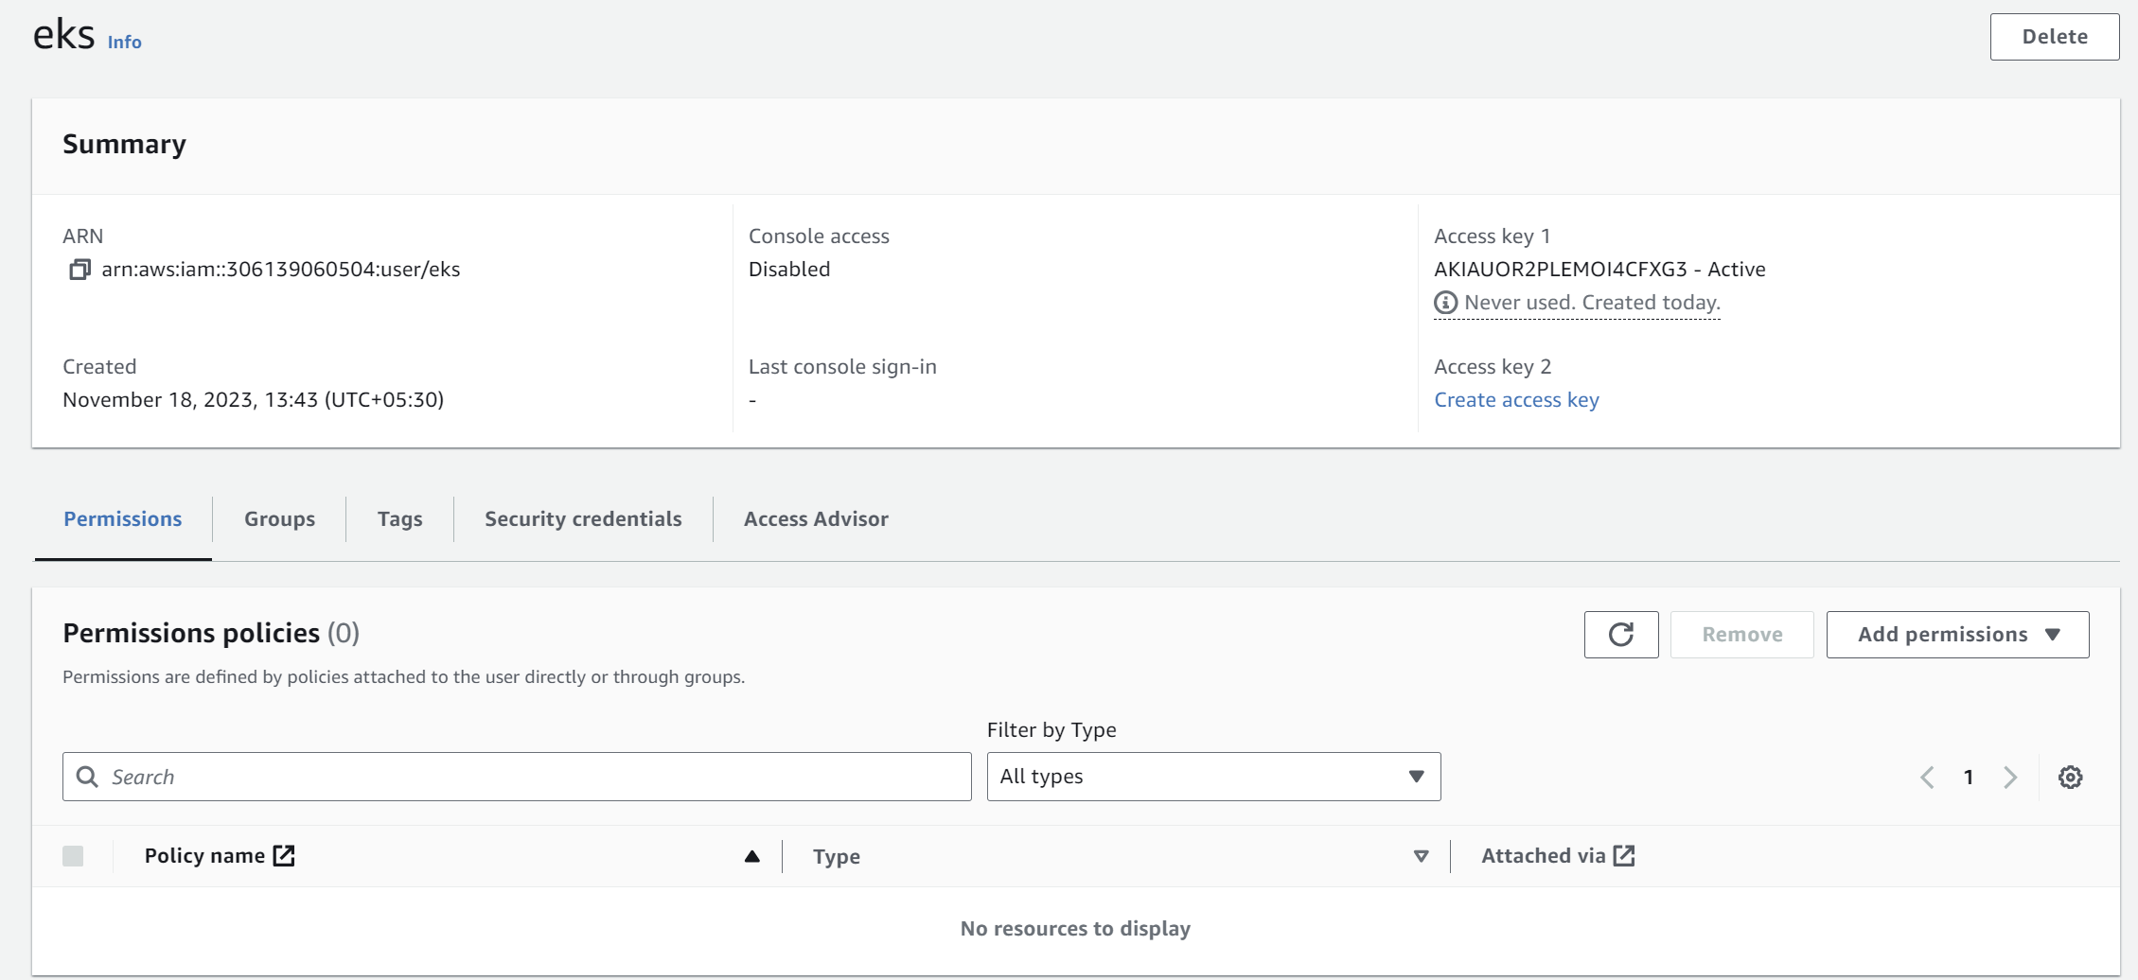

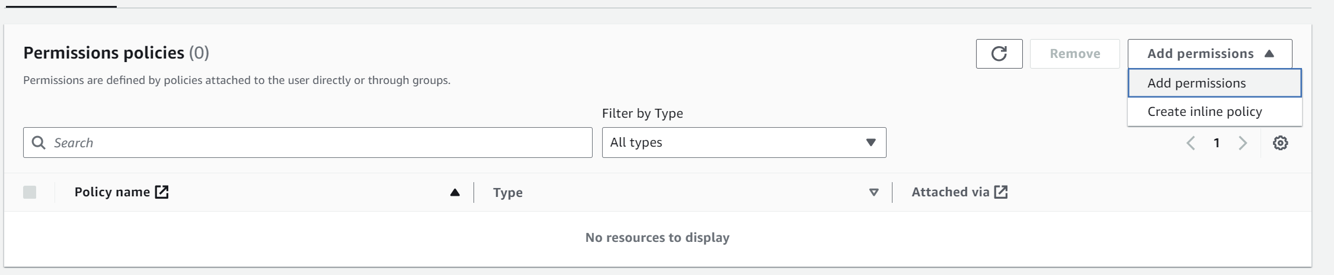

**Step-8:** Click on “Attach policies directly” and choose the following permissions and click on next and save them.

**AdministratorAccess**

**AmazonAPIGatewayAdministrator**

**AmazonEC2ContainerRegistryFullAccess**

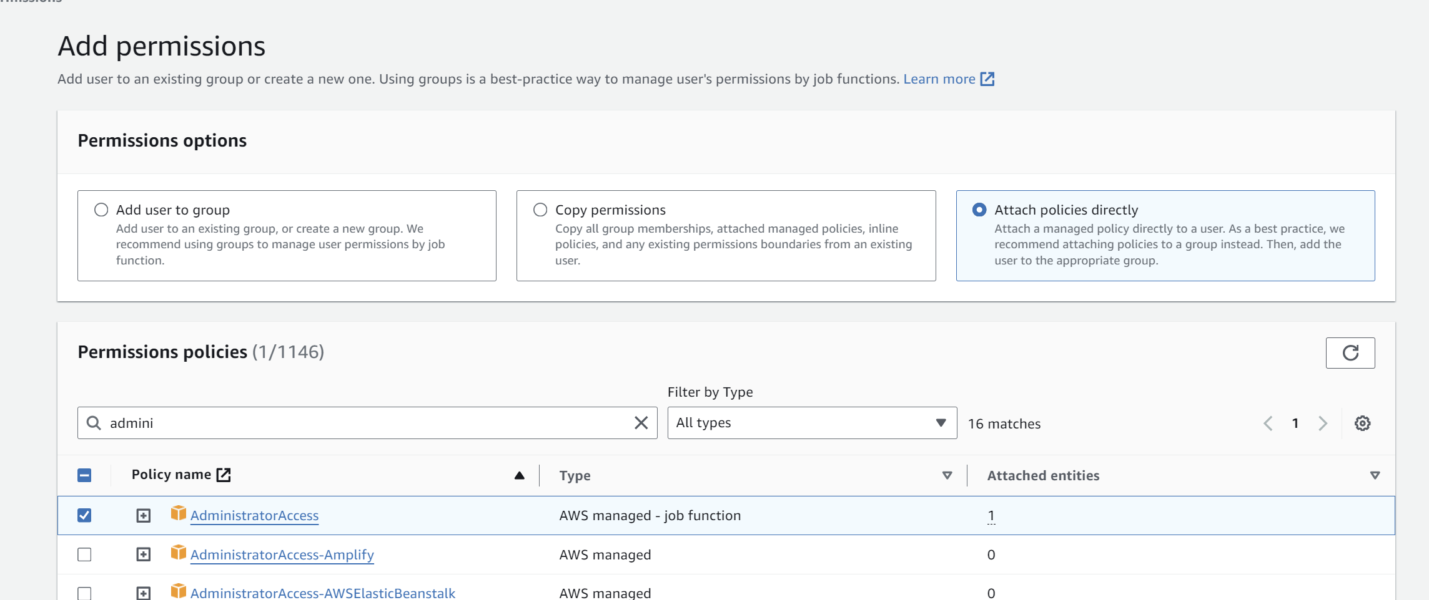

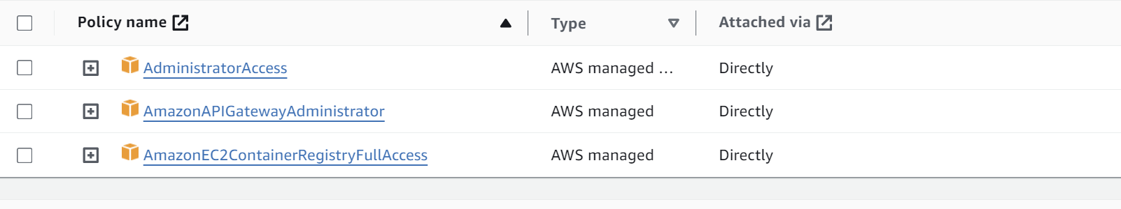

**Step-9:** Now go to AWS Console and search “**AWS Cloudshell**”.

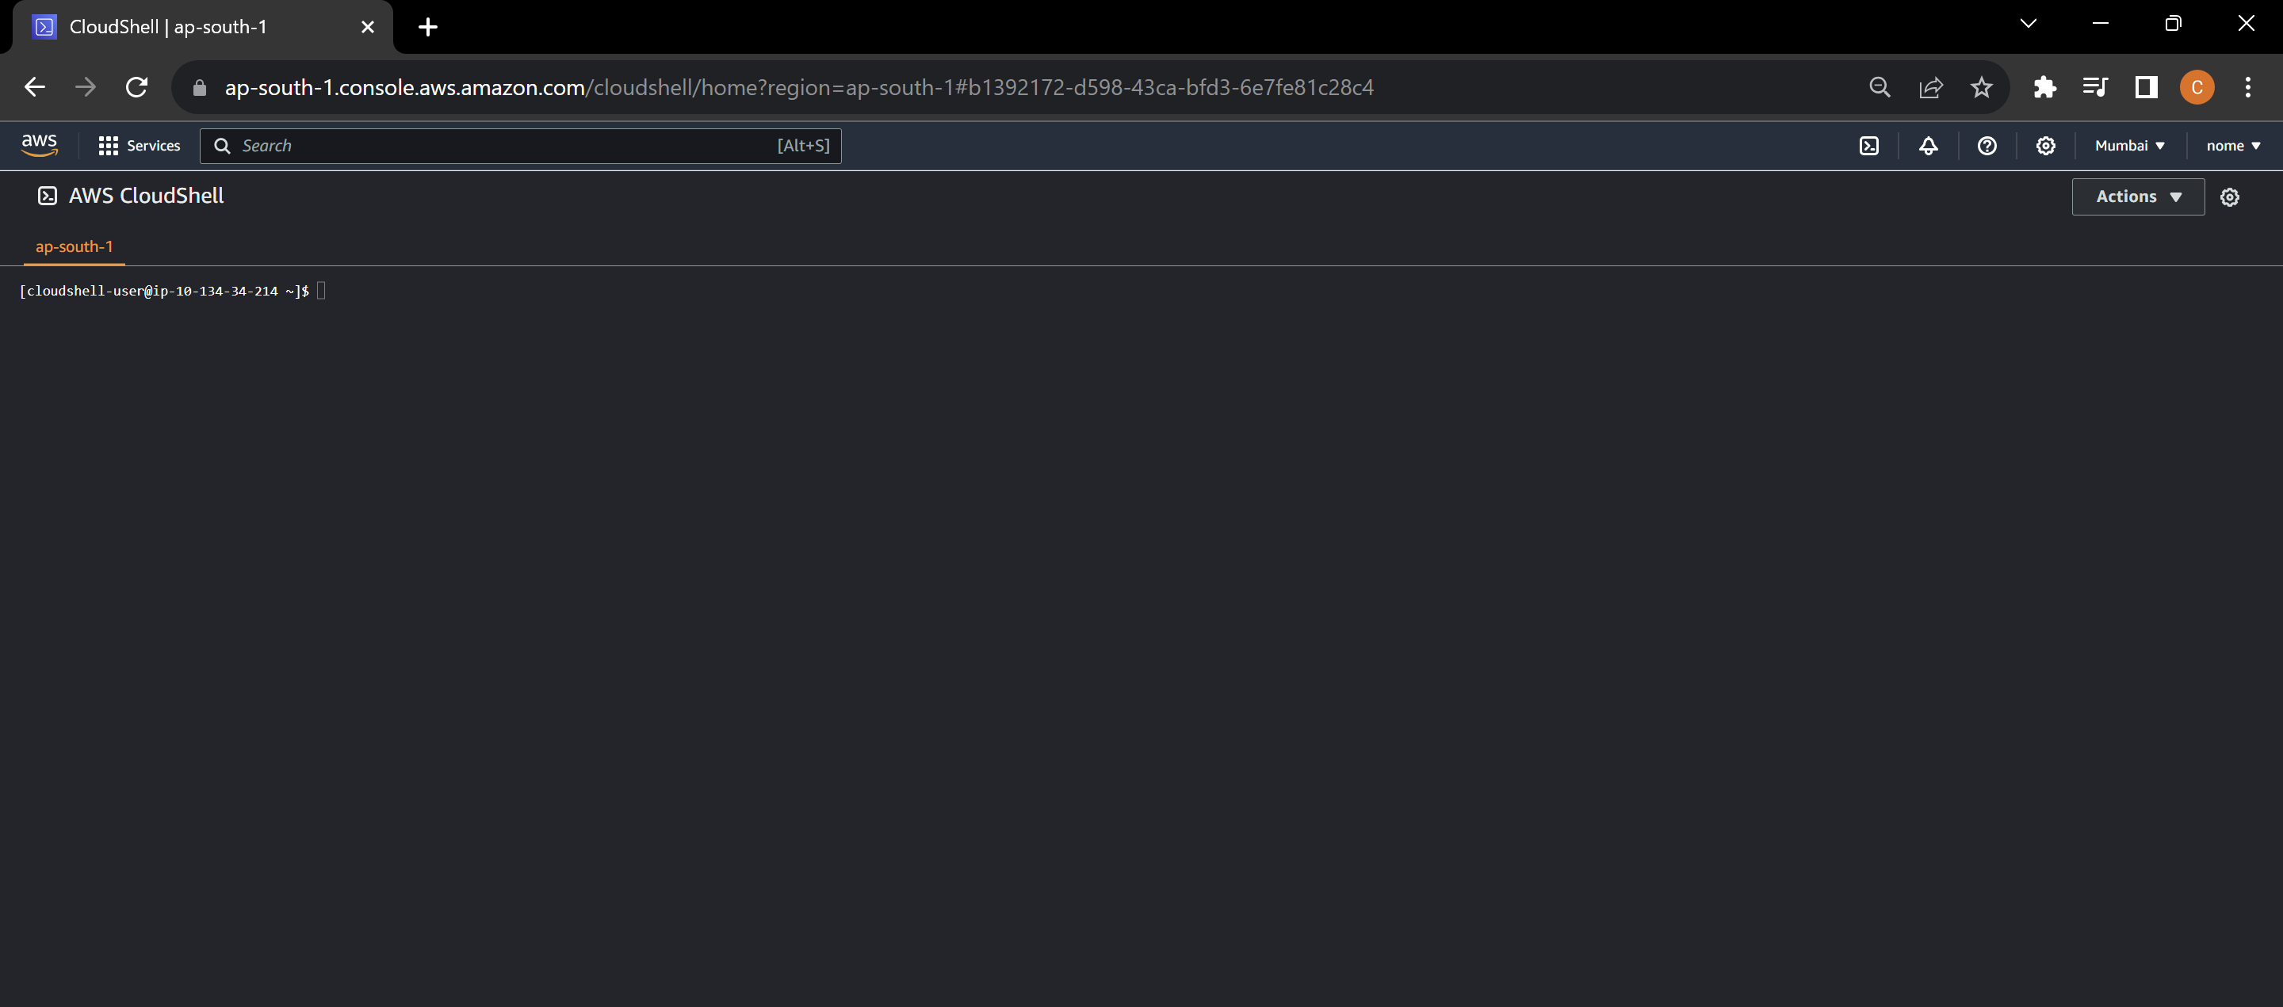

**Step-10:** First step is to configure AWS CLI. Write the command “**aws configure**”. After that provide the access key and secret access key that you have copied earlier. Write your region and the format. Keep the format in “**json**” for example.

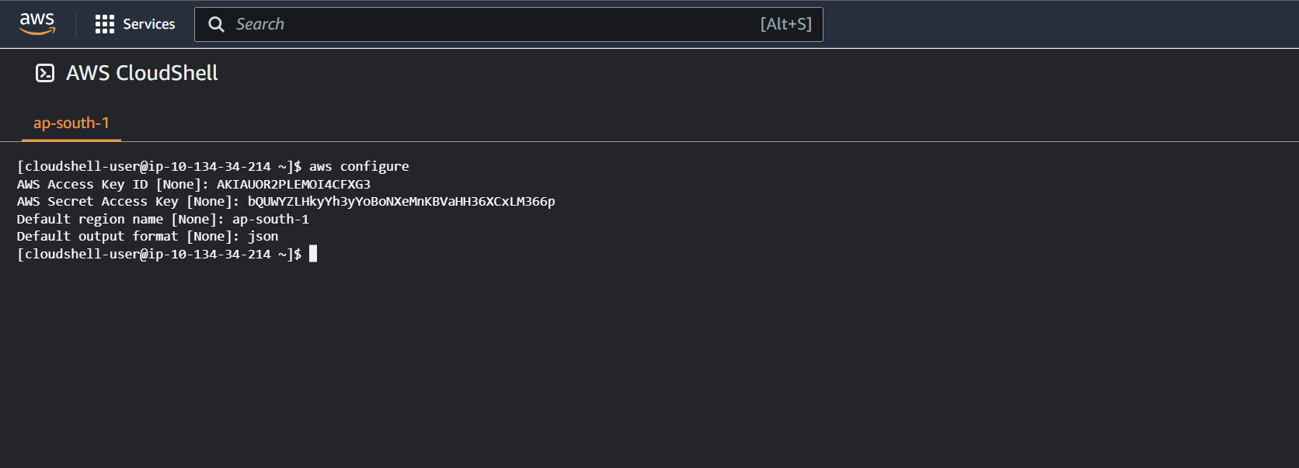

**Installing the required tools**

**Step-11:** Now install **kubectl** using the following command:

curl -LO [https://dl.k8s.io/release/$(curl -L -s https://dl.k8s.io/release/stable.txt)/bin/linux/amd64/kubectl](https://dl.k8s.io/release/$(curl%20-L%20-s%20https://dl.k8s.io/release/stable.txt)/bin/linux/amd64/kubectl)

* **kubectl is the command-line tool used to interact with Kubernetes clusters**.

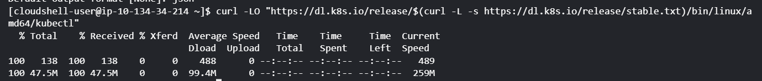

**Step-12:** After the installation is complete, run the following command:

sudo install -o root -g root -m 0755 kubectl /usr/local/bin/kubectl

* **This command is installing the kubectl binary into the /usr/local/bin directory with root ownership and executable permissions, allowing users to run kubectl commands globally on the system.**



**Step-13:** In order to install the “**eksctl**” command line tool, we need to create a script. Create a file called “**eksctl.sh**” using vim or nano or any other test editor.

vim eksctl.sh

* eksctl is a command-line utility for creating, managing, and interacting with Amazon Elastic Kubernetes Service (EKS) clusters.



**Step-14:** Now in order to insert text, press **“I”** and then copy the below given commands inside it.

ARCH=amd64PLATFORM=$(uname -s)_$ARCHcurl -sLO "https://github.com/weaveworks/eksctl/releases/latest/download/eksctl_$PLATFORM.tar.gz"# (Optional) Verify checksumcurl -sL "https://github.com/weaveworks/eksctl/releases/latest/download/eksctl_checksums.txt" | grep $PLATFORM | sha256sum --checktar -xzf eksctl_$PLATFORM.tar.gz -C /tmp && rm eksctl_$PLATFORM.tar.gzsudo mv /tmp/eksctl /usr/local/bin

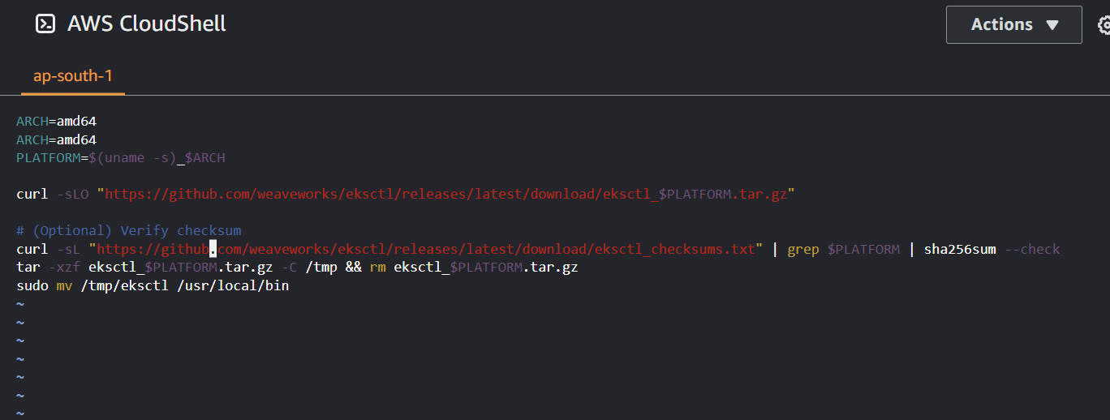

**Step-15:** Run the below commands:

chmod +x eksctl.sh

sudo sh eksctl.sh

* The command **chmod +x eksctl.sh** is used to grant execute permissions (+x) to the file named eksctl.sh.
* The command **sudo sh eksctl.sh** is attempting to run the script named **eksctl.sh** that we created.

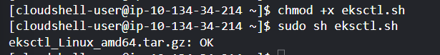

**Creating an EKS Cluster**

**Step-16:** Now create a new Amazon EKS cluster using the `**eksctl**` command:

eksctl create cluster --name my-eks-cluster --region ap-south-1 --nodegroup-name my-nodegroup --node-type t2.small --nodes 3 --nodes-min 1 --nodes-max 5 –managed

* The **eksctl create cluster** command is creating an Amazon EKS cluster named "**my-eks-cluster**" in the **Asia Pacific (Mumbai) region** with a managed node group named "**my-nodegroup**," using **t2.small** instances with a **desired** count of **3 nodes**, a **minimum** of **1 node**, and a **maximum** of 5 nodes.

**Note:** Make sure to change the region name to your specific region in the command portion that is highlighted.

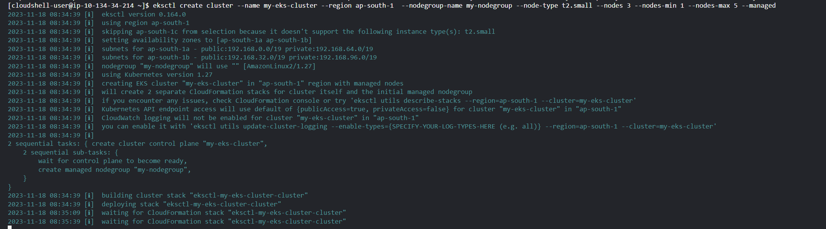

**Step-17:** Now after the creation is complete in the above step, go to **AWS console** and search **“EKS”.** You can see that the cluster is created.

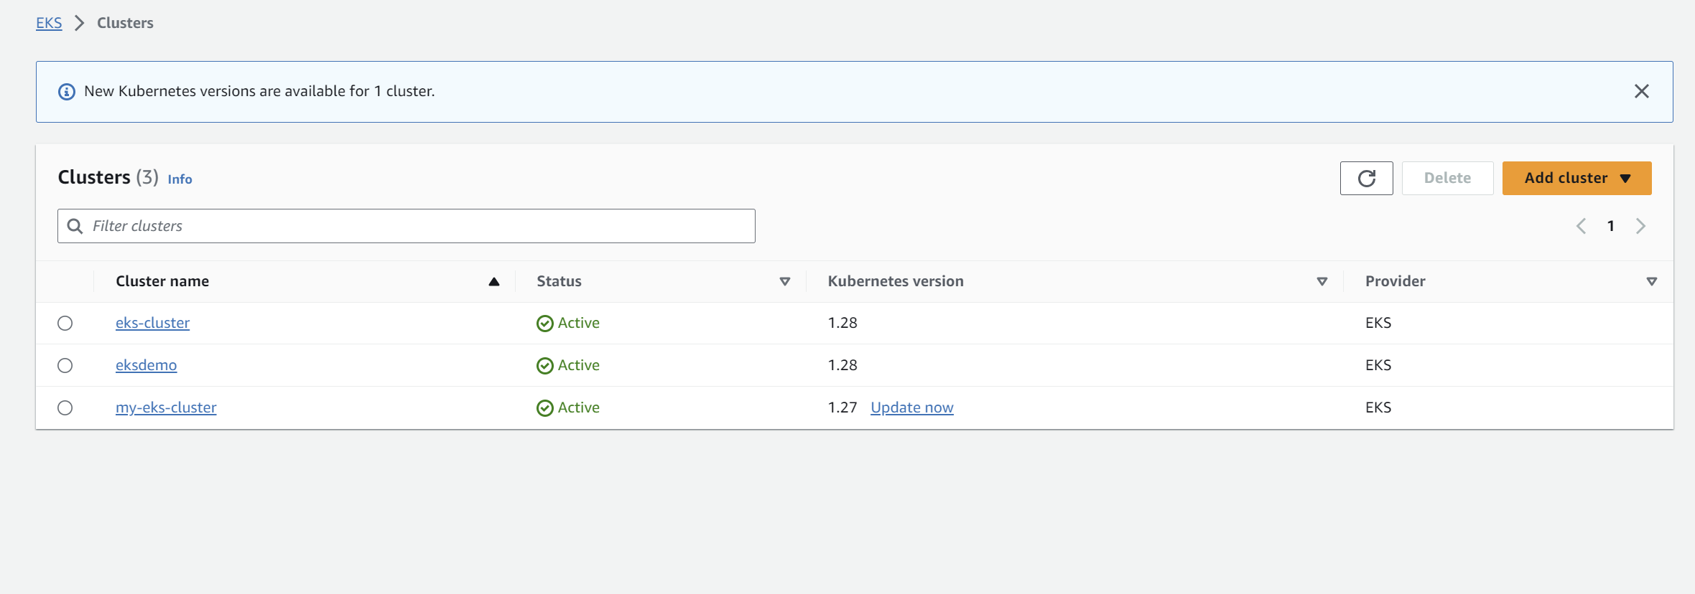

**Step-18:** Also go to **EC2** Dashboard and click on instances. We can see that the specified number of node instances are created i.e. 3.

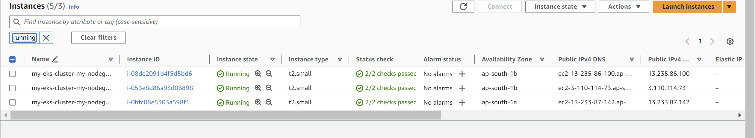

**Deploying a sample application**

**Step-19:** Now create a “**deployment.yaml”** file using any editor and copy the following yaml code.

NOTE: MAKE SURE THE INDENTATION OF THE YAML FILE IS SAME AS SHOWN OTHERWISE IT WILL THROW MAPPING ERROR.

apiVersion: apps/v1kind: Deploymentmetadata: name: nginx-deploymentspec: selector: matchLabels: app: nginx replicas: 3 template: metadata: labels: app: nginx spec: containers: - name: nginx image: nginx:1.14.2 ports: - containerPort: 80



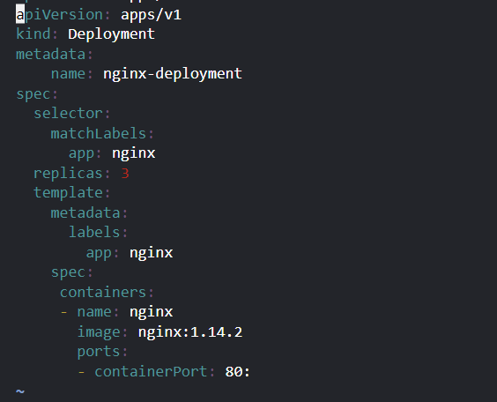

**Step-20:** Deploy the sample application to your EKS cluster:

kubectl apply -f deployment.yaml



**Exposing the Application**

**Step-21:** Now expose the application using a Kubernetes service and get the external IP address of the LoadBalancer:

kubectl expose deployment nginx-deployment --type=LoadBalancer --name=my-service

* The **kubectl expose command** is creating a new Kubernetes Service named "**my-service**" and exposing the "**nginx-deployment**" Deployment to the external network using a **LoadBalancer** type service.

kubectl get services my-service

* The **kubectl get services my-service** command is used to retrieve information about the Kubernetes Service named "**my-service**," displaying details such as the **service's IP address, ports**, and other relevant information.



**Step-22:** Now go to EC2 dashboards and click on load balancers.

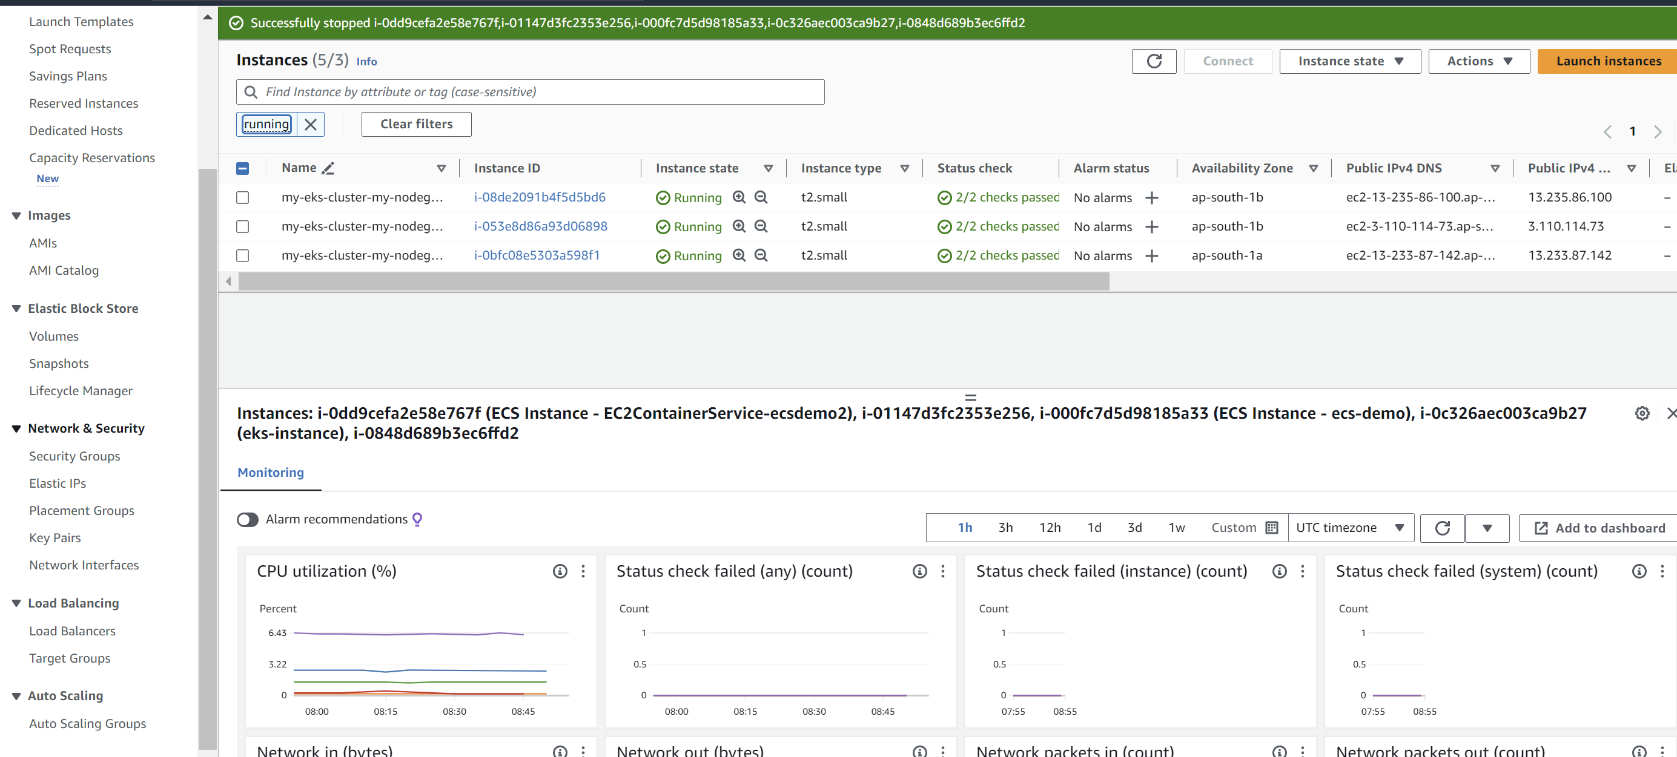

**Step-23:** We can see on the dashboard a “**classic**” load balancer that is made by default after running the command.

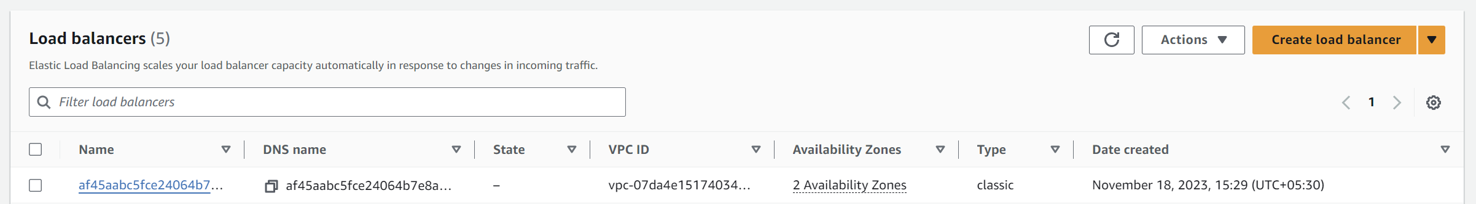

**Step-24:** Copy the **DNS name** and paste it in browser to check whether the service is accessible or not.

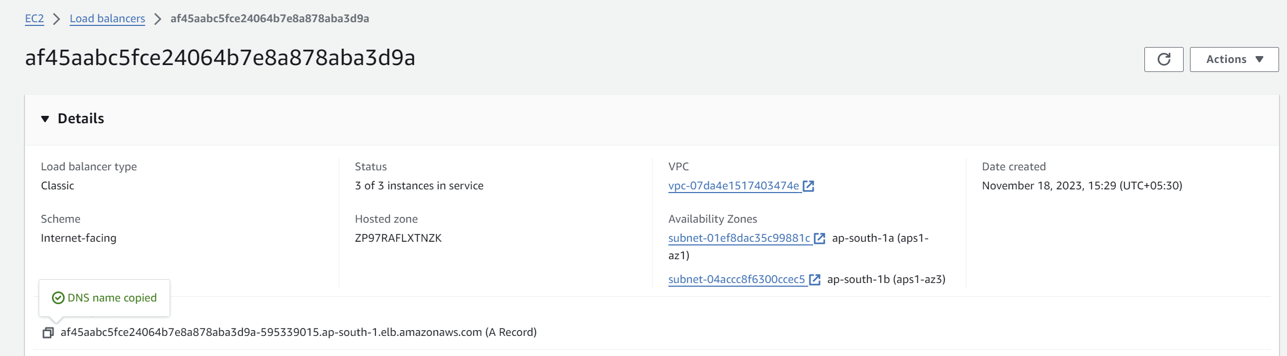

We can see that it is accessible on browser.

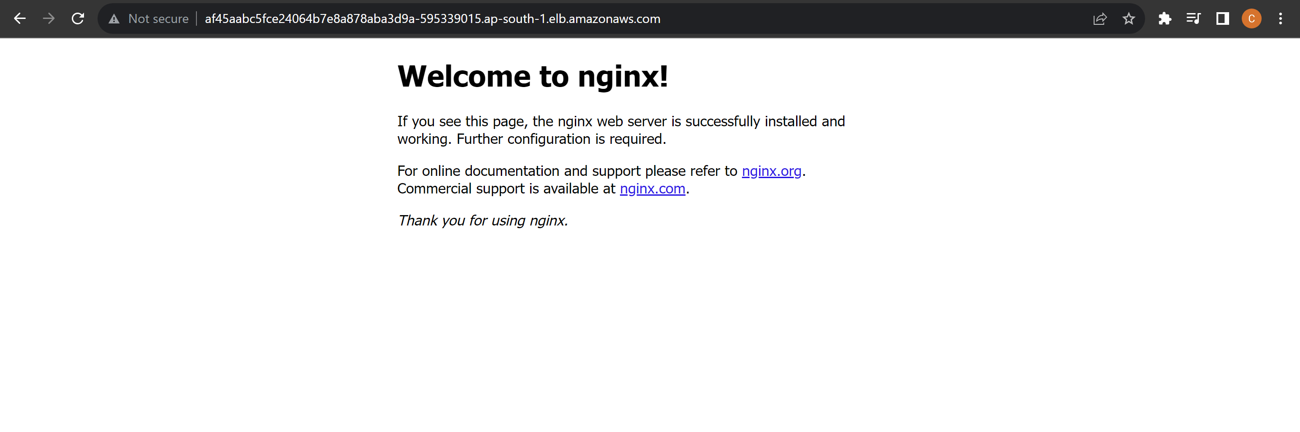

**Setting up Horizontal Pod Autoscaler**

Step-25: Now create a new file named `**hpa.yaml**`(just like we made the deployment.yaml) with the following content:

apiVersion: autoscaling/v1kind: HorizontalPodAutoscalermetadata: name: nginx-deployment-hpaspec: scaleTargetRef: apiVersion: apps/v1 kind: Deployment name: nginx-deployment minReplicas: 3 maxReplicas: 10 targetCPUUtilizationPercentage: 50

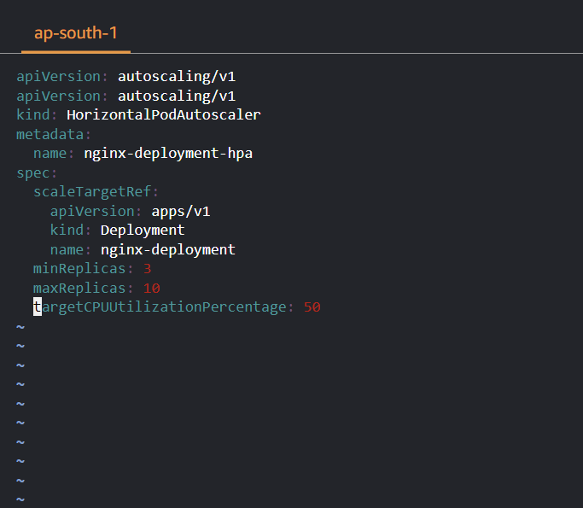

**Step-26:**

kubectl apply -f hpa.yaml



Step-27: After performing the above commands, you can delete the service and cluster using the following commands:

kubectl delete svc my-serviceeksctl delete cluster --name my-eks-cluster